Reception Home Learning – Summer term 1 Our topic is called ‘Are we there yet?’ It’s all about transport and journeys.
Number bonds to 10  Learn these songs to help you learn your number bonds to 10.  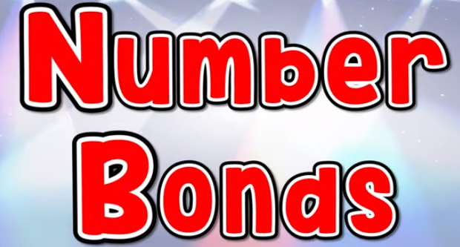  https://www.youtube.com/watch?v=lD9tjBUiXs0  https://www.youtube.com/watch?v=ch7KzI3n2Zk  Complete the tasks in the resources | Money  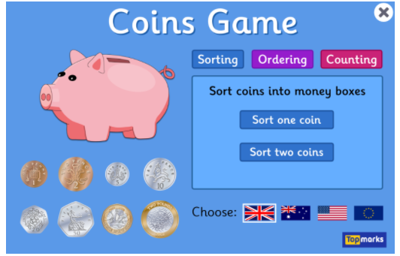  https://www.topmarks.co.uk/money/coins-game  Can you play the money games?  Can you go to the shop with a family member and use coins to pay for an item? | CVC word reading    https://www.starfall.com/h/word-machines/?mg=m  Can you use your phonic knowledge to read the cvc words?  Can you write the words down?  Can you complete the cvc worksheet? | Phonics  Letters and sounds  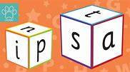  https://lettersandsounds.org.uk/for-home/reception  There are lots of individual lessons here that teach each sound.  You will need to go back to autumn term and start from there so you don’t miss any sounds. | Journey - map drawing  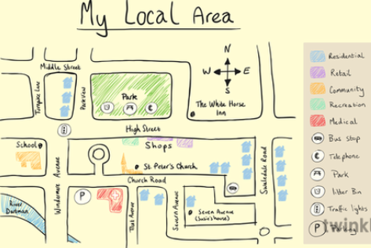  Can you look at the map of Adamsdown and find your house?  Can you make a map of your local area? Can you include; your house, our school and the park?
Story  The Train Ride  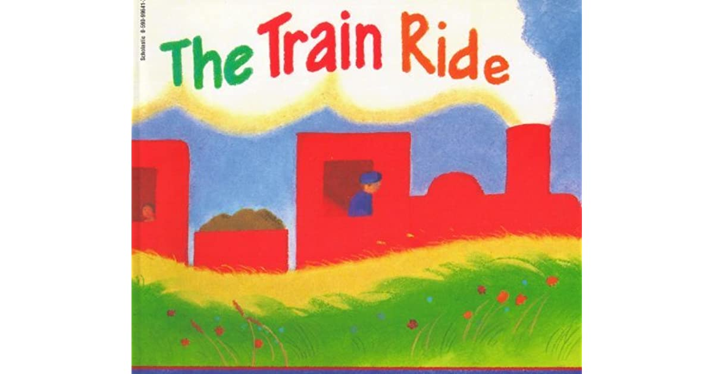  Watch the teacher’s flipgrid  https://flipgrid.com/0b27527b  Song  https://www.youtube.com/watch?v=jHbE8kaBDKU | Welsh  Learn the welsh song all about feelings    Mr Hapus ydwi i  https://www.youtube.com/watch?v=lGozXPt9M-Y  Also find the lyrics in the resources | Art and Design  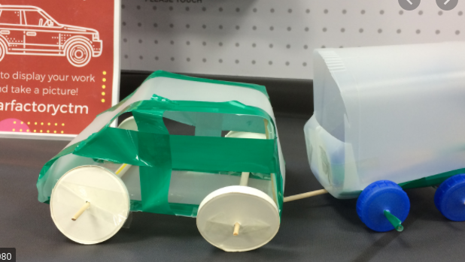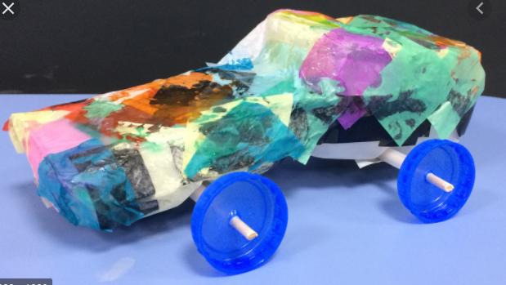  Can you make a vehicle with materials you can find around your house? | Reading    Oxford Owl for Home: help your child learn at home | Oxford Owl  Story Time - Stories for kids - CBeebies - BBC | Counting in 10’s  https://www.youtube.com/watch?v=_yr-IuM4SEA  Counting in 2’s  https://www.youtube.com/watch?v=G2iStjfHxrk  Can you sing along to the songs?  Download and complete the counting worksheets.

