Reception Home Learning – 25.01.2021 This week is all about healthy lunches! 💚
Monday | Tuesday | Wednesday | Thursday | Friday
Start each day with a 10 minute shake up game  Mike and Sulley's Scare Challenge | 10 Minute Shake Up | Change4Life (www.nhs.uk) | Start each day with a 10 minute shake up game  Crush and Squirt's Turtle Travel | 10 Minute Shake Up | Change4Life (www.nhs.uk) | Start each day with a 10 minute shake up game  Roo's Whoopty-Dooper Bounce | 10 Minute Shake Up | Change4Life (www.nhs.uk) | Start each day with a 10 minute shake up game  Dory's Blue Fin Boogie | 10 Minute Shake Up | Change4Life (www.nhs.uk) | Start each day with a 10 minute shake up game  Hank's Hopscotch | 10 Minute Shake Up | Change4Life (www.nhs.uk)
🍏Adamsdown healthy lunch week 💚  Watch the check in video on Flipgrid  Then send one back!  Hello my name is…  I am feeling…  I am having … for my healthy lunch today.  Healthy lunch challenge  *Can you share your healthy lunch on Twitter or google classroom each day this week?  The winner of the healthy lunch challenge will be announced in an assembly by Mrs Thomas next week. | Phonics  Today we are learning about the letter ‘d’.  ‘d’ for dice, dog  Watch the video below:  https://www.youtube.com/watch?v=idzucVLvQvY  https://www.youtube.com/watch?v=-91wZedIs6E&feature=youtu.be  Watch the Flip grid video on Google classroom  * Can you go on a hunt around your house for things beginning with ‘d’?  ** Can you write the ‘d’ words from the worksheet? | Food Technology  Can you follow a healthy recipe to make a healthy snack? I like the sound on this one:  Choc Cherry Popcorn Cakes | Recipes | Change4Life (www.nhs.uk)  You can choose your own recipe but make sure that it’s healthy! This website has lots of great ideas:  https://www.nhs.uk/change4life/recipes  *Can you make a short video about your snack?  **Can you include details of how you made it? | Weighing  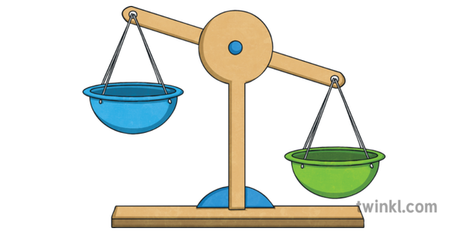  Can you find a range of objects in your house?  Can you order them from lightest to heaviest?  Complete the PowerPoint. Try and decide if things are Heavy or light. | Food Technology    Can you design and make your own healthy snack to have after your healthy lunch?  Create a recipe for it and share it with us so we can make it too!  You could even make a video to show us how to make it.
Weighing  The week we are learning about ‘heavy’ and ‘light’. Watch the video below:  https://www.bbc.co.uk/iplayer/episode/b0bc2ckr/kit-pup-series-1-9-heavy-and-light  *Can you find heavy and light objects in your home?  **Can you say which is the heaviest and which is the lightest? | 🌈Children’s commissioner for Wales 🌈  You’ve been staying home over the last few weeks because of Coronavirus.  People who can help to make a difference to your life want to listen to how you feel about staying at home.  https://www.childcomwales.org.uk/wp-content/uploads/2021/01/Picture-Activity_English_s2.pdf  Please read the information to your child and ask them to draw a picture | Writing    Can you write down the instructions for the healthy recipe you made?  Watch your teacher’s flipgrid to help you write instructions.  Use these words to start your sentences.  - First……  - Next……  - Then……  - Finally….. | Reading  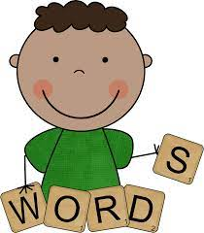  Use the resources to learn the tricky words.  Do not sound the words out - just look and say.  *Learn the orange flashcards first | Welsh    Dw i’n hoffi?  Look at the pictures of fruit and say:  Dw i’n hoffi…...  I like…  Use the resources provided and watch the flipgrid video by your teacher.

Things that you can do everyday with your child throughout the day:
Exercise time    It’s really important to keep our bodies moving while we are at home.  Can you choose a different workout video to complete everyday? Click on one of the links below.  CBeebies - Andy's Wild Workouts (bbc.co.uk)  Cosmic Kids Yoga - YouTube | Reading    Oxford Owl for Home: help your child learn at home | Oxford Owl  Story Time - Stories for kids - CBeebies - BBC | Letter sounds    https://lettersandsounds.org.uk/for-home/reception  There are lots of individual lessons here that teach each sound.  Go back to autumn term so you don’t miss any sounds.  Each lesson is just 7/8 mins long so it would be easy to complete one each day! | Numbers    Counting Games  https://www.topmarks.co.uk/maths-games/3-5-years/counting  Adding games  https://www.topmarks.co.uk/maths-games/3-5-years/addition  Number games  https://uk.splashlearn.com/number-games-for-year-1 | Sing along  Sing some of our favourite songs from class with your family.  https://www.youtube.com/watch?v=cSPmGPIyykU - exercise and rhyme  https://www.youtube.com/watch?v=_MVzXKfr6e8 – count to 20 and workout  https://www.youtube.com/watch?v=u4_L7CM46M4 - 5 little fish  https://www.youtube.com/watch?v=Ik_-OAgzD-8 - doubles rap

