Reception Home Learning
Complete these activities at home. Please post pictures for us on Twitter
@ReceptionMoon @MrsJ_Silver
  Can you design a Christmas card for someone in your family?  You could draw a colourful picture on the front and then write your name on the inside!   |   Do you like christmas cookies? Why don’t you bake some with your family? Here’s a good recipe that you could follow:  https://www.bbc.co.uk/food/recipes/christmasbiscuits_93733  Can you describe your cookie? What shape is it? What colour is it? |   What is your favourite christmas song?  Could you make an instrument to play while you sing along?  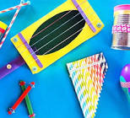
  Can you be just like our bossy elf and write some bossy instructions on how to bake cookies?  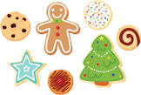 |   Watch the video below to find out how Christians celebrate Christmas.  https://www.youtube.com/watch?v=IO6hjEjPxoM  What is your favourite occasion that you and your family celebrate? |   Do you have a Christmas tree in your home?  Can you count the baubles on the tree?  or  Download the Christmas tree counting activity.

