Reception Home Learning – 18.01.2021 This week is all about Kindness! 💜 #adamsdownactsofkindness
Monday | Tuesday | Wednesday | Thursday | Friday
🌈Adamsdown Acts of Kindness 💜  https://www.youtube.com/watch?v=H98Rfljxmsc  Watch the video above and the Powerpoint in resources.  This week is about kindness  * Can you complete the Kindness diary each day?  ** Can you make a kindness jar for your family?  (resources are all in this week’s folder) | Symmetry  Watch the video  https://www.bbc.co.uk/bitesize/clips/ztpyr82  * Can you make a symmetrical picture?  Use the game below on the computer, or you could use paint or colouring pencils  https://pbskids.org/peg/games/symmetry-painter  https://www.youtube.com/watch?v=042uDqg2k3g | Food Technology  Try making a fruit salad or a smoothie.  Use some fruit from the story or your own favourite fruit.  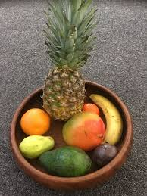  *Can you film yourself making the smoothie?  **Can you talk about what you are doing?  Watch the teacher’s Flipgrid | Phonics  Today we are learning about the letter ‘m’.  ‘M’ for mouse, mango  Watch the video below:  Lesson 8 - Reception - YouTube  * Can you go on a hunt around your house for things beginning with ‘m’?  ** Can you write the ‘m’ words from the worksheet? |   Creative  1.Can you draw or paint your favourite fruit from the story?  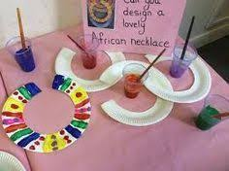  2.Can you make an African necklace out of a paper plate?
Story of the week  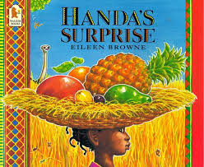  HANDA'S SURPRISE Picture Book Animation - YouTube  *Can you answer the questions about the story?  Teachers have recorded a Flip Grid for this - find it on Google Classroom | Welsh  Fruit names in Welsh  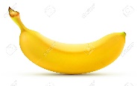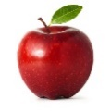  Listen to the Welsh song  Can you sing along?  https://www.youtube.com/watch?v=KZDElMGWYWs  First, they count 10 bananas  Then they count 10 apples  See if you can do it! | Writing  Can you write a list of ingredients that went into your fruit salad or smoothie?  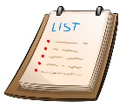  Watch the flip grid video  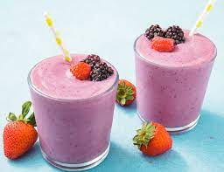 | Symmetry  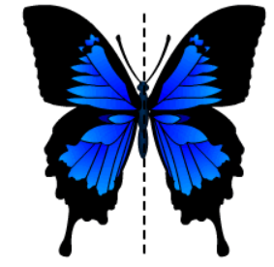  **Can you sort the symmetrical pictures?  https://www.topmarks.co.uk/symmetry/symmetry-sorting  or download and print the sorting activity. | 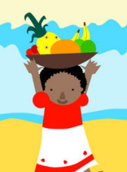  Physical  How many pieces of fruit can you balance in a bowl on your head?  Make it a competition with your family!  *How many did you balance?  **How many did your teacher manage?  Watch the flip grid to see!  *Tip – if you don’t have much fruit at home you could use rolled up socks!

Things that you can do everyday with your child throughout the day:
Exercise time    It’s really important to keep our bodies moving while we are at home.  Can you choose a different workout video to complete everyday? Click on one of the links below.  CBeebies - Andy's Wild Workouts (bbc.co.uk)  Cosmic Kids Yoga - YouTube | Reading  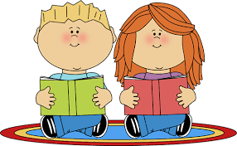  Oxford Owl for Home: help your child learn at home | Oxford Owl  Story Time - Stories for kids - CBeebies - BBC | Letter sounds  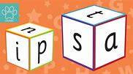  https://lettersandsounds.org.uk/for-home/reception  There are lots of individual lessons here that teach each sound.  You will need to go back to autumn term and start from there so you don’t miss any sounds.  Each lesson is just 7/8 mins long so would be easy to complete one each day! | Numbers  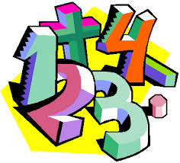  Counting Games  https://www.topmarks.co.uk/maths-games/3-5-years/counting  Adding games  https://www.topmarks.co.uk/maths-games/3-5-years/addition  Number games  https://uk.splashlearn.com/number-games-for-year-1 | Sing along  Sing some of our favourite songs from class with your family.  https://www.youtube.com/watch?v=cSPmGPIyykU - exercise and rhyme  https://www.youtube.com/watch?v=_MVzXKfr6e8 – count to 20 and workout  https://www.youtube.com/watch?v=u4_L7CM46M4 - 5 little fish  https://www.youtube.com/watch?v=Ik_-OAgzD-8 - doubles rap  https://www.youtube.com/watch?v=L3DW45WIXgY - pwy wyt ti?  https://www.youtube.com/watch?v=OEbRDtCAFdU - 2D shape song

Early years resources for learning at home - BBC Bitesize - website with links to every subject and lessons.

