Reception Home Learning
Complete these activities at home. Please post pictures for us on Twitter
@ReceptionMoon @MrsJ_Silver
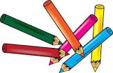  Use the sounds we have learnt to make words.  Put these letters onto little pieces of paper and put them together to make words  s a t p i n  sit, sat, pat, pin, tip, pit, sip, nip, nap, tan, tin, tap  *Once you have made the words write them down.  ** Can you use the words in a sentence  PLEASE FIND MORE RESOURCES ON OUR CLASS PAGE | 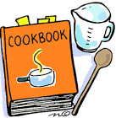  Help to cook one of your favourite meals and then enjoy it all together.  Take some photograph/make a video to show us what you make.  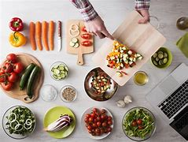 | 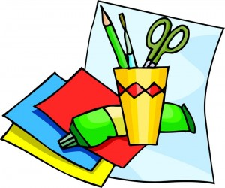  Make a Wreath using the shapes that you know to decorate it.  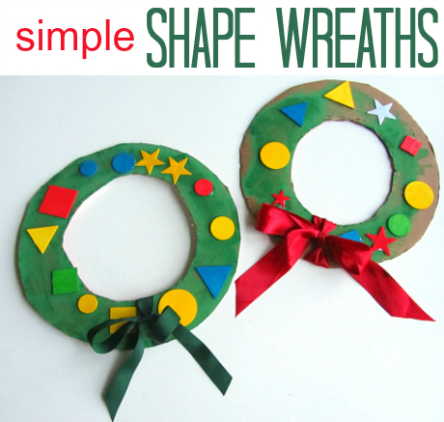
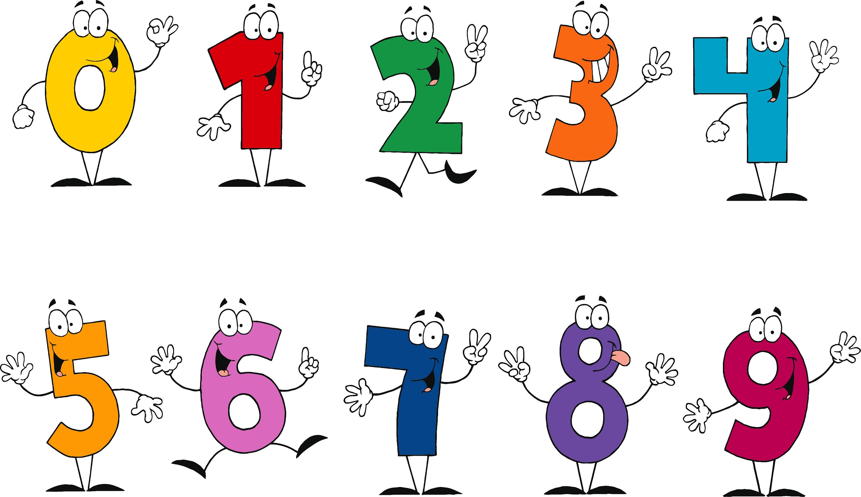  Number Activities  Complete the number activities on our class page.  Play these christmas themed maths games  https://www.topmarks.co.uk/learning-to-count/teddy-numbers  https://www.topmarks.co.uk/learning-to-count/gingerbread-man-game |   Watch the Pantomime  Alice in Wonderland  https://www.bbc.co.uk/iplayer/episode/b06s2h64/cbeebies-presents-stage-shows-alice-in-wonderland  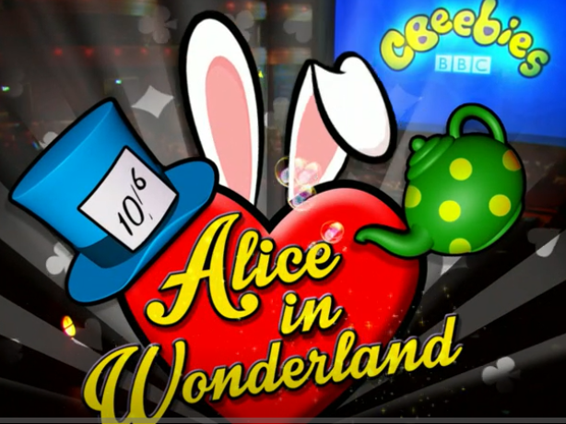 | 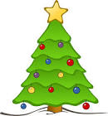  Make a salt dough decoration  Follow these instructions:  https://www.bbcgoodfood.com/howto/guide/salt-dough-christmas-decorations  