Reception Home Learning
Complete these activities at home. Please post pictures for us on Twitter
@ReceptionMoon @MrsJ_Silver
  Can you make a picture of your family?  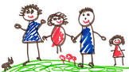  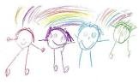 |   We are reading the story of the Three Little Pigs  Listen to the story.  You can join in with the parts you know.  https://www.youtube.com/watch?v=JDYfnfUuD00 |   Can you count to 10?  Watch and join in with these songs  https://www.youtube.com/watch?v=6RfIKqkvHTY  https://www.youtube.com/watch?v=lqX1NdKAhH
  Can you write your name?  Practice writing your name  Don’t forget the first letter is a capital letter the rest of the letters are lowercase.  capital letter → Jane | 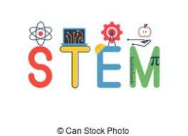  Can you build a house for one of the 3 Little Pigs?  You can use lego, sticks, boxes or anything else you can find around your house.  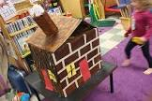 | 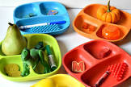  Can you find some coloured objects from around your house and sort them into the colours?  Can you name all of the colours you found?