Reception Home Learning – 11.01.2021
Monday | Tuesday | Wednesday | Thursday | Friday
Story of the week  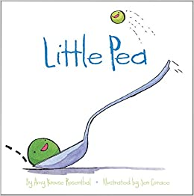  Listen to the story: https://youtu.be/tdF6nDBm7v0  Watch the flip grid video from your teacher… or look at the questions about the video and answer them. | 3D shapes  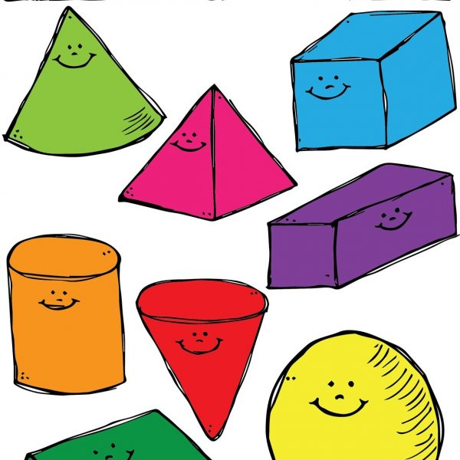  The 3D shape song - KS1 Maths - BBC Bitesize  *Can you learn the names of the 3D shapes? | Healthy swaps  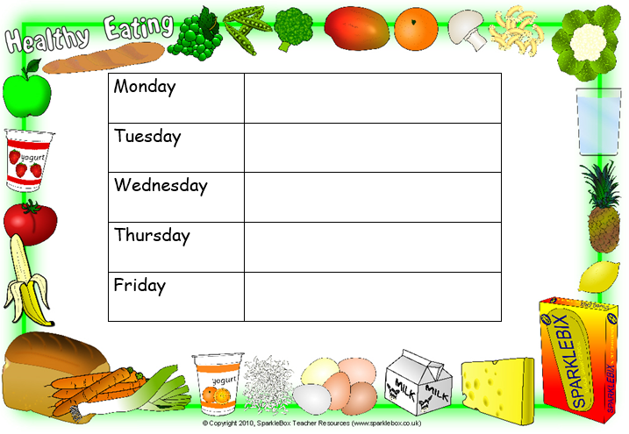  Little Pea eats candy everyday for his dinner.  *Can you draw a picture of a healthy swap for little Pea to eat for each day?  **Can you write the initial letter of each food? | 3D shapes  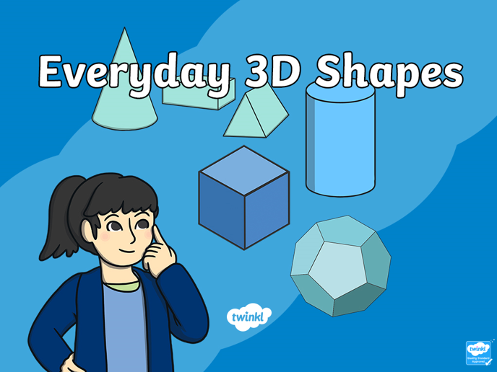  Download and read through the 3D shapes powerpoint  *Can you download and play the ispy 3D shapes game?  **Can you find any 3D shapes in your home? Can you take a picture of them all? | Phonics  Watch the video  Set One sounds | Phase 2 Phonics | s a t p sounds | s a t p words - BBC Bitesize  Watch the short video clip  *Can you think of a word for each sound? Can you write each sound? (You could use pen and paper or chalk on the floor in your garden?  **Can you play the CVC read and race game?
Writing  In the story Little Pea tells us what he likes to do.  Can you say and then write some sentences about what you like to do to make you happy?  Start your sentences with:  I like to______________  E.g. I like to play with my toys.  Write the sentences on paper.  The children will need to copy the words and that is fine! | Healthy living  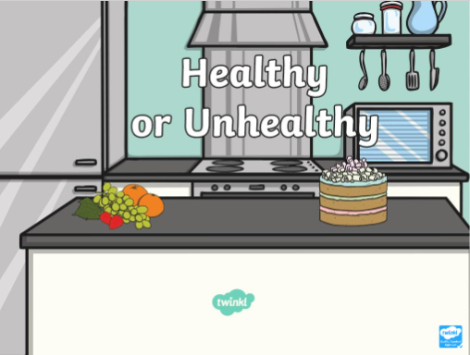  Look at the Healthy Living Powerpoint  *Can you sort the healthy and unhealthy items in the powerpoint?  ** Can you think of other foods you could add? | Welsh  Click on the link and listen to the Welsh song.  Lliwiau'r Enfys - YouTube  *Can you make a rainbow with things that you have in your home? E.g food, clothes or toys.  **Can you name each colour? | Food Technology  Can you make a happy face, healthy lunch  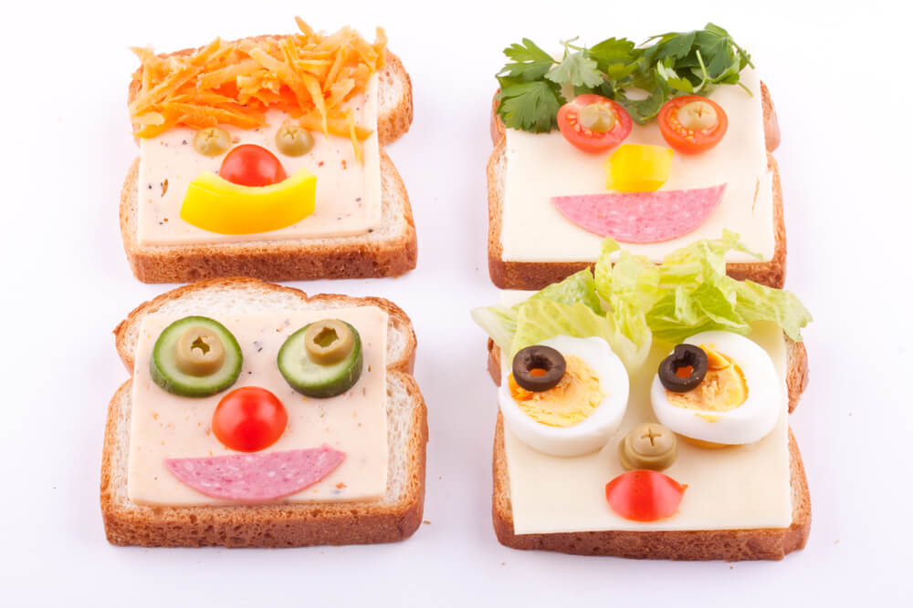  *How did it taste?  ** What food did you use? | Singing and Dancing  Singing and dancing can make you feel really happy. You should know these songs from class - Teach them to your family!  https://www.youtube.com/watch?v=r5EZ59taAwM - Wiggle like spaghetti  https://www.youtube.com/watch?v=KJonGSbUWX - Elephants have wrinkles  https://www.youtube.com/watch?v=pPrwQ9L42cs - Shake your eggs  https://www.youtube.com/watch?v=NwT5oX_mqS0 - Shake your sillies out

Things that you can do everyday with your child throughout the day:
Exercise time    It’s really important to keep our bodies moving while we are at home.  Can you choose a different workout video to complete everyday? Click on one of the links below.  CBeebies - Andy's Wild Workouts (bbc.co.uk)  Cosmic Kids Yoga - YouTube | Reading  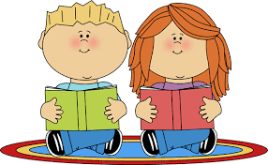  Oxford Owl for Home: help your child learn at home | Oxford Owl  Story Time - Stories for kids - CBeebies - BBC | Letter sounds  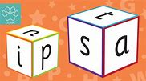  Can you form the letters s, a, t, p, i and n? Listen to these songs, they will help you with the pronunciation.  Satipn songs/ Jolly phonics Phase 1 songs/ Jolly phonics phase 1/ - YouTube | Numbers  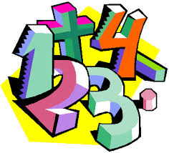  Addition To 10 (topmarks.co.uk)  Learning to Count up to 15 with Teddy Numbers Interactive Maths Game (topmarks.co.uk)  Ladybird Spots - Counting, Matching and Ordering game (topmarks.co.uk) | Sing along  Sing some of our favourite songs from class with your family.  https://www.youtube.com/watch?v=cSPmGPIyykU - exercise and rhyme  https://www.youtube.com/watch?v=_MVzXKfr6e8 – count to 20 and workout  https://www.youtube.com/watch?v=u4_L7CM46M4 - 5 little fish  https://www.youtube.com/watch?v=Ik_-OAgzD-8 - doubles rap  https://www.youtube.com/watch?v=L3DW45WIXgY - pwy wyt ti?  https://www.youtube.com/watch?v=OEbRDtCAFdU - 2D shape song

Early years resources for learning at home - BBC Bitesize - website with links to every subject and lessons.

