Reception Home Learning
Complete these activities at home. Please post pictures for us on Twitter
@ReceptionMoon @MrsJ_Silver
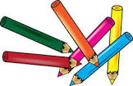  Can you draw a picture of your favourite dinner?  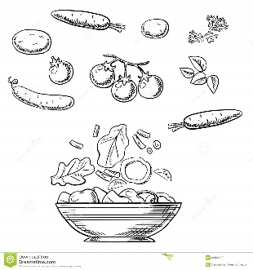  Make sure you include your favourite vegetable! | 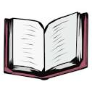  We are reading the story of ‘Goldilocks and the three bears’  Listen to the story.  You can join in with the parts you know.  https://www.youtube.com/watch?v=0oUP2PFeOi8 |   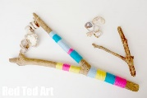  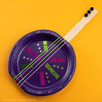  Can you make a musical instrument at home?  https://artsycraftsymom.com/diy-musical-instruments-for-kids-to-make-and-play/  (some good ideas on here)  *Can you create a beat with your instrument?
  Can you write your numbers to 10?  Don’t forget the 0 at the beginning.  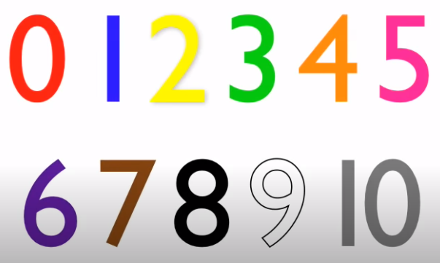  You can write them big or small, inside or outside. Can you take a picture of your numbers? | 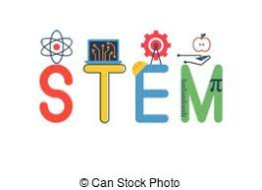  Can you find items around your house and sort them into big, medium and small?  You can use your toys or teddies, sticks from your garden or anything else you can find around your house.  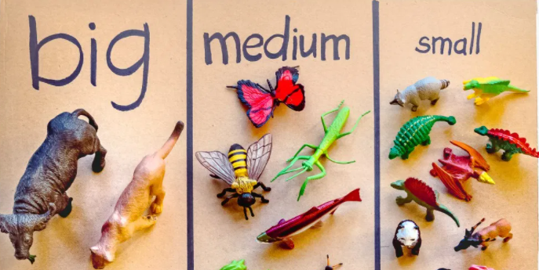 | 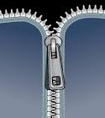  Can you practice putting on your coat and doing up your zip?  Do you have any buttons? Can you do them up?  