Reception Home Learning – 01.02.2021
Monday | Tuesday | Wednesday | Thursday | Friday
Daily Dance  Wake up shake up  https://www.youtube.com/watch?v=2RYJ-rX8vwE | Daily Dance  Count to 20 and workout  https://www.youtube.com/watch?app=desktop&v=_MVzXKfr6e8 | Daily Dance  I like to Move it  https://www.youtube.com/watch?v=ymigWt5TOV8 | Daily Dance  The letter ‘g’ dance  https://www.youtube.com/watch?v=0KXtxIiQ7gk | Daily Dance  Lets all jump for Friday  https://www.youtube.com/watch?v=yXhyE2hxtUs
🕮Story of the week🕮  🐛The Very Hungry Caterpillar🐛  Watch your teachers Flipgrid video or listen to the story here:  https://www.youtube.com/watch?v=eXHScpo_Vv8  (This can be played on a mobile phone)  *Can you retell the story to a grown up or can you record a video and send it to your teacher? | Phonics  Today we are learning about the letter ‘g’.  ‘g’ for gas, gate  Watch the video below:  https://www.youtube.com/watch?v=wiI16fMPr1Q  Watch the Flip grid video on Google classroom  * Can you go on a hunt around your house for things beginning with ‘g’?  ** Can you write the ‘g’ words from the worksheet? | Knowledge & understanding  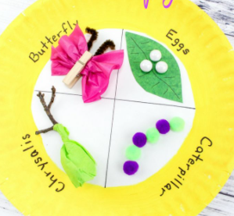  https://www.youtube.com/watch?v=QYbMScXPEV0  (This can be played on a mobile phone)  *What does the very hungry caterpillar turn into?  **Can you make the life of a butterfly? | Learn it’s  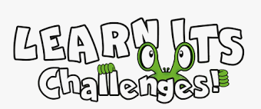  Watch your teacher's Flipgrid video.  *Can you complete the Learn Its challenges?  **Can you practice writing the number sentences yourself?  Maybe you could use your favourite colour pen or some chalk on the floor! | Art & craft  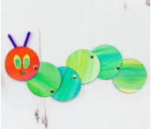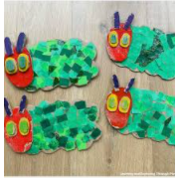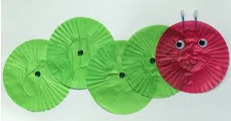  Can you make the very hungry caterpillar?  You can use a variety of items that you have at home.
Maths  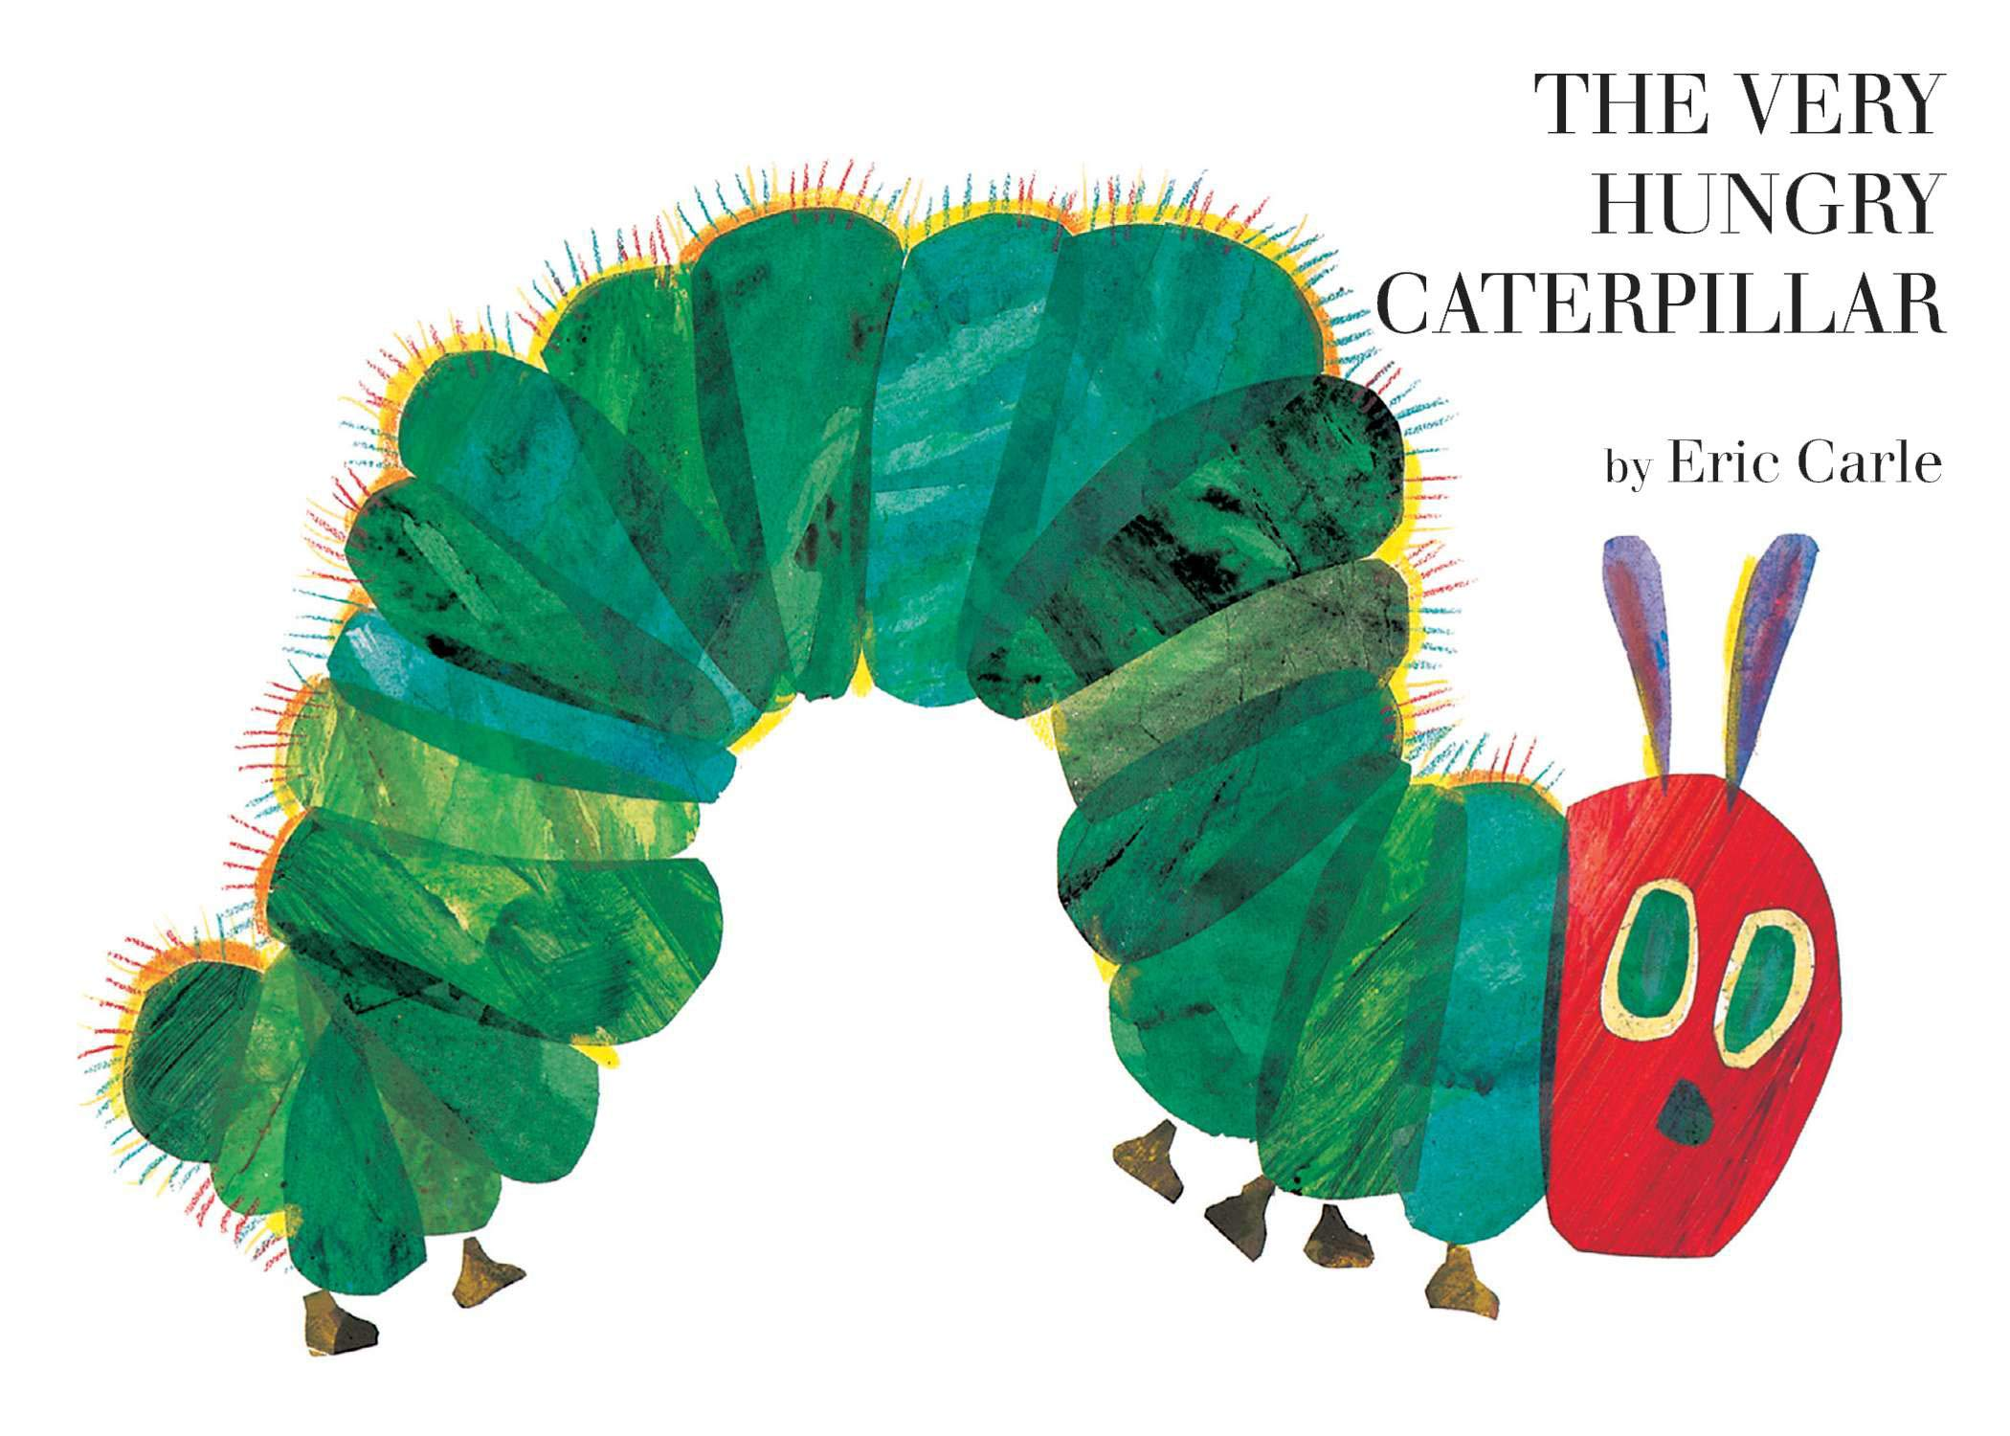  Can you complete all the Hungry Caterpillar maths activities?  *Can you complete the Maths booklet?  **Can you complete the number sequencing activity? | Knowledge & Understanding  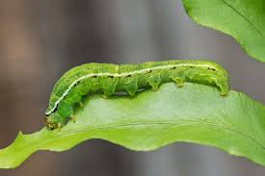  Can you find out some facts about a caterpillar?  You can read the cards in the resources or search on the Internet  Write the facts on a fact sheet draw a picture too?  See a blank example in resources | HFW  Can you play Snap or Pairs with the High Frequency Words?  Write these words on small pieces of paper and play a game to learn these words  I to  go into  no the | 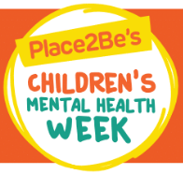  Express Yourself!  Can you answer these check in questions?  Watch the flip grid and send a video back to your teacher.  1. What is your name?  2. How are you feeling?  3. What would you like to be when you grow up? | Yoga time  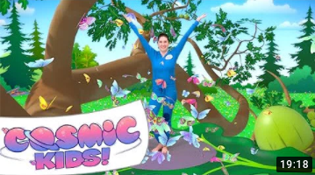  https://www.youtube.com/watch?v=xhWDiQRrC1Y  (This can be played on a mobile phone)  If you can’t access the link there are some yoga cards in the resources.

Things that you can do everyday with your child throughout the day:
Exercise time    It’s really important to keep our bodies moving while we are at home.  Can you choose a different workout video to complete everyday? Click on one of the links below.  CBeebies - Andy's Wild Workouts (bbc.co.uk)  Cosmic Kids Yoga - YouTube | Reading    Oxford Owl for Home: help your child learn at home | Oxford Owl  Story Time - Stories for kids - CBeebies - BBC | Letter sounds  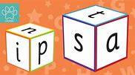  https://lettersandsounds.org.uk/for-home/reception  There are lots of individual lessons here that teach each sound.  Go back to autumn term so you don’t miss any sounds.  Each lesson is just 7/8 mins long so it would be easy to complete one each day! | Numbers    Counting Games  https://www.topmarks.co.uk/maths-games/3-5-years/counting  Adding games  https://www.topmarks.co.uk/maths-games/3-5-years/addition  Number games  https://uk.splashlearn.com/number-games-for-year-1 | Home Maths Challenges  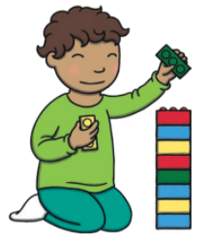  One more and One Less  Choose and complete the challenges on the home challenge sheet.  (see resources)

