**Handa’s Surprise Questions**

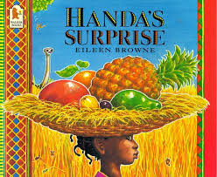

1. What did Handa do to show kindness to her friend?
2. What fruit did the monkey take from the basket?
3. Which animal took the orange from the basket?
4. When the animal hit the tree, which fruit fell into the basket?
5. Why was Handa surprised at the end of the story?