Sun Class Home Learning – 02.09.20
Monday | Tuesday | Wednesday | Thursday
Listen to the story  Listen to Jack and the Beanstalk with a grown up. Can you talk about the story?  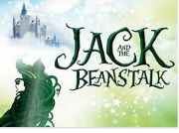  https://youtu.be/XnnSRy3v-1Q  Draw a picture of one part of the story and tell someone about it. | Measuring  In the story the Beanstalk is very tall and so is the giant!  Can you find things around your house that are taller than you or shorter than you?  Make a list with your grown up.  Example  Taller than me Shorter than me  The door My sister My cat  Use the sentence…  “The ---- is taller/shorter than me”. | Make a castle  Can you make a castle just like the one that the giant lives in?  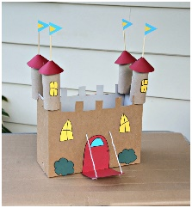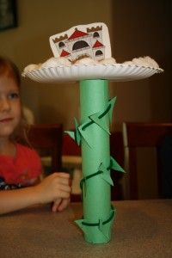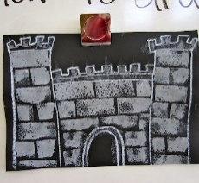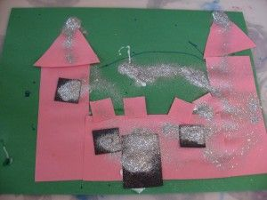 | Count the objects  Can you count the objects and match them to the numbers?  Write down numbers 1 -5. Ask the children to count the right number of objects  example: dried beans, lego blocks, pieces of pasta.  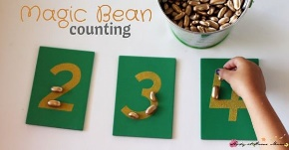  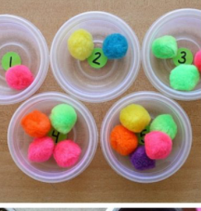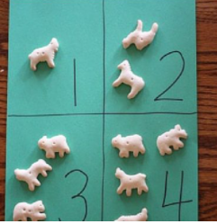  If that is easy, try higher numbers
Go on a letter hunt.  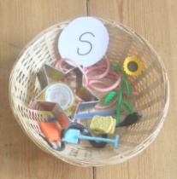  Can you find things beginning with ‘s’    Take a picture to show me what you find.  Here are some ideas:  Scissors, sock, scarf, spoon, salt  You could also try with the letter ‘a’ | Name writing  Make sure you have a capital letter to start your name and the rest should be lowercase.  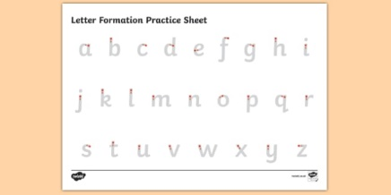  *If you can already write your first name you could learn your second name | Fireworks  Talk about fireworks.  You may have seen or heard them.  What sounds do they make?  What patterns? What colours?  Watch the video  https://www.youtube.com/watch?v=2ks1U-8bojU  Can you make some firework art!    https://artsycraftsymom.com/15-sparkling-fireworks-craft-ideas-for-kids/ | Sing along  Sing some of our favourite songs from class with your family.  https://www.youtube.com/watch?v=6RfIKqkvHTY – Zero superhero  https://www.youtube.com/watch?v=6RfIKqkvHTY – count to 20 and workout  https://www.youtube.com/watch?v=ffeZXPtTGC4- a is for apple  https://www.youtube.com/watch?v=uSVzk2pqWB4  the letter s  https://www.youtube.com/watch?v=gsb999VSvh8  the letter a
I have planned 2 tasks for you to do at home each day. Please post pictures for me on Twitter (@MrsJ_Silver). I look forward seeing you all on Friday 6th November.

