Reception St David’s Day Homework

On March the 1st it is St David’s Day. Here are a few tasks you can do at home to help celebrate. Please send us some pictures on email, Google Classroom or via Twitter to show us what you do..

St David’s Day  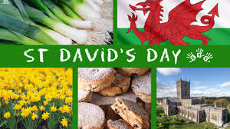  Watch the video below to see how St David’s Day is celebrated.  https://www.youtube.com/watch?v=awy4whEQt4A  This year it will be celebrated differently but people will still wear red and wear welsh symbols (daffodils and leeks). They will also eat traditional Welsh food.  What do you think is the best part about the celebrations? | Arts and Crafts  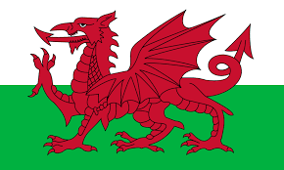  Can you make a Welsh Dragon?  You can make a model from recycled materials or even paint a picture.  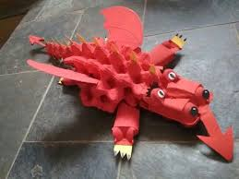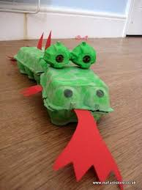  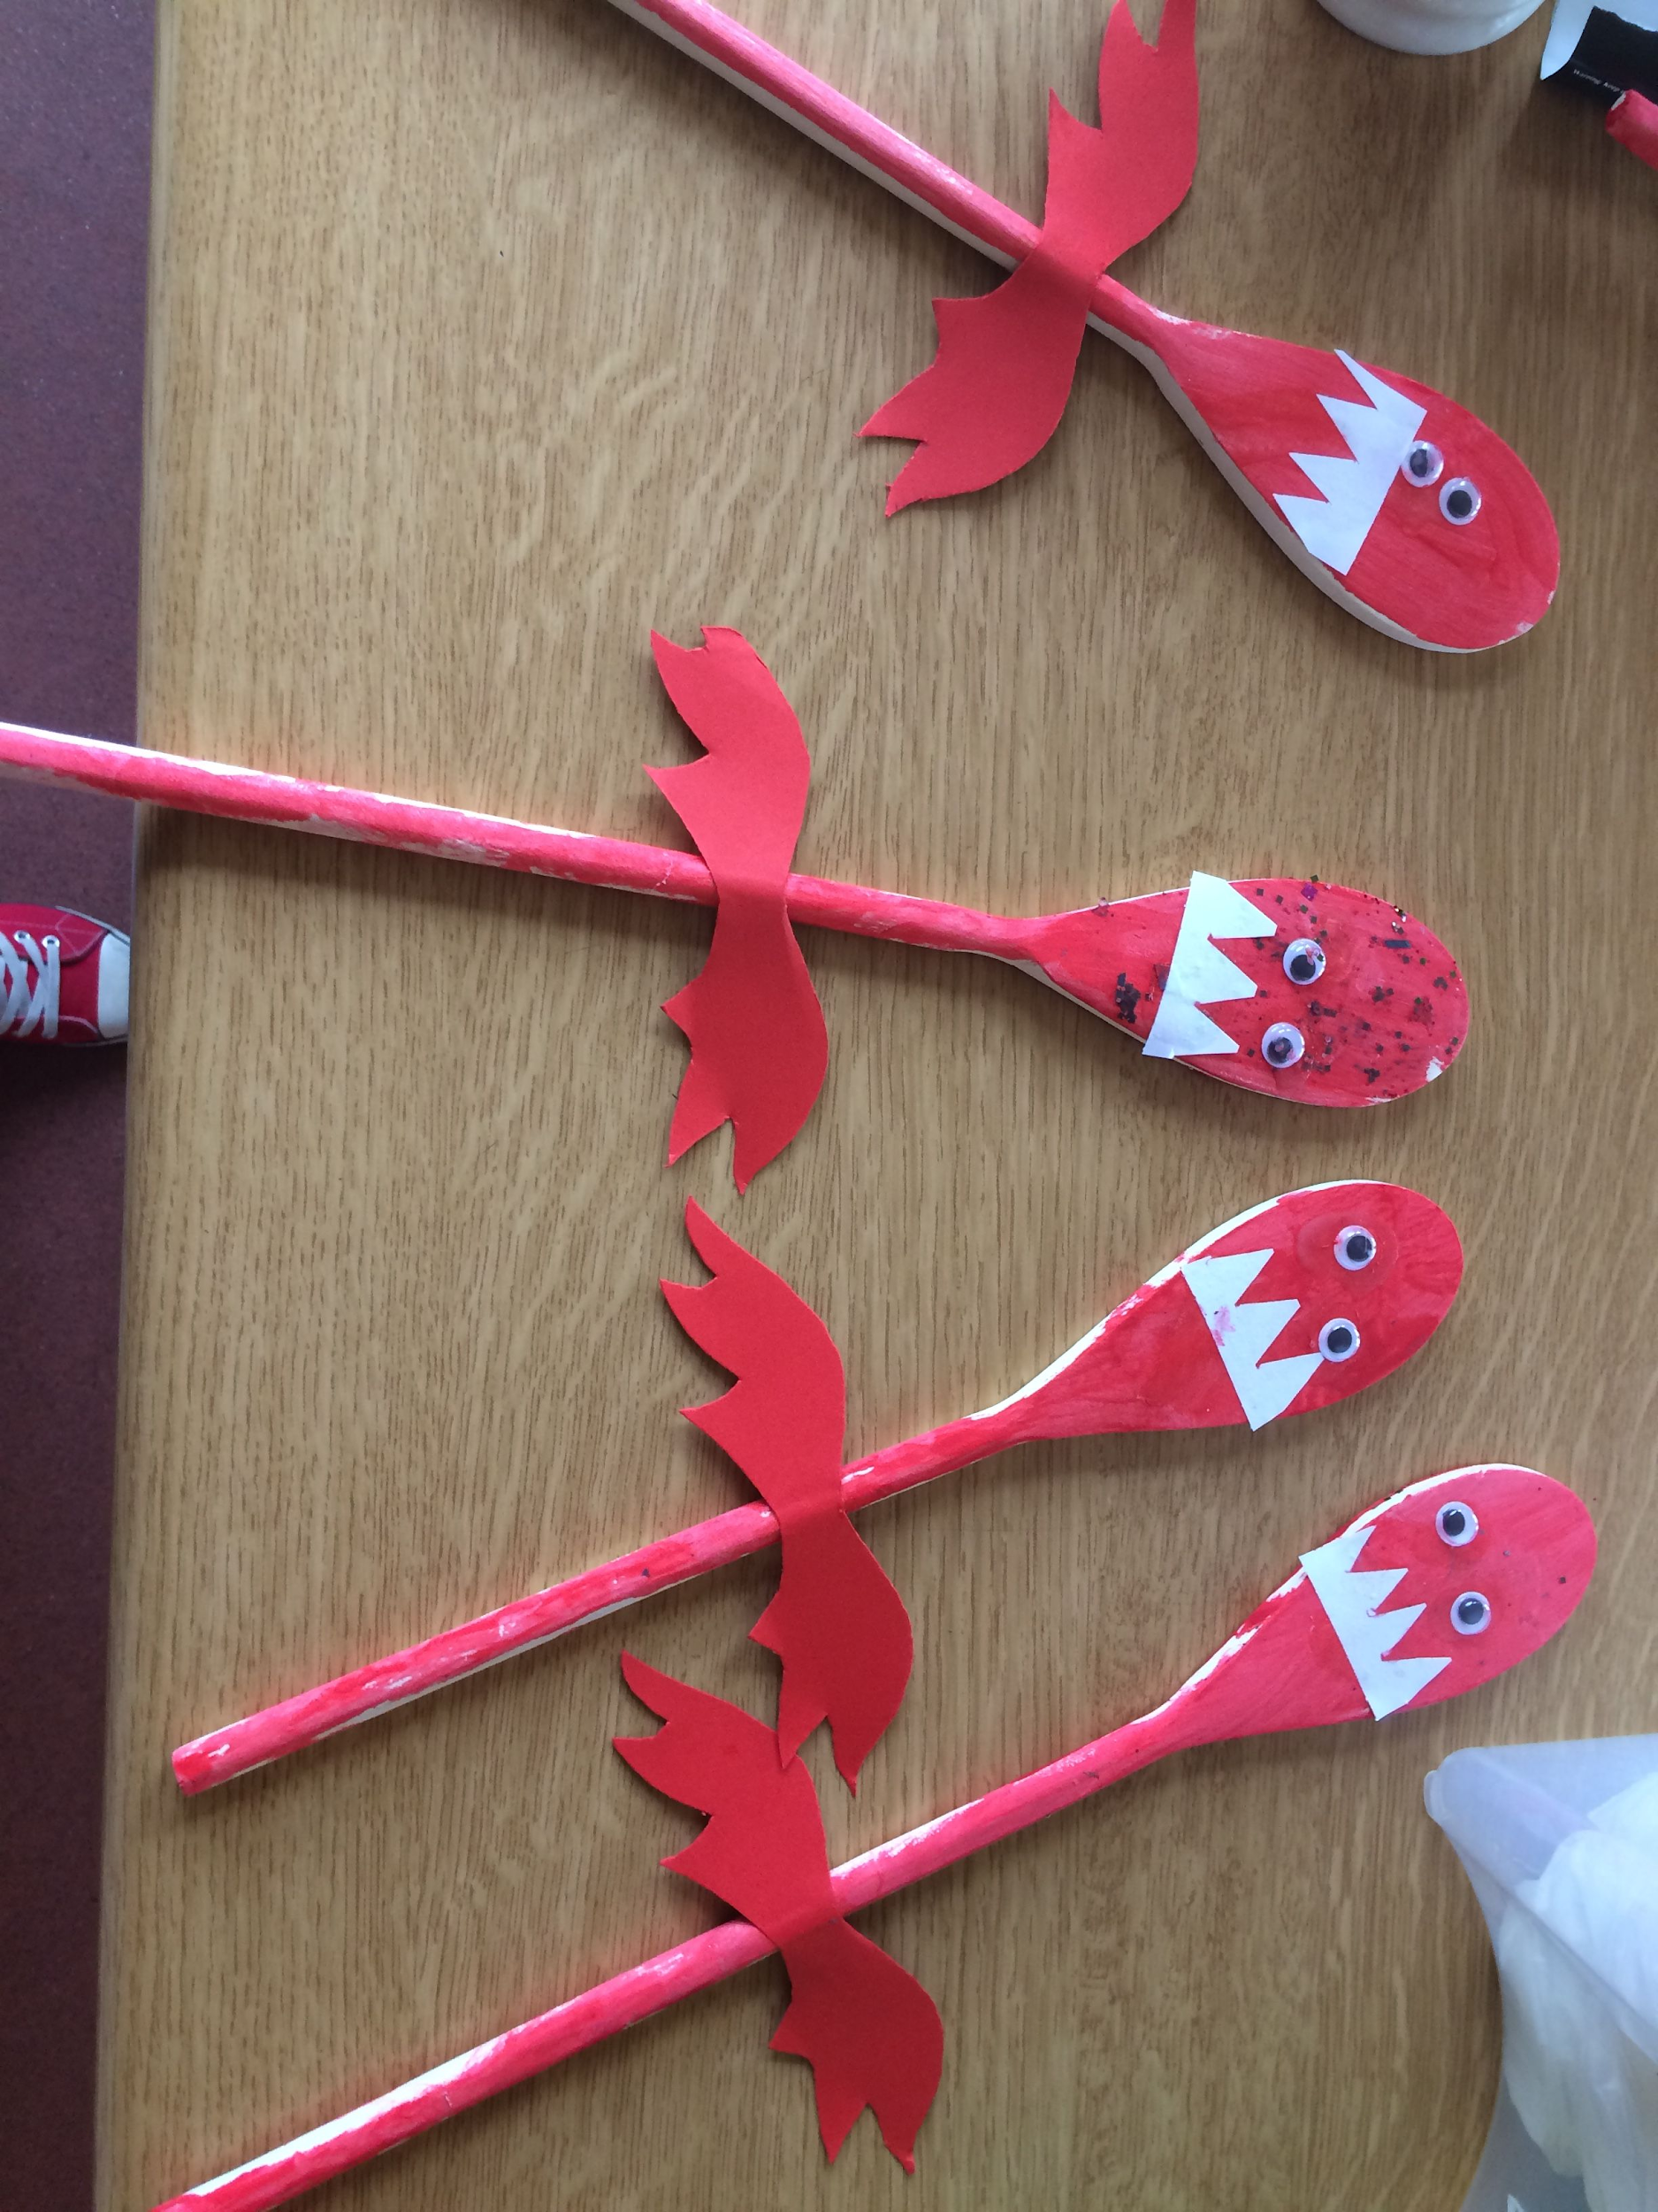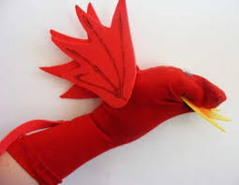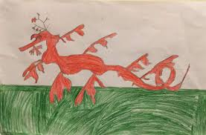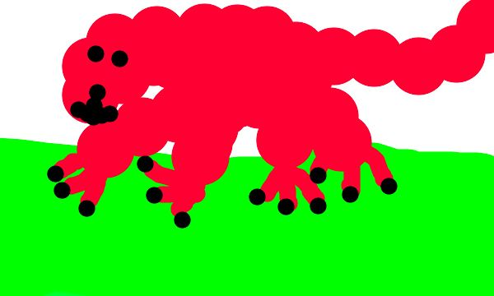 | Cooking  Can you make some traditional Welsh food?  Below are some links to some delicious recipes you could try:  Vegetable Cawl  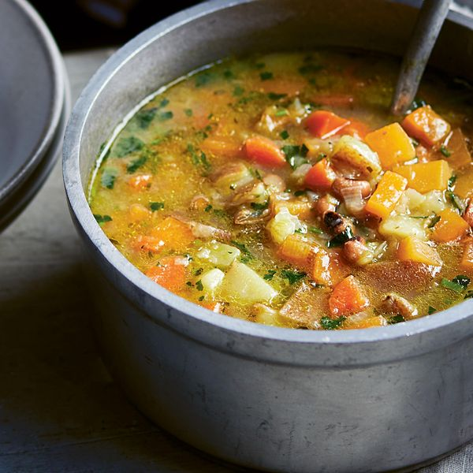  https://thehappyfoodie.co.uk/recipes/cawl  Welsh cakes  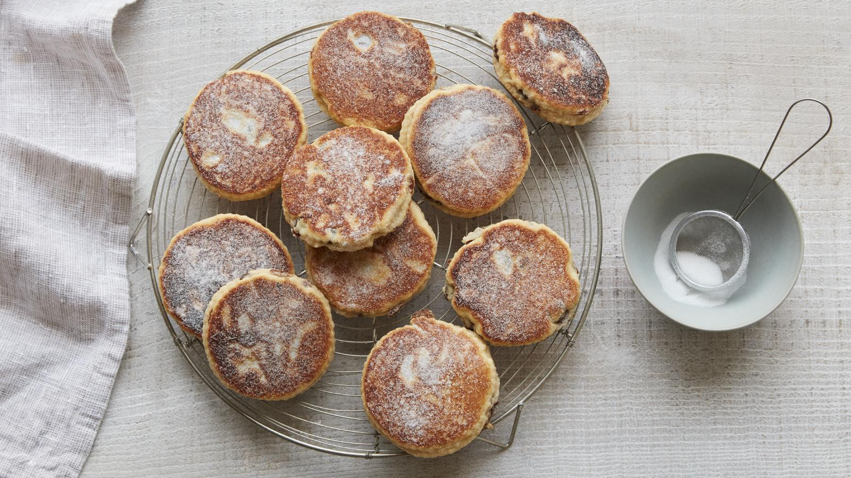  https://www.bbc.co.uk/food/recipes/welshcakes_6726

