Reception Home Learning – 05.01.2021
Tuesday | Wednesday | Thursday | Friday
Start the day with a story  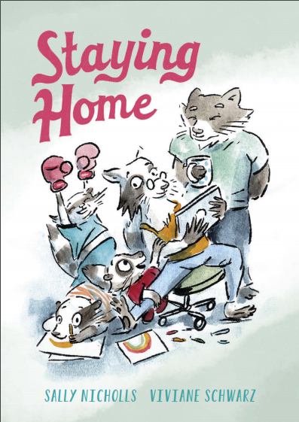  Click on the link to access the story:  https://www.andersenpress.co.uk/wp-content/uploads/2020/04/STAYING_HOME_medium-res.pdf  *Can you draw a picture of you and your family in your home?  **Can you write the names of all of the people in your family? | Go on a letter hunt  Can you find things beginning with the letters s, a, t, p, i and n?    Take a picture to show me what you find.  Here are some ideas:  Spoon, apple, table...  *Now write each sound, using the correct formation. Be careful when holding the pencil or pen.  **Can you practise writing these letters everyday? | Adding  Listen to the song below, do you know any of the addition sums?  https://www.youtube.com/watch?v=UqQ1VkBvuRs    Download the adding sheet.  *Can you complete the sums?  **Can you make addition sums with fruit and vegetables in your home? | Fine motor skills  We all need to become independent in our personal care routines. This involves dressing ourselves right from our feet to our head.  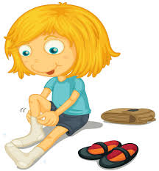  Can you practice putting on your socks and shoes?  Can you get yourself dressed in the morning?  Can you do up your own buttons and zips?
Exercise time    It’s really important to keep our bodies moving while we are at home. Can you choose a different workout video to complete everyday this week?  https://www.youtube.com/playlist?list=PLoOc9M0VgduMnQiJ56Gw5TX7wsGIF7kmv | Taste the rainbow  Look at the different colours in a rainbow. Can you find and taste a healthy food for each colour?    For example you could eat a strawberry for red, some broccoli for green and a grape for purple.  *Can your family help you to write the name of your favourite food in your rainbow?  **Can you explain why it was your favourite? | Craft  Can you make a person using healthy foods?  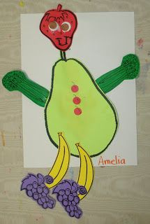  You can use real food or draw different fruits and vegetables for the different body parts.  *Can you label the different foods you used? | Sing along  Sing some of our favourite songs from class with your family.  https://www.youtube.com/watch?v=cSPmGPIyykU - exercise and rhyme  https://www.youtube.com/watch?v=_MVzXKfr6e8 – count to 20 and workout  https://www.youtube.com/watch?v=u4_L7CM46M4 - 5 little fish  https://www.youtube.com/watch?v=Ik_-OAgzD-8 - doubles rap  https://www.youtube.com/watch?v=L3DW45WIXgY - pwy wyt ti?  https://www.youtube.com/watch?v=OEbRDtCAFdU - 2D shape song

