Colour all the ‘m’ sounds:

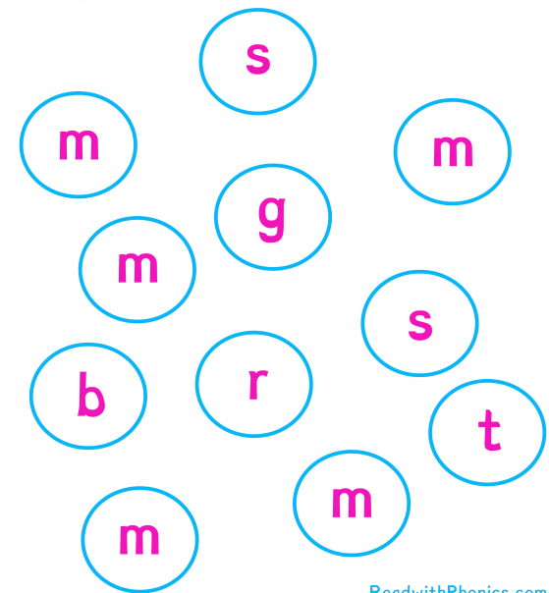

Can you write the ‘m’ sound?

m m m m m m

m m m m m m

m m m m m m

________________________________________________

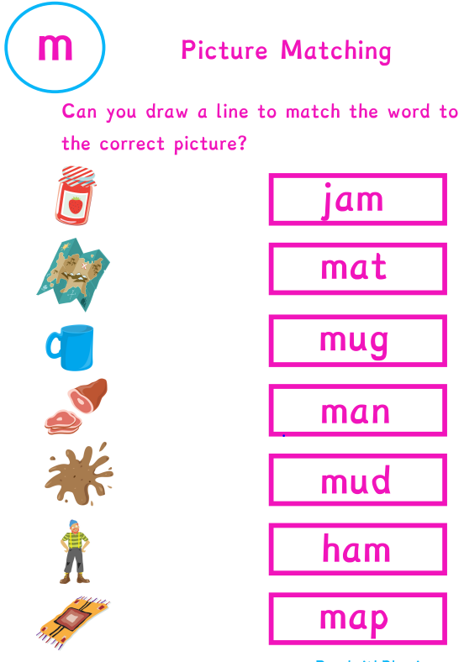

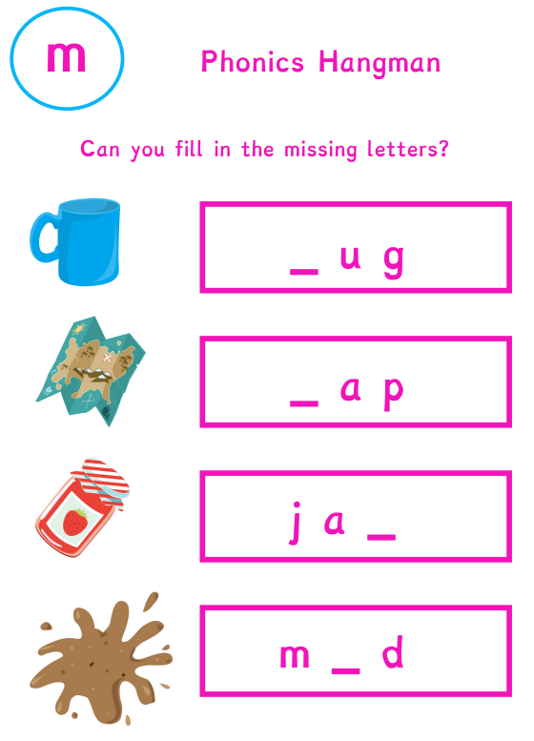

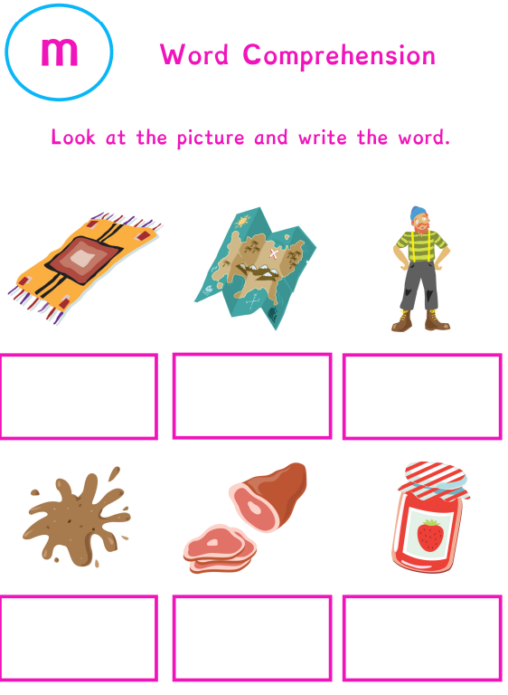

Can you read these sentences?

