Reception Home Learning – 08.02.2021 This week we are participating in CCFC festival from home ⚽ Everytime you complete a challenge, please can you upload to Twitter use the hashtag #BluebirdsfromHome and tag your teacher!
Monday | Tuesday | Wednesday | Thursday | Friday
  Each day you will have a player's physical challenge to complete!  Here is one of the CCFC players completing today’s challenge:  Bluebirds From Home 2: Phoebie Poole’s Player Challenge on Vimeo  Watch your teacher completing the challenge on Flipgrid! | Each day you will have a player's physical challenge to complete!  Here is one of the CCFC players completing today’s challenge:  Bluebirds From Home 2: Curtis Nelson Player Challenge on Vimeo  Watch your teacher completing the challenge on Flipgrid! | Each day you will have a player's physical challenge to complete!  Here is one of the CCFC players completing today’s challenge:  Bluebirds From Home 2: Siobhan Walsh’s Player Challenge on Vimeo  Watch your teacher completing the challenge on Flipgrid! | Each day you will have a player's physical challenge to complete!  Here is one of the CCFC players completing today’s challenge:  Bluebirds From Home 2: Sheyi Ojo’s Player Challenge on Vimeo  Watch your teacher completing the challenge on Flipgrid! | Bluebirds from home sports day!  Please download the sports day PDF. You can complete as many of the challenges as you like. Please send videos or pictures and use the hashtag #BluebirdsfromHome
PSE - Your feelings    In Monday’s resources you will find a document ‘My feelings’  Can you talk to your parents about what makes you feel a certain way or something you like to do when you feel a certain way. | Literacy -  Find the missing letter    Look at the pictures.  *Can you find the missing letter?  **Can you practice writing all of your letters?  ***Can you use the letters to spell your name? | PSE - my movements  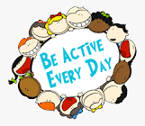  *Can you identify ways in which you can keep moving while at home?  **Can you plan an activity for each day of the week? | Literacy - word matching  Look at the Cardiff City Football club shirts!  *Can you match the word to the correct shirt? Use the initial sounds to help you!  **Can you write the name of something that matches each colour? E.g green - leaf | Parents  Please can you complete this feedback form  Bluebirds From Home feedback form (google.com)  All parents completing feedback questionnaires will be entered into a draw to win a Cardiff City FC Kit for their child and a PE equipment bag for their school worth over £250.
Can you make a story map of the Hungry Caterpillar?  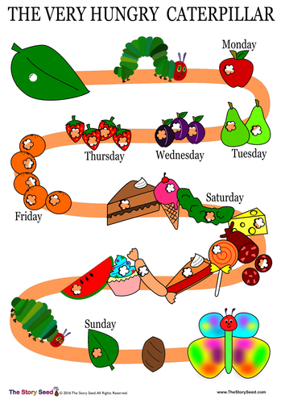  You could use the pictures provided or draw it yourself.  If you watch the flip grid your teacher will show you how. | Phonics  Today we are learning about the letter ‘o’.  ‘o’ for orange, on, off  Watch the video below:  https://www.youtube.com/watch?v=w0GvbRAYqpU&feature=youtu.be  And watch the Flip grid video on Google classroom  * Can you go on a hunt around your house for things beginning with ‘o’?  ** Can you complete the ‘o’ workbook tasks | Butterfly Art  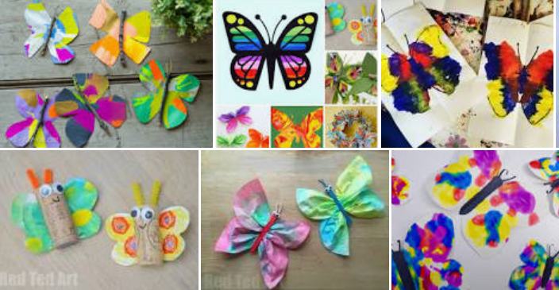  Can you make a Butterfly?  Look at the link below there are 35 different ideas?  https://www.redtedart.com/35-butterfly-crafts/  How will you make your butterfly? | Subraction  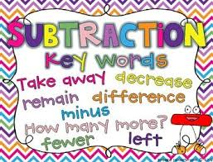  Watch the video below  https://www.youtube.com/watch?v=pwQKugrFmJQ  *Can you complete the subraction Powerpoint?  ** Can you complete the Hungry Monkey worksheet?  ***Can you answer the subrtaction questions to colour the butterfly? | Story time!  Listen to the story below or from your teacher on flip grid.  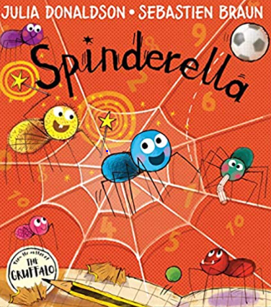  https://www.youtube.com/watch?v=9639_WmGRLk  Send us a video or reply to tell me what was your favourite part?

Things that you can do everyday with your child throughout the day:
Exercise time    It’s really important to keep our bodies moving while we are at home.  Can you choose a different workout video to complete everyday? Click on one of the links below.  CBeebies - Andy's Wild Workouts (bbc.co.uk)  Cosmic Kids Yoga - YouTube | Reading    Oxford Owl for Home: help your child learn at home | Oxford Owl  Story Time - Stories for kids - CBeebies - BBC | Letter sounds    https://lettersandsounds.org.uk/for-home/reception  There are lots of individual lessons here that teach each sound.  Go back to autumn term so you don’t miss any sounds.  Each lesson is just 7/8 mins long so it would be easy to complete one each day! | Numbers    Counting Games  https://www.topmarks.co.uk/maths-games/3-5-years/counting  Adding games  https://www.topmarks.co.uk/maths-games/3-5-years/addition  Number games  https://uk.splashlearn.com/number-games-for-year-1 | Sing along  Sing some of our favourite songs from class with your family.  https://www.youtube.com/watch?v=cSPmGPIyykU - exercise and rhyme  https://www.youtube.com/watch?v=_MVzXKfr6e8 – count to 20 and workout  https://www.youtube.com/watch?v=u4_L7CM46M4 - 5 little fish  https://www.youtube.com/watch?v=Ik_-OAgzD-8 - doubles rap

