**School Prospectus**



**September 2022**

**Our school vision is:**

**To nurture kind, respectful children who show ambition.**

**For all pupils to progress through a range of meaningful experiences enabling them to learn and apply the skills needed for a successful future.**

***Aim High, Be Kind, Show Respect***

   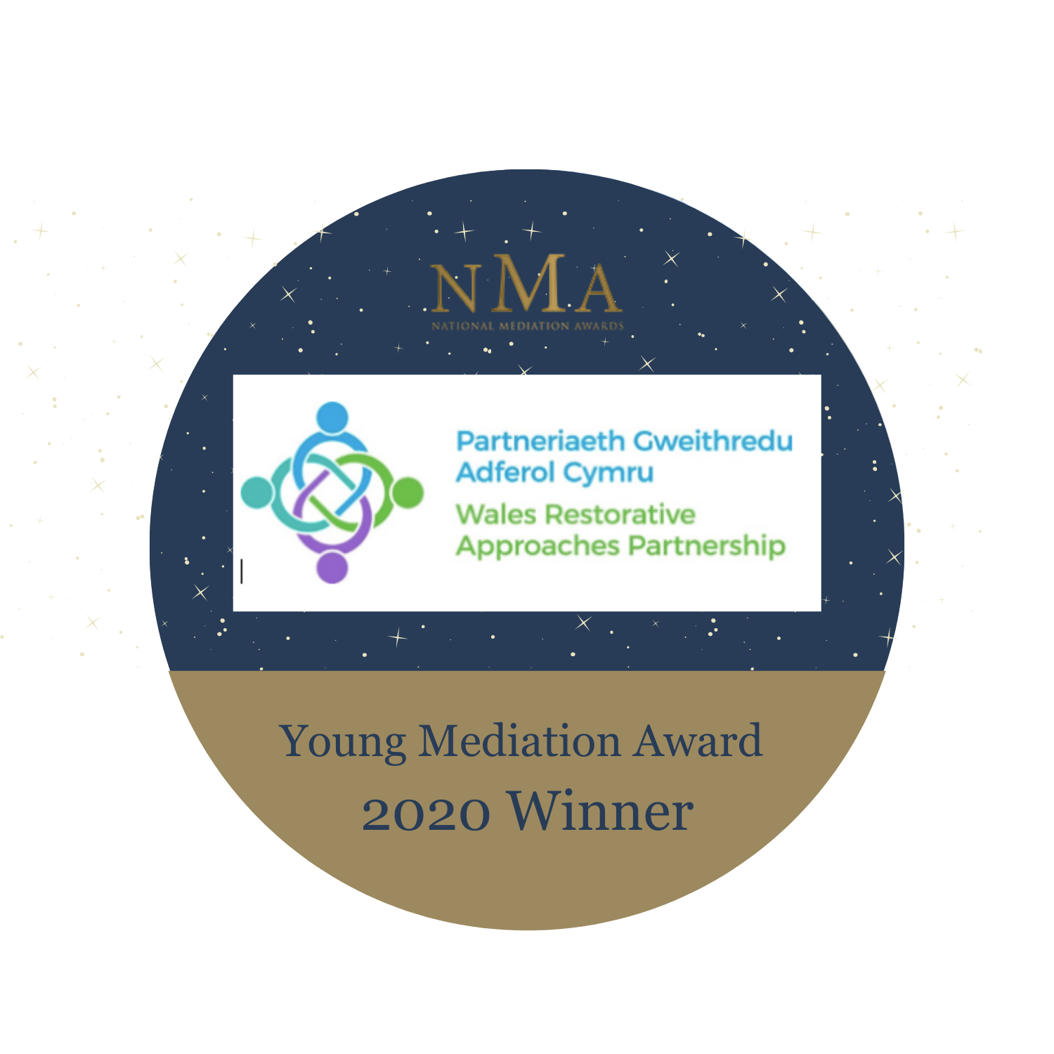  

**CONTENTS**

1 Cover  
2 Contents  
5 Introduction  
6 Head Teacher’s Welcome  
7 General Information  
8 The School Governors  
10 About our School  
11 The Vision  
13 Safeguarding and Child Protection Policy  
14 Equal Opportunity  
14 Equality Statement  
14 Pupil’s with Disabilities  
15 School Security  
15 Our Staff  
18 Our School’s Curriculum  
19 Collective Worship and Religious Education  
20 Sex and Relationships Education  
21 Assessment  
21 Additional Learning Needs  
22 School Sports Provision  
23 Access to Documentation and Information  
24 Parents as Partners  
24 Home School Agreement  
24 Home School Reading  
25 Curriculum Events  
25 In the Classroom  
25 Special Occasions  
26 Parent Governors  
26 Community Links  
27 Support for Charities  
27 Environmental Education  
27 Sustainable Development Project  
27/28 Complaints Procedure (Curriculum and other Related Matters)  
28 School Milk  
28 Charging for School Activities  
28/29 Educational Visits  
29 Discipline and Welfare  
29 Parent/Teacher Consultations  
30 Informing Parents  
30 Arrangements to view Documents/Freedom of Information  
31 How to Help your Child and the School  
31 Attendance at School  
31/32 School Attendance Figures  
33 Emergency Information  
33 Medical Care  
33 Medicines in the School  
33 Toilet Facilities  
34 Healthy Schools  
34 School Dinners  
34 Snack  
34 Homework  
35 Jewellery, Toys and Mobile Phones  
35 Lost Property  
36 School Clothing  
36/37 PE/Games/Dance  
37 Travelling to and from School  
37 The School Day  
38 School Dates  
39 After School Activities

**INTRODUCTION**

The aim of this prospectus is to give parents information about our school. The information on the forthcoming school year, which appears in this prospectus, is correct at the time of printing but maybe subject to change before the start of, during, the school year or in subsequent years. Parents and prospective parents are welcome to visit the school, preferably by prior arrangement with the Deputy Head teacher who oversees all of our pupil admissions.

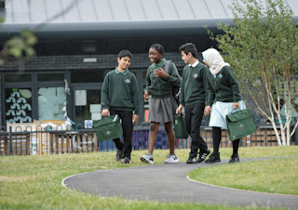





**HEAD TEACHER’S WELCOME**

Dear Parent/Guardian,

Croeso i’r Ysgol Gynradd Adamsdown. Welcome to Adamsdown Primary School.

I am the Head Teacher of Adamsdown Primary School. I believe we are lucky to serve the vibrant and exciting community of Adamsdown which is so diverse and full of potential. Our children are friendly, polite and sociable children who have earnt our school a reputation as warm and welcoming to all.

Adamsdown Primary School is a caring and friendly school. It is our vision that we will encourage all children to become kind and respectful whist achieving their full potential in life. We are very proud of our reputation as an inclusive and multi-cultural school. We welcome families from all over the world whilst also instilling a sense of pride that we all live in Wales together! We have high expectations of all our children and work together to help them develop academically, emotionally and socially.

You will meet our staff when you child starts school who will work with you to settle your child into school. We value the whole school community and as parents we look forward to working with you and your family to ensure your child’s time at Adamsdown is a happy one.

I look forward to meeting you and showing you our school.

Kind regards

Mrs Emma Thomas (NPQH)

Head Teacher



**GENERAL INFORMATION**

**ADDRESS:** System Street, Adamsdown, Cardiff, CF24 0JF

**TEL:** 029 20493600

**FAX**:  029 2048 1976

**EMAIL**: [schooladmin@adamsdownprm.cardiff.sch.uk](mailto:schooladmin@adamsdownprm.cardiff.sch.uk)

**WEBSITE**: [www.adamsdownprm.cardiff.sch.uk](http://www.adamsdownprm.cardiff.sch.uk)

**TWITTER:** @adamsdownprm

**Head teacher:** Mrs Emma Thomas

**Deputy Head teacher:** Ms Helen Williams

**Assistant Head Teacher**  Mrs Jody Jenkins

The School is maintained by Cardiff Local Education Authority and is the special responsibility of

THE CHIEF SCHOOLS OFFICER

CARDIFF COUNTY COUNCIL

COUNTY HALL

ATLANTIC WHARF

CARDIFF

**THE SCHOOL GOVERNORS**

The Governors are appointed for a four year term and represent**: The LEA, the Parents, the Staff and the Community**

The Governors and the LEA share the responsibility for the school, its building and the curriculum. The Head teacher is responsible to the Governors for the day to day management and administration of the school and its curriculum.

**The Governors of Adamsdown Primary School are:**

**CHAIRPERSON:**  Cllr Owen Llewellyn Jones

**Head Teacher:** Mrs Emma Thomas

**Community Governors:** Mr Andrew Gallagher (Vice Chair)

Mr Joe Redmond

Mr Ian Protheroe

**LEA Governors:**  John Dixon

Cllr Grace Ferguson-Thorne

Cllr Owen Llewelyn Jones

**Parent Representatives:** Mrs Zainab Mohammed

Mr Charles Stead

Mrs Salam Abdelquadir

Mr Abdul Mujib Yahaya

**Teacher Rep:**  Mrs Amelia Harrison

**Non-teaching Staff:**  Miss Tabitha Brunker

**Clerk to Governing Body**; Mr**s** Jan Knowles **Non-participant Observers:** Ms Helen Williams

Mrs Jody Jenkins

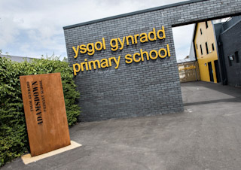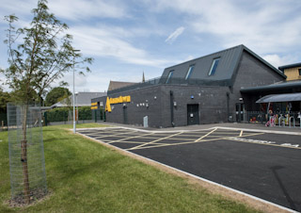**ABOUT OUR SCHOOL**

Adamsdown Primary School is an inner city school situated in System Street on the south side of the city. The school building was originally built in 1980 as a replacement for the old Adamsdown School in Adamsdown Square. The school was extended and refurbished in 2010/11 to accommodate a Flying Start integrated children’s centre which opened in spring 2011. Our state of the art extension opened in Autumn 2016 to house the increase in pupil numbers. The catchment area consists of Adamsdown itself and includes a large section of the city centre including shops, offices, public houses and some apartment blocks.

Adamsdown caters for children aged between 3 and 11. The school is a two form entry primary school. Currently we have 15 classes which are named after the streets surrounding our school grounds.

Our school nursery currently has 80 part time places.

The school is built on one level and is fortunate to be well resourced. The school has 15 internal classrooms, a parental engagement room, several smaller group rooms, 2 generous sized halls, canteen and extensive school grounds.

**THE VISION**

To nurture kind, respectful children who show ambition.

For all pupils to progress through a range of meaningful experiences enabling them to learn and apply the skills needed for a successful future.

*Aim High, Be Kind, Show Respect*

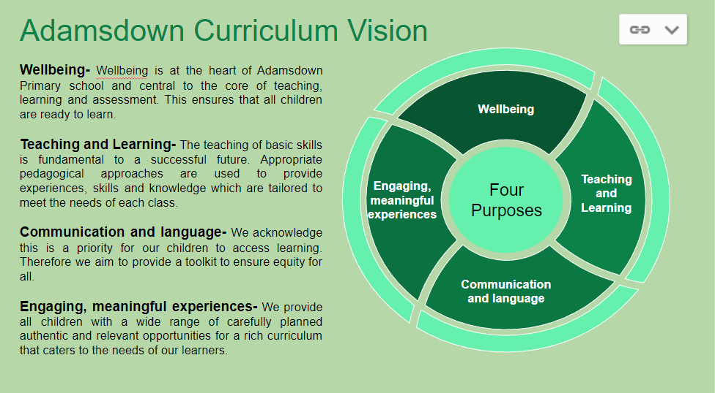



**SAFEGUARDING AND CHILD PROTECTION**

Safeguarding and Child Protection are key priorities for Adamsdown Primary School. We aim to support vulnerable children to ensure that they are as safe as they can possibly be. Our school is committed to ensuring the safety and protection of all children and will take action to safeguard their well-being. We acknowledge that children have a right to protection and this is supported in the general ethos of our school.

The school’s policy applies to the whole school’s workforce, along with volunteers, governors and any contractors working on the school site. In particular Staff recruitment and selection – ensuring that all staff (volunteers etc) have been appropriately DBS checked for their suitability, using the Safe Recruitment procedures.

We work in partnership with outside agencies to safeguard children.

When there are concerns it may be necessary to make a referral to Children’s services.

At Adamsdown Primary School we have a comprehensive safeguarding/child protection policy. All staff undertake safeguarding training that equips them to recognise and respond to child welfare concerns.

**These concerns are then passed to the:**

**Designated Child Protection Officer:** Mrs Emma Thomas (Head teacher)

or in her absence

**Deputy Designated Child Protection Officer:** Ms Helen Williams (Deputy Head teacher)

They follow strict guidelines on how to deal with any concerns as set out in the All Wales Child Protection Procedures

**The nominated Governor for Child Protection is:** Cllr Owen Llewellyn Jones

**EQUAL OPPORTUNITIES**

We have an equal opportunities policy, equality statement and equalities scheme in place and all staff strive to fulfil the aims within these.  We work hard to ensure that all pupils have equal access to the curriculum whatever their sex, race, faith, disability, learning need or social background.  We also endeavour to challenge traditional stereotypes and provide children with positive role models.

**EQUALITY STATEMENT**

The school is committed to working towards equality regardless of disability, race, gender, pregnancy and maternity, religion or belief, sexual orientation and gender reassignment.  We are striving to promote an inclusive culture in which every individual, regardless of ability and background, is enabled to participate and is valued as a member of the school community.  We therefore promote positive approaches to difference and foster respect for people of all cultural backgrounds.  We ask that *all* visitors to our school respect our commitment.

**PUPILS WITH DISABILITIES**

Applications from pupils with disabilities to attend Adamsdown Primary School, are welcomed. We can accommodate physically disabled pupils following comprehensive risk assessment of individual needs. We ensure that pupils with disabilities have equal access to the curriculum and we seek guidance and support from outside specialists and agencies as appropriate. Our recently refurbished building includes a disabled toilet and shower facilities and is on one level to allow for wheelchair access.

**SCHOOL SECURITY**

The school has a magnetic lock security system with intercom at the System Street entrance to the school. Visitors to school between the hours of 09.00 and 14.50 will need to access the school via this entrance. There is security lighting and an intruder alarm system for out of school hours. We also have a fire alarm system which is tested regularly and we carry out fire drills every term. Details of all these systems are procedures are available in the school’s Health and Safety Policy.

**OUR STAFF 2022 - 23**

The re-arrangement of the school is delegated to the Head teacher, together with the Deputy Head teacher and the team of staff listed below:-

**Senior Leaders**

* Head Teacher – Mrs E Thomas
* Deputy Head teacher – Ms H Williams, ALNco
* Assistant Head teacher – Mrs J Jenkins

**Early Years Team** – led by Mrs J Jenkins

* Nursery teacher – Miss S Parle
* Nursery teaching assistants – Mrs K Maynard, Mrs E Vale, Mrs S Kaur
* Reception Sun teacher – Mrs E Picton
* Reception Sun teaching assistant – Mrs Ali, Mrs Goode, Mrs Stephens
* Reception Moon teacher- Mrs K Jones
* Reception Moon teaching assistant – Miss H Parmar

**Lower School Team (Years 1 & 2) –** led by Miss E Chichester

* Dosbarth Star teacher – Mrs K Goodwin
* Dosbarth Star teaching assistant – Miss S O'Leary
* Dosbarth Comet teacher – Miss E Chichester
* Dosbarth Comet teaching assistant – Mr B Thomas
* Dosbarth Silver teacher – Mrs Walker
* Dosbarth Silver teaching assistant – Miss S Harris
* Dosbarth Topaz teacher – Miss L Davies
* Dosbarth Topaz teaching assistant – Miss T Brunker

**Middle School Team (Years 3 & 4)** – led by Mr R Andrews

* Dosbarth Eclipse teacher – Mrs E Biggin
* Dosbarth Eclipse teaching assistant –  Miss H Kadima
* Dosbarth Pearl teacher – Mr M Woods
* Dosbarth Pearl teaching assistant – Mrs E Mouleon
* Dosbarth Emerald teacher – Mrs J Moshid
* Dosbarth Emerald teaching assistant – Mrs A Bocheva / Mrs K Boukhalfa
* Dosbarth Planet teacher – Mr R Andrews
* Dosbarth Planet teaching assistant - Miss K Schiazza

**Upper School team (Years 5 & 6)** – led by Mrs C Southard

* Dosbarth Sapphire teacher – Mrs C Southard
* Dosbarth Gold teacher – Miss T Beames
* Dosbarth Diamond teacher – Miss M Rees
* Dosbarth Meteor teacher – Mrs S Pitman
* Upper School teaching assistants – Miss C Pupuri, Miss H Lloyd, Miss A Pinnell, Miss N Cowley

**Additional support staff, working across the school**

* New Arrivals Teacher – Mrs C Peace
* PPA/Support Teachers - Mrs S Davies, Mrs A Harrison
* HLTA - Mrs T Gallagher
* 1:1 Teaching Assistants -  Mrs B Begum, Miss S Nicholas,
* Family Engagement Officer - Mrs A Foley (Tuesday to Friday)
* Wellbeing Teaching Assistant - Mrs R Bowen
* Admin – Mrs L Prusinowski, Miss L Price
* Estates – Mr S Hutchinson
* Kitchen – Mrs M Lock, Mrs K Kinsella,
* Midday Supervisors – Mrs R Khatun, Miss J Begum, Mrs B Skiba, Mrs M Alzain
* Breakfast Club – Miss L Price, Mrs M Lock, Mrs K Kinsella, Miss S Mcauley
* Our school is also supported by a number of specialist outside agencies who visit to assist pupils with hearing/speech/behavioural difficulties.

**OUR SCHOOL’S CURRICULUM**

Our school has designed a bespoke curriculum offer for all our pupils which is based around the four purposes of the Welsh Government Curriculum for Wales: <https://hwb.gov.wales/curriculum-for-wales>

Our pupils have designed a character called Globie to help them remember how we are always working towards the four purposes of the curriculum:



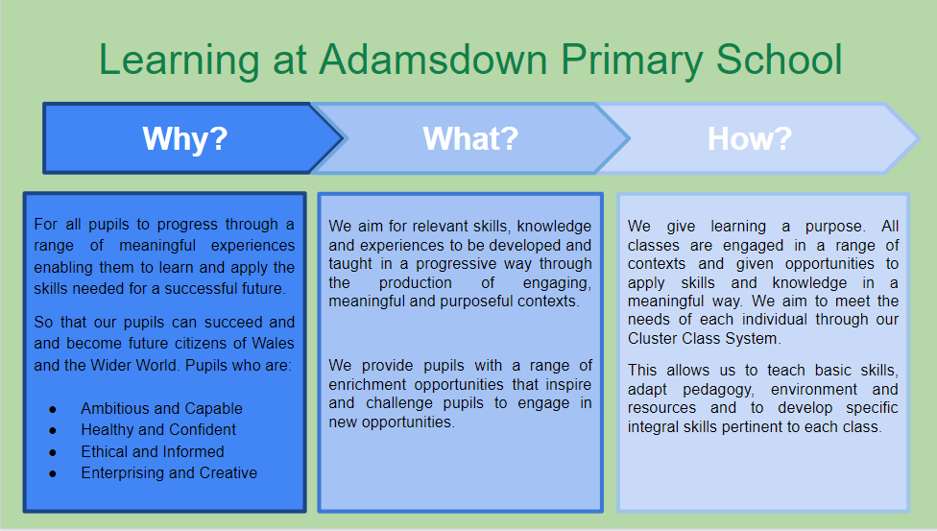

**COLLECTIVE WORSHIP AND RELIGIOUS EDUCATION**

The children are involved in a daily act of collective worship. This is centred on “Values Education” which encourages the children to think about different values, what they mean to them and ways of ensuring that their growing understanding of these values supports their moral, spiritual, emotional and social development.

We aim to relate Religious Education to the children’s own experiences in everyday life and our programme follows the Local Authorities guidelines. We are a school that is made up of pupils from a variety of religions and we believe this is what makes us such a diverse and welcoming and inclusive place to be.

Weekly Assembly Timetable:

|  |  |
| --- | --- |
| Monday | Class check in |
| Tuesday | Team Collective Worship |
| Wednesday | Whole School virtual assembly led by Head Teacher |
| Thursday | Team collective worship |
| Friday | Whole school Happy Friday assembly |

**SEX AND RELATIONSHIPS EDUCATION**

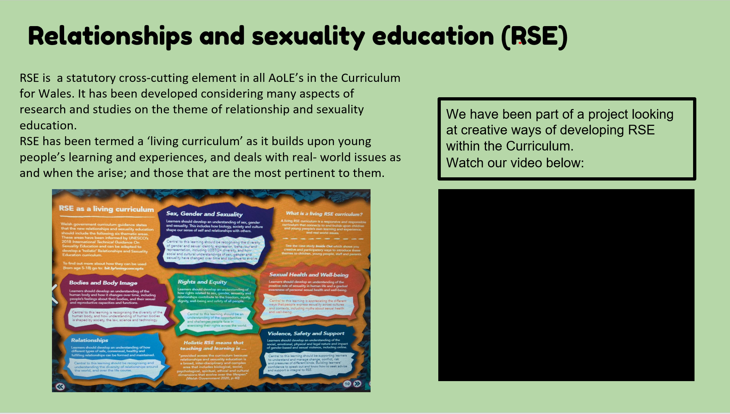

**ASSESSMENT**

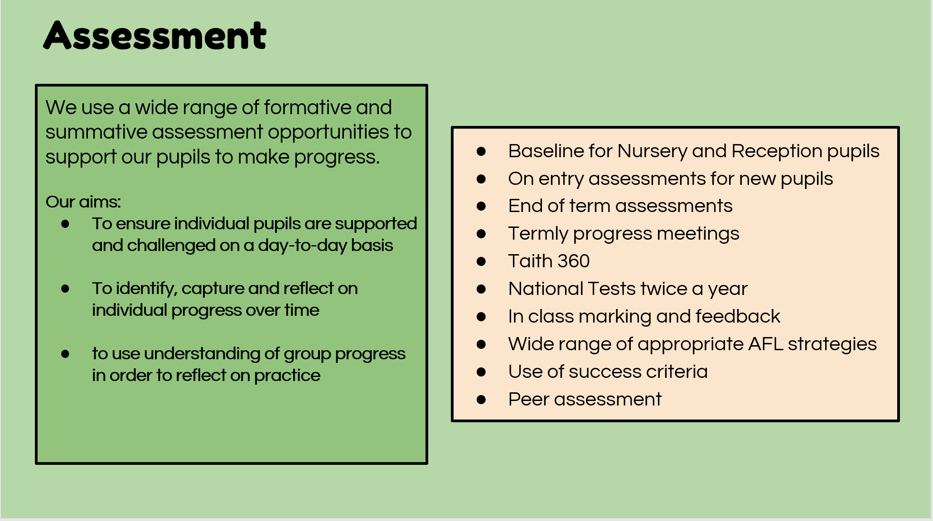

**ADDITIONAL LEARNING NEEDS**

Some children have additional learning needs that affect their progress in school. Through careful observation and assessment we can offer specific support. In some cases we need to refer children to the Educational Psychologist or other agencies who will at some stage visit the school to see the child, evaluate their progress and offer the school support to help overcome their difficulties.

Parents and carers will be kept informed by the Headteacher and the ALNCO (Additional Learning Needs Co-ordinator), Ms Helen Williams will be invited into school to discuss the situation. We have a firm commitment to inclusive education and do everything we can to meet every child’s individual needs.

From September 2021, the current Special Educational Needs framework will be replaced with a new and reformed system called Additional Learning Needs and Education Tribunal (Wales) Act.

All schools in Wales will be required to make changes to their current systems. We are currently working in collaboration with Cardiff County to ensure a smooth transition to the new ALNET Act.

**SCHOOL SPORTS PROVISION**

We recognise the importance of physical activity and a promoting a healthy lifestyle to our pupils. There are a range of opportunities available to the children in relation to sport and dance. The school has very close links with Rubicon Dance who deliver weekly dance sessions to different year groups. We also take part in the annual schools dance performance at the Sherman Theatre. We have fully implemented the PESS Physical Education scheme of work.

The PE curriculum is divided into games, athletics, dance, gymnastics, adventurous activities and swimming. All children will experience these activities as part of the planned PE curriculum. In addition we run a range of after school sports clubs covering aspects such as football, dance and netball.

Our school is always seeking new ways to encourage the pupil’s participation in sporting activities and have associations with many sporting clubs in and around Cardiff e.g. Glamorgan Cricket, Tag rugby fest with Future Blues at Cardiff Arms Park, Football tournaments with Sport Cardiff and also any new initiatives with Cardiff City Football club as they arise. In 2013-14 we won local athletic and football competitions, achievements we repeated for the next year also!

The School has a playground for outdoor games and a hall which is used for dance and PE. The children in our Nursery and Reception classes also have access to a range of wheeled vehicles with which to develop their gross motor control skills. Children in years 1 and 2 also have a selection of wheeled vehicles available to them.

We encourage the children to share their sporting achievements out of school by bringing in their certificates and awards.

**ACCESS TO DOCUMENTATION & INFORMATION**

As the school develops, documentation will be continually reviewed and drawn up and these documents may be seen at the school or on the website. They will include:

* National Curriculum Documents
* Welsh Office Statutory Instruments and circulars relating to the National Curriculum
* The School’s Current Schemes of Work and Policy Documents
* General policy documents – statutory and non-statutory
* Religious Education Syllabus Guidelines
* School Improvement Plan

Policies are available on the website for parents to view, or if the website is under review please ask at the office. If you wish to see any other information then please contact the Head teacher.

**PARENTAL ENGAGEMENT**

Hello, I am Andrea Foley, your Family Engagement Officer.

My role is to offer support for parents, children and families if there are any concerns you wish to discuss and to help with any issues in relation to supporting your children, either at home or in school.

*Life is not always straightforward*

I am here to listen and help with any worry or query, large or small, that you may feel you need support with. I also have access to a number of agencies who provide advice and assistance.

I organise a range of free courses in The Cwtch, Family Engagement Room (old school building), for parents throughout the year.

You are welcome to come along to The Cwtch on Monday mornings for the

Chat & Chill coffee morning session between 9-10.30am for free refreshments and toast. It is an opportunity to meet other parents, sit and read a book or

find out about the free courses.

**Need advice or just a chat?**

Ask the office staff to contact me

or

Come to see me when I am around the school

at the beginning or end of the day

**Andrea Foley**

**Family Engagement Officer**

Emailt: [afoley@adamsdownprm.cardiff.sch.uk](mailto:afoley@adamsdownprm.cardiff.sch.uk)

**HOME-SCHOOL AGREEMENTS**

This is a partnership agreement which the pupils, parents and teachers are asked to sign. It concerns working together for the good of the children in an environment of mutual respect. You will be asked to sign this when your child starts school.

**HOME-SCHOOL READING**

When your children start school they will bring home picture and story books to share with you. We also use Reading Eggs, an online reading portal that your child can use in school and at home. This is an important stage in their learning to read. Research shows that when parents show an interest in this way, children’s reading improves. Children can also choose library books to bring home as we have good links with two libraries in the area and classes are encouraged to visit these regularly.

**CURRICULUM EVENTS**

We aim to hold events with parents to discuss the learning and teaching that goes on in Adamsdown Primary School. These are designed to help parents to understand what and how we are teaching the children. It also gives parents an opportunity to ask questions and informally talk to staff. We also offer longer term courses for parents through “Families Learning Together” – these are usually ten week courses in either literacy or numeracy where parents come in to school and work alongside their children to develop a deeper understanding of how to support their child’s learning.

**IN THE CLASSROOM**

We welcome parents to help in school in all sorts of ways and parents are an important part of our school. Your child’s teacher can tell you more about how you can be involved in this way if you have the time. We usually ask parents to help out on our school trips or if you have a particular skill or hobby that you could share with us then please speak to your child’s teacher. In order to safeguard our children it is essential that all parent volunteers have an up to date DBS (Disclosure and Barring Service).

**SPECIAL OCCASIONS**

Parents are invited into school to share class assemblies and special celebrations. We also plan concerts and plays at special times of the year to which parents, governors and members of our local community are invited.

**PARENT GOVERNORS**

The Parent Governors are your voice in decisions about how the school is run. They are elected by the parents through a ballot. If you have any queries, the names of your representatives are contained in this brochure. If you are interested in becoming a Parent Governor yourself, then let us know.

**COMMUNITY LINKS**

We have strong links with the following companies (and many more) who offer us support through our in school enrichment programme, reading volunteers, sponsorship, and their valuable time.



[](http://www.bing.com/images/search?q=rubicon+dance+cardiff&FORM=HDRSC2#view=detail&id=F6A8D54DBD8D9CAE08F3DD6AD67B1CFDB3FD4BEC&selectedIndex=88) 

**   **

**SUPPORT FOR CHARITIES**

Adamsdown is a caring school and we attempt at every opportunity to raise pupils’ awareness of people who are less fortunate than we are. With this in mind, we provide positive support for many local, national and international charities including: Children in Need, Comic Relief, Ty Hafan, Cancer Research and many more

**ENVIRONMENTAL EDUCATION – Eco Platinum Flag achieved in July 2015 and 2017, reviewed in 2019 and 2021**

The School has a very active Eco Committee and the pupils create their own action plans, deciding how to help look after our school, the community and the wider world each year. We have just received our third Platinum Eco Flag which recognises the achievements of the school across seven key environmental areas. The whole school community plays a vital role in these achievements. Every class has access to environmental education and learn about it through the different curriculum areas.

**COMPLAINTS PROCEDURE (CURRICULUM AND OTHER RELATED MATTERS)**

The school implements fully the Local Authority's Complaints Procedure. This was introduced by Section 409 of the Education Reform Act 1996. Details of arrangements covering complaints are available at the school.

In general, there are three levels at which a complaint could be considered. The first stage is via informal discussion with the Head teacher. It is hoped that most complaints will be dealt with at this level. In the event where this is not possible, the two other levels of complaint are a formal complaint to the Governing Body and a formal complaint to the LEA.

Details regarding the procedure for consideration of a formal complaint are available at the school.

**SCHOOL MILK**

Foundation Phase pupils are provided with free school milk. Key Stage Two pupils have access to their water bottles throughout the day in class which are regularly cleaned and refilled on a daily basis.

**CHARGING FOR SCHOOL ACTIVITIES**

The Governing Body of the school has, in response to the 1988 Education Act, formulated a policy on charging for school activities. The Governing Body has decided to adopt the Local Authority's policy with the added proviso that when an activity occurs, the school may invite voluntary contributions from the parents. A charging and Remissions Policy is available at the school. However if there are insufficient funds to meet the cost of the activity then the activity will not be able to go ahead.

**EDUCATIONAL VISITS**

During the school year many educational visits are made to places of interest. The school is particularly well supported by both the parents and the PTA in these activities. Places we have visited in the last two years include: Bristol Aquarium, St.Fagan’s Museum of Welsh Life, The Cardiff Story, National Museum of wales, Cardiff Castle, Barry Island, The Big Pit, Rhondda Heritage Park, The Wales Millennium Centre, The Welsh Government Assembly Buildings. Year 5 & 6 are given an opportunity to take part in a 2 day residential trip to Llangrannog Centre in West Wales. This is an exciting opportunity open to all pupils.

**BEHAVIOUR AND RELATIONSHIPS WITHIN SCHOOL**

To encourage positive behaviour pupils are expected to follow our school motto which has been designed with the whole school:

***Aim high, Be Kind, Show Respect***

**PARENT/TEACHER CONSULTATIONS**

Parents are given specially arranged opportunities to talk to their child’s teacher during the course of the year. Parents are kept regularly informed of their child's development by means of Open Evenings held three times a year, together with a written report at the end of the academic year. Open lessons are held in the Foundation Phase when family members and friends can share the school experience with their children. Adamsdown has an 'open door' policy and arrangements can be made to enable Staff and Parents to talk more frequently, should the need arise. Also, the Head teacher will always endeavour to be available to meet with parents.

**INFORMING PARENTS**

We place great importance on keeping our parents fully informed about developments in the school as a whole. We have the Schoop communication app. Please see the office for more details. Letters are either sent to parents regularly regarding issues affecting their children’s time in school. Current school newsletters will also be posted on the website. At the start of each term every class teacher sends home an Information Sheet giving an overview of what is going to be covered in class during the term to come. Our school twitter account is very popular and used by most teachers to show what learning has taken place in school.

**ARRANGEMENTS TO VIEW DOCUMENTS/FREEDOM OF INFORMATION**

All parents are at liberty to view much of the school documentation. A list of the documents, which can be viewed, may be requested from the Head teacher.

***HOW TO HELP YOUR CHILD AND THE SCHOOL* ATTENDANCE AT SCHOOL**

**-THE EDUCATION (PUPIL ATTENDANCE RECORDS) REGULATIONS**

Schools have to differentiate between authorised and unauthorised absences. In order to help the school conform to this legislation, the Head teacher kindly asks all parents to contact the school as soon as possible, so that we may be informed of all absences due to illness. If contacting the school immediately is not possible, we ask all parents to send a note of explanation with the child when he/she returns to school. We are then able to delete all unauthorised absences. It is not recommended that pupils are taken out of school for holidays but if this is necessary, permission must be sought from the Head teacher. A “Leave of Absence” form should be requested from the office manager. It should be noted that the Head teacher can only authorise up to 10 school days in a year; further days are automatically recorded as Unauthorised Absence. Please note the Local Authority are currently updating their policy and procedures for “Holiday” requests and this will preclude our school from authorising these requests when implemented.

Please note that it is in the children’s interest that they arrive punctually and attend regularly.

**SCHOOL ATTENDANCE FIGURES**

[](http://tredegarvilleprm.cardiff.sch.uk/)We are delighted to report that Adamsdown’s overall attendance percentage is an average of 93%. Please note the unauthorised absences were mainly due to a few pupils, some of whom have taken additional holiday or have not given the school any information/explanation about absence either by telephone or letter. Fixed Penalty Notices are now in operation within the school as explained below:-

As a group of local schools, we have decided to adopt a cluster approach to securing the best attendance possible. As you are aware, the Welsh Government has introduced a new system of fining parents and the £60 fines will be issued per child for the following reasons:

* When a pupil is absent for any five days in a term with no good reason;
* When a pupil arrives late in school more than ten times in a term;
* For any holiday absence during term time.

When we have concerns about on-going attendance and punctuality, we will be sending you a letter to warn you that you are at risk of being fined. No warning letters will be sent in the case of holidays where fines will be automatic.

There may be very exceptional circumstances where the school may consider authorising absences in line with Welsh Government guidance but prior attendance will always be taken into consideration.

Please remember that children need to be in school on time every day in order to achieve the best possible outcomes for their future lives. Thank you for your support in this matter.

Yours sincerely

The Head Teachers of the Willows Cluster of Primary Schools

**EMERGENCY INFORMATION**

It is vitally important that the school has an address and telephone number where parents may be contacted quickly in case of emergency. Up-dating of changes in the information is essential. The information will be treated in confidence.

**MEDICAL CARE**

If a pupil is taken ill or has an accident whilst in our care, we shall do our best to contact parents/guardians as soon as possible. However, we will always try to act in the best interests of the child and an ambulance will be called in an emergency. If a visit to hospital is required we will ensure that a parent/carer or teacher accompanies the child. Some of our pupils have specific medical conditions e.g. asthma, diabetes. In these circumstances, all staff are made fully aware and are fully briefed/trained on the appropriate actions to take.

**MEDICINES IN THE SCHOOL**

All permanent staff are first aid trained, and there is one enhanced first aid officer on site. Medication can be given in school with the correct medical permission forms being completed by the parent/guardian of the child.

**TOILET FACILITIES**

The Welsh Government Governing Body Report guidelines state this report has to contain information on toilet facilities. The nursery and reception classes have their own toilet facilities. There are boys and girls toilets off the Foundation Phase corridor and 3 boys’ and 3 girls’ toilet facilities in the junior section of the school. Toilets are thoroughly cleaned and disinfected every day. There are 4 toilets for the disabled.

**HEALTHY SCHOOLS**

The school has been part of the Healthy Schools Network since 2004 has won Healthy School National Quality Award over the period of this award. We promote healthy eating and have an active Food and Fitness Committee who promote healthy eating through fun activities.

**SCHOOL DINNERS**

Please remember that dinner money should always be paid in advance and sent in to school on a Monday morning. The payment should be in an envelope marked with your child’s name and class. Please remember to send the correct money in to school on a Monday as we can no longer send change home.

A school dinner costs £2.50 per day or £12.50 per week.

**SNACK**

Fruit is available to purchase in most classrooms at break time. Healthy snacks are sold at morning break.

**HOMEWORK**

Homework is given on a weekly basis from Reception to 6 to reinforce and extend your child’s learning. Please read with your child on a regular basis using the school online reading scheme provided by school

**JEWELLERY, TOYS AND MOBILE PHONES**

We follow Local Authority procedures over the wearing of jewellery and make up. We do reserve the right to decide what is suitable in respect of personal appearance, for example, make-up and jewellery is not accepted except for watches, earring studs and religious medallions. Also we do not consider extremes of hairstyles to be appropriate for school.

Also, we try to discourage the bringing of toys to school. We have no provision for the safe keeping of valuables at the school. Mobile phones are banned from school and may only be brought to school after a parent has requested permission in writing. No responsibility can be taken by the school for mobile telephones on the premises.

**LOST PROPERTY**

Pupils are advised that all lost property should be reported immediately when it goes missing. Please ensure all clothing items are labelled with the child’s name.

We centralise lost property in a Lost Property Box. All items left behind in cloakrooms over a long period of time are placed in this box. The box is kept in the hall. Parents are encouraged to check these at their convenience. The Lost Property Box is emptied at the end of each term, and placed on display in the School Hall. Property not claimed at that particular time is disposed of.

**SCHOOL CLOTHING**

The uniform is Bottle green and Grey. Parents are requested to dress their children in the appropriate school uniform.

**Boys: Girls:**

Grey or black trousers/Jog pants Grey skirt/tunic/trousers/Jog pants

Green/white/polo shirt Green/white/ blouse/polo shirt

Green jumper or cardigan Green jumper or cardigan

Green Fleece / Coat Green fleece / Coat

The co-operation of parents regarding uniform is very much appreciated, although the wearing of school uniform in primary schools is not compulsory it is good practice, promotes equality and avoids disagreements in the mornings. Jog suits, fleeces etc. bearing the school motif are available via forms from the school. Please help us by labeling all items of clothing. Uniform is available for sale at school, where we sell it at cost price making no profit. We would request that pupils wear shoes and not trainers to school. This not only looks smarter but is healthier for the pupils themselves.

A range of second hand school uniform is available to purchase for 50p per item

**PE/GAMES/DANCE**

Children are required to have a PE kit which should be kept in a PE bag (preferably “draw string” to hang on a peg). Black plimsolls or trainers should be worn for games. Shorts and t-shirt are required for autumn, spring and summer term and a jog suit for winter these should all be labelled with your child’s name so that there is no confusion.

**TRAVELLING TO AND FROM SCHOOL**

Car parking is a concern at Adamsdown as it is a hazard for those who use the school and inconsiderate parking or dropping off/collecting is potentially annoying to our neighbours as well. In order to alleviate the problem please do not park on the yellow zig zag lines outside the two entrances to the school on System Street and Metal Street.

**THE SCHOOL DAY**

Classrooms are open from 8.45am, teaching and learning commences when children enter the classroom

All pupils must be on site by 8.55am

School lunches are staggered between 11.30 – 1.15pm

School finishes at 3pm

**SCHOOL DATES:**

**Available on council website**

**After School Activities**

