**ADAMSDOWN PRIMARY SCHOOL**

*Ysgol Gynradd Adamsdown*

[](https://www.adamsdownprimarycardiff.co.uk/)

**Aim High, Be Kind, Show Respect**

**Learning and Teaching Policy**

**Article 28 of the UNCRC says that children and young people have the right to education no matter who they are: regardless of race, gender or disability; if they’re in detention, or if they’re a refugee.**

**Date: March 2023**

**Review date: March 2024**

**Signed (Head Teacher):**

**Signed (Chair of Governors):**

**Aims and Objectives of Learning and Teaching in Adamsdown Primary School**

Our vision is:

**To nurture kind, respectful children who show ambition and for all pupils to progress through a range of meaningful experiences, enabling them to learn and apply the skills needed for a successful future.**

**Aim High, Be Kind, Show Respect**

We have six core values that underpin our vision for all pupils

|  |  |  |
| --- | --- | --- |
| **Unique** | **Resilient** | **Empathetic** |
| **Kind** | **Respectful** | **Confident** |

At Adamsdown Primary School we provide a rich and varied learning environment that allows children to develop their skills and abilities to their full potential. Our curriculum offer outlines how pupils will be supported and challenged to reach their full potential.

**The Key elements of our Curriculum Offer**

***Wellbeing***

Wellbeing is at the heart of Adamsdown Primary school and central to the core of teaching, learning and assessment. This ensures that all children are ready to learn.

***Teaching and Learning***

The teaching of literacy, numeracy and digital skills is fundamental to a successful future. Appropriate pedagogical approaches are used to provide experiences, skills and knowledge which are tailored to meet the needs of each class.

***Communication and language***

We acknowledge this is a priority for our children to access learning. Therefore we aim to provide a wide toolkit of resources and strategies to ensure equity for all.

***Engaging, meaningful experiences***

We provide all children with a wide range of carefully planned authentic and relevant opportunities for a rich curriculum that caters to the needs of our learners.

**Aims for our pupils:**

The four purposes are at the heart of our curriculum. It is important to us that we meet the individual needs of all of our learners so that they are ready to learn and progress to become capable, confident and active citizens within Wales and the wider world. They are the starting point for all experiences, supporting our pupils to be:

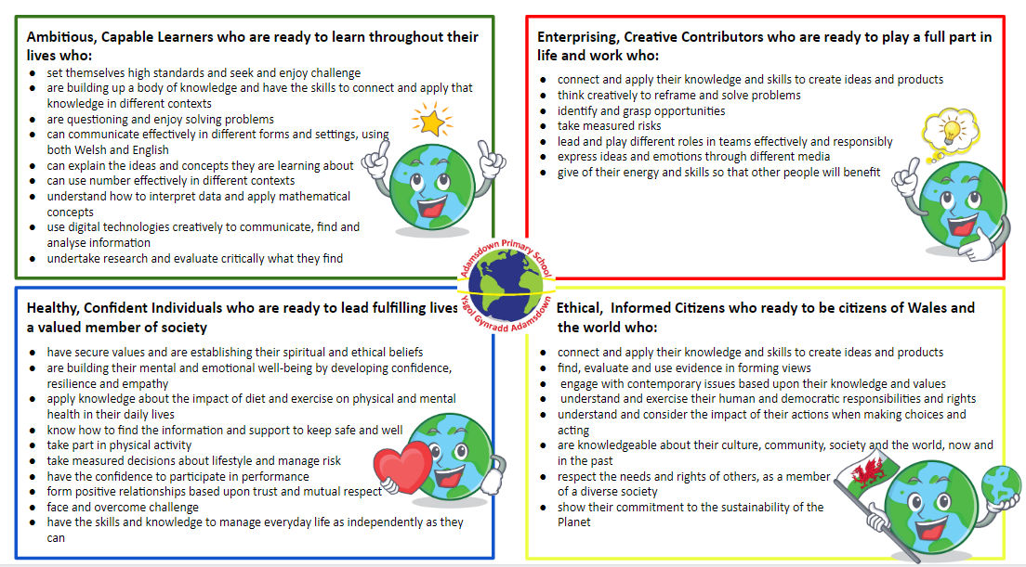

At Adamsdown Primary School we understand that a school’s curriculum is everything a learner experiences in pursuit of the four purposes. It is not simply what we teach but why we teach it.

Therefore, we ensure that our curriculum:

* has the Four Purposes at the core
* is broad and balanced
* covers the six Areas of Learning and Experience and the 27 statements what matters
* is tailored to meet the needs of all of our learners
* provides opportunities for pupils to revisit skills, knowledge and experiences in order to deepen understanding and make progress.
* provides opportunities for children to have rich, meaningful experiences
* embed the mandatory curriculum components of RSE and RVE, Welsh and English
* Includes the cross cutting themes of RSE, Human Rights, Diversity, Careers and work-related experiences and inform pupils about the world including local, national and international contexts.
* develops the cross curricular skills of literacy and numeracy skills and digital competence

**Cluster Class Model**

We deliver our Curriculum provision for all pupils through a unique class model in which we adapt teaching and pedagogy in a responsive way enabling us to promote effective learning and success for all.

We aim to adapt our provision to meet the needs of each class of pupils, we understand that differentiation is not effective as a single approach to meeting the needs of a cluster class. As effective practitioners we need to design provision that will break down any barriers to learning for all the pupils.

Our cluster class model ensures a range of pedagogical approaches are used to meet the needs of all of our learners and that appropriate experiences, skills and knowledge are tailored to meet the needs of each class.

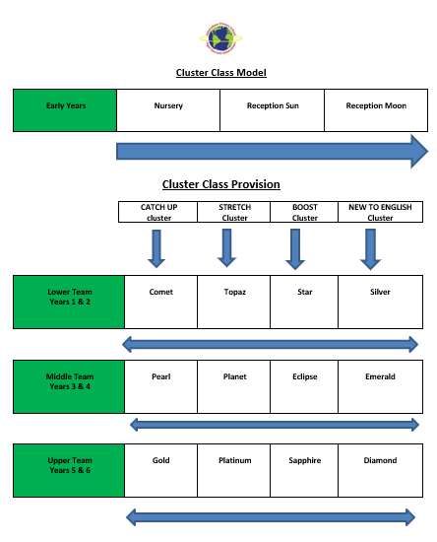

**Cluster Class Model**

We know that pupils have different learning styles which means they progress at different rates and require different levels of support in order to succeed.

In our Cluster Classes we seek to understand pupils’ differences, prior knowledge and experiences and potential barriers to learning. We use this information to adapt teaching in a responsive way allowing us to meet the needs of the learners.

**For this year’s current barriers and strategies see attached file:** [Class and strand barriers](https://drive.google.com/drive/folders/1Sd8EPMdPCpWGRICFAVFfyarP7dOs5sHS)

|  |  |
| --- | --- |
|  | **Common Barriers in strands** |
| **New to English** | * Low levels of language acquisition * Often no experience of an education system/very different experience (formal). * Asylum Seeker/refugee families may have experienced trauma * Limited or very different life experiences. * High mobility of pupils |
| **Catch Up** | * Poor working memory/retention * Low self esteem/confidence in core areas of learning specifically literacy * Poor attendance/punctuality * Low parental engagement |
| **Boost** | * Independence in learning * Communication and collaborative skills * Resilience |
| **Stretch** | * Accepting Failure/making mistakes * Group collaboration * Interpersonal skills |
| **Early Years** | * Language and communications * Physical skills * Gaps child development * Lack of experiences |

**Additional Learning Needs**

We appreciate that all pupils learn in different ways and at different rates. Teachers provide an environment that is inclusive and accessible for all. Teaching is adapted and differentiated to meet the needs of the class.

If a pupil requires additional support to make progress then they will receive targeted help in the class or through an intervention and progress will be monitored.We currently run interventions to boost: Language (Language Links), Speech (Speech Links), Reading (Rainbows), Maths (Big Maths catch up) and emotional health (ELSA, Thrive and Talkabout)

We work closely with the team of specialist teachers in the local authority for Speech and Language, Emotional Health and Wellbeing, Learning Support, Autism Support who regularly visit school l to provide advice. We also work with health professionals and the Educational Psychologist.

When identifying if a pupil has Additional Learning Needs (ALN) we follow the guidelines set out In the Additional Learning Needs Code for Wales 2021 We follow the timeline guidance set out in this code. If we believe that a child has an **Additional Learning Need** (ALN) which requires **Additional Learning Provision** (ALP) then a **Personal Centred Meeting** (PCM) is held to which all adults working with the child (parents, teacher, health, local authority) are invited to contribute.

As a result, an Individual Development Plan (IDP) is created to identify ways forward for the child.

**Pedagogical Principles**

Our teachers use the twelve pedagogical principles to enable them to meet the needs of all learners in their class.

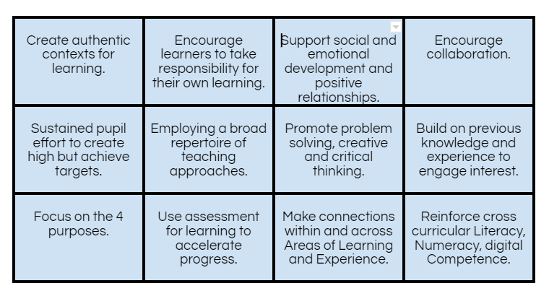

**Integral Skills**

Our curriculum is also underpinned by Integral Skills. We have identified the integral skills relevant to our pupils and we aim to develop these throughout a wide range of of teaching and learning experiences.

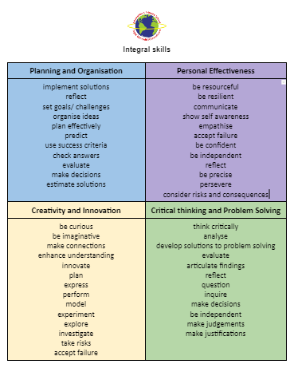

**Curriculum Structure**

Our children are engaged in meaningful whole school theme contexts which revisit key What Matters Statements, knowledge and skills in order to deepen understanding and allow pupils to make progress in all areas.

Team contexts sit under our whole school contexts and are purpose driven. All of our children have the opportunity to play a key part in their own learning journey ensuring each team context is relevant, flexible and influenced by pupil needs and interests. Pupils are given the relevant experiences, skills and knowledge they need throughout the context so that they can apply knowledge and skills in a meaningful way.

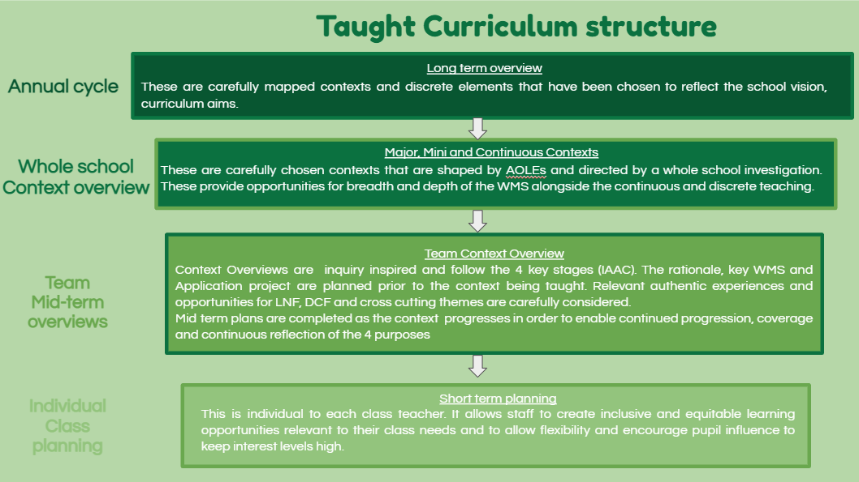

**Context Process**

When first considering the planning of a context, teachers follow the same design process each time to ensure the context is relevant and responsive to the needs of the pupils in their team.

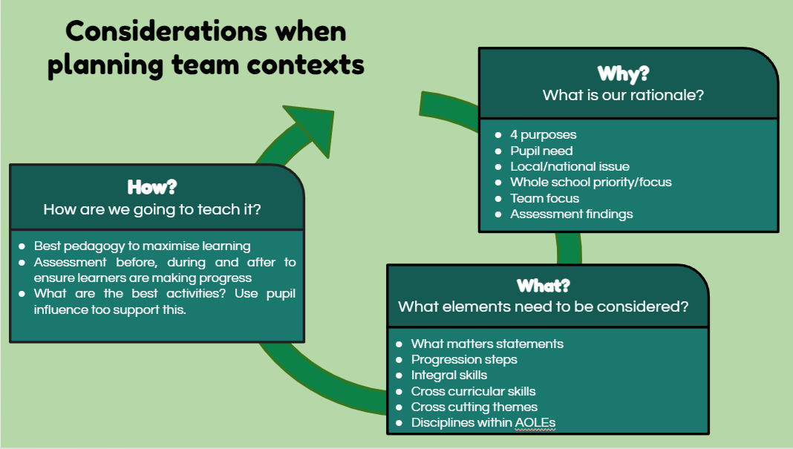

Each context itself also follows a process, we call this the ***IAAC*** process. We use a backward planning process for this. We first start with what we want the pupils to achieve in the ***A*pplication** Phase. Then we plan the **Inception** phase to find out prior knowledge, experiences and any barriers to learning, we also ensure that pupil voice begins to influence the planning in this stage. The ***A*cquisition** Phase is then planned carefully to ensure the pupils acquire the skills, knowledge and experiences they need. Finally, the ***C*ontemplation** Phase is planned.

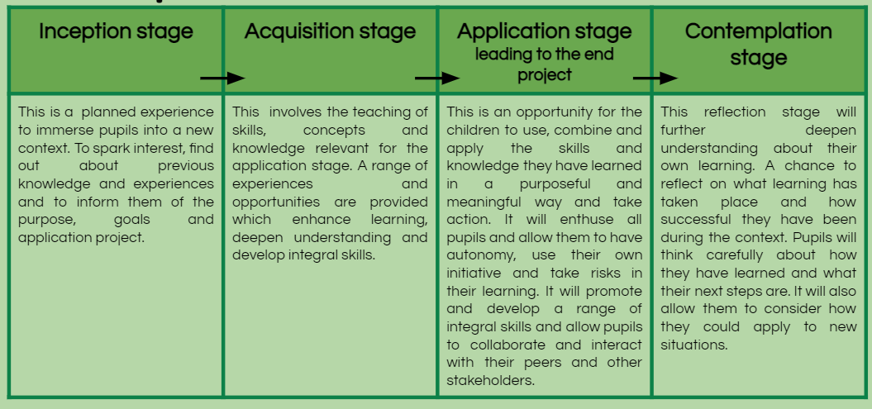

**Review Process**

Following each context, a thorough review is completed. This is carried out by SLT, Cluster Teams, relevant AOLE teams, and pupils. All findings from the review are shared and will have an impact on future planning, pedagogy and progression of pupils.

**Nursery Offer**

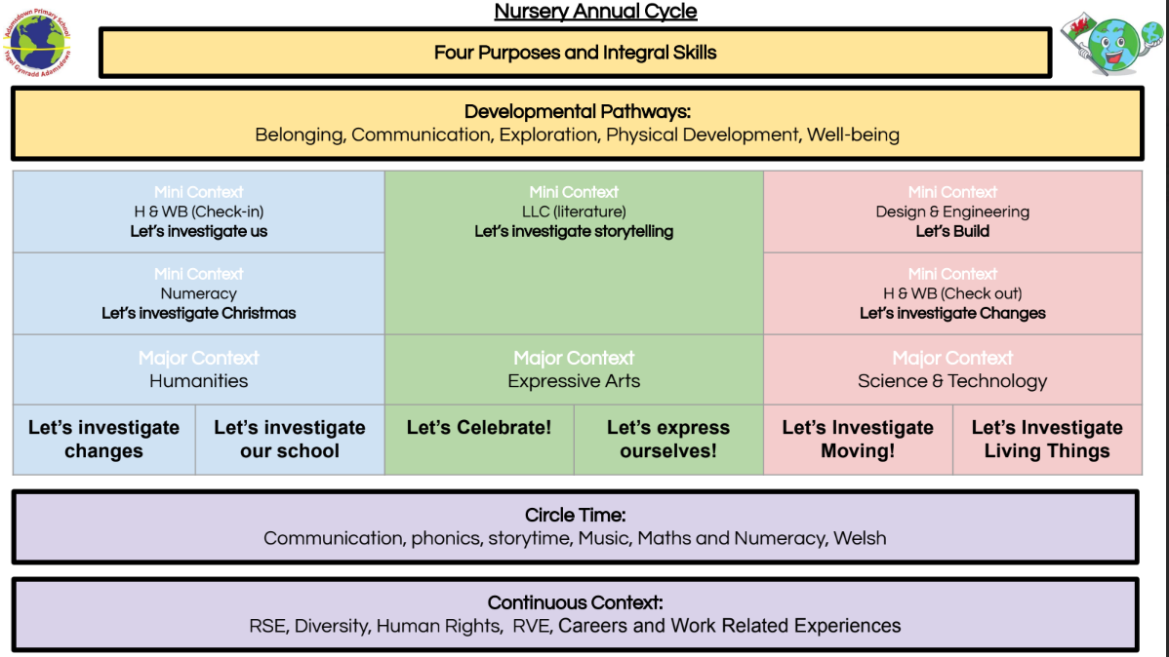

**School Enrichment Experiences**

We understand the importance and benefits of pupils learning through experience. Therefore,we carefully plan a broad range of enrichment experiences for all of our pupils.

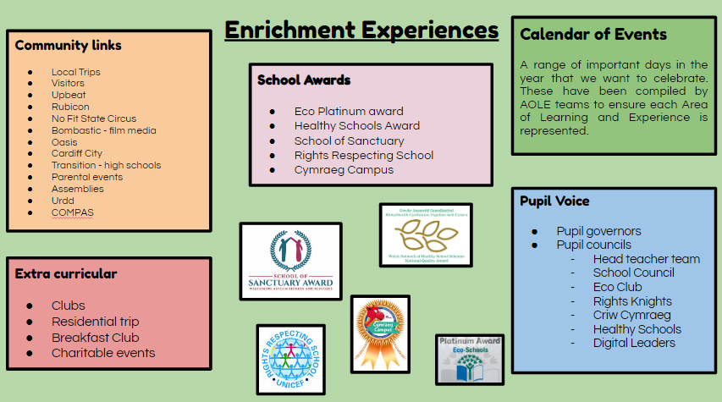

**Assessment and Progression**

All of our teachers use a wide range of formative and summative assessment opportunities to support our pupils to make progress.

Our aims:

* To ensure individual pupils are supported and challenged on a day-to-day basis
* To identify, capture and reflect on individual progress over time
* to use understanding of group progress in order to reflect on practice

*(For more information see our Assessment overview , Assessment for Learning Policy)* [Adamsdown Assessment overview](https://docs.google.com/document/d/1rHHFlFybtzQsPzxpTxD4c2fG9gDvn_lM6OKUb03PePA/edit)

[Policy for Assessment for Learning 2022.docx](https://docs.google.com/document/d/1QSV6OytoYa03o8R1W-x74Kj9yePzc6zZ/edit)

**Professional Learning**

Professional standards describe the skills, knowledge and behaviours that characterise excellent practice and support professional growth. All of our teaching staff work towards the Professional Teaching and Leadership Standards. They are intended to:

* set clear expectations about effective practice during a practitioner’s career including, where applicable, entry to the profession
* enable practitioners to reflect on their practice, individually and collectively, against nationally agreed standards of effective practice and affirm and celebrate their successes
* support practitioners to identify areas for further professional development
* form a backdrop to the performance management process

For staff to work towards these professional standards we provide the following opportunities:

* Performance management cycle in which targets are linked to the SIP and the professional standards
* All teaching staff engage in a professional Learning Inquiry in which they follow the Spiral of Inquiry Model. During this process staff receive specific **P**rofessional **L**earning **O**ffer **T**ime (PLOT) in which they can spend time away from their classrooms and concentrate on professional inquiry linked to the needs of their pupils.
* Weekly staff professional Learning INSET sessions and 5 whole school INSET days
* Fortnightly Team meetings in which staff can share best practice and engage in professional dialogue
* Relevant training opportunities for individuals
* Termly progress meetings/Class review meetings

Learning and teaching is monitored and evaluated in order to provide a clear picture of the quality of practice across school. We monitor and evaluate teaching and Learning through:

* Classroom observations and learning walks
* Context reviews
* Scrutiny of pupil’s work
* Discussion with pupils
* Sharing pupils’ work throughout school and discussing quality

**Roles and responsibilities**

***Senior Leaders should:***

* Implement the Learning and Teaching Policy
* Ensure that the school implements the requirements of the new curriculum effectively across the school.
* Monitor, evaluate and report to governors on the effectiveness of teaching and learning through the school’s self-evaluation processes
* Identify opportunities for and facilitate the sharing of good practice within the school
* Monitor the range of teaching and learning activities, ensuring that approaches are fully integrated;
* Update teaching pedagogy through the provision of appropriate training

***Governors should:***

* Be fully aware of the Teaching and Learning Policy
* Appoint a Governors with a specific responsibility for Teaching and Learning
* To ensure the Teaching and Learning Committee engage in monitoring, evaluating and reporting on the effectiveness of the policy.
* To ensure that the Teaching and Learning Committee keep all governors informed of developments within teaching and learning and implementing the curriculum
* Provide a summary of teaching and learning in the annual report to parents
* To attend Curriculum Learning Walks and provide feedback to Head Teacher

**Teachers should:**

* Implement the Learning and Teaching Policy fully
* Adapt pedagogy to meet the individual needs of the pupils in regards to their learning.
* All teachers to ensure provision meets the needs of pupils with ALN
* Engage with professional learning opportunities
* Work closely with colleagues to reflect and enhance their own practice
* Respond to feedback from monitoring activities to improve practice