**Welsh Assembly Government Aim:**

The Stay Safe, Stay Learning policy statement states:

*“…we believe the most important thing in this time of unprecedented change and disruption is the safety and well-being of our children and our workforce and doing all we can to support the physical and mental well-being of our children and young people throughout this period.”*

*(Developing approaches to support distance learning, WAG, 2020)*

Across our education system we are prioritising support for all learners to keep learning and transition effectively back into school when the time comes. Therefore, this advice focuses on the work of settings and schools in considering how all learners can be supported to return to education in a positive frame of mind, and to continue as seamlessly as possible with their learning.

To help make this happen schools, PRUs and settings are advised to make all efforts to:

* keep all children safe and well
* offer access to childcare for critical workers
* ensure learners who are at most risk are being supported
* support the well-being of the education workforce
* allow learners to access learning through digital or other accessible methods in a
* practical and uncomplicated way
* support all partners’ shared understanding of how effective, organised distance
* learning can provide a breadth of learning experiences
* support parents/carers access to guidance to understand their role in supporting
* their children within distance learning
* support the well-being and basic skills of learners through effective contact and
* communications.

Settings and schools will have access to support from regional consortia and local authorities as they develop their approaches to distance learning. This advice includes signposting to some models that settings and schools may wish to adopt or adapt as part of their distance learning strategy.

*(Developing approaches to support distance learning, WAG, 2020)*

**Introduction:**

In recent years, online learning has formed an integral part of teaching and learning.

Online resources are regularly accessed to enhance the curriculum and to promote independent learning, with the vast array of resources accessible in school and at home, as appropriate. Following school closures in March 2020, online learning became the main avenue to continue teaching and learning with the view that this would continue alongside a blended model of at home/in school education for coming months. This policy brings together important information linked to best practice, online safety, resources as well as support for teaching staff, parents/carers and our young people. Our approach is that online learning does not replace faceto-face teaching, but it is a vehicle to continue teaching and learning and ensuring we uphold our school vision statement:

*“to nurture kind, respectful children who show ambition and are able to learn, then apply the skills needed for a successful future”*

*(Adamsdown Primary Vision Statement)*

An effective blended learning approach as part of the “new norm” has been be developed, building upon our distance learning strategies that worked efficiently throughout the lockdown period. Adamsdown Primary’s blended learning approach has been produced upon basis of learners’ needs rather than attempting to carry on with business as usual, using the “Road Map” guidance from Hwb / Central South Consortium[1]. We believe that communication with parents is vital, whether there should be a whole class shut down or whether individuals are needing to self-isolate and that the well-being of our pupils is paramount.

**Blended Learning:**

There are many different types of blended learning models, but the main traits remain the same as defined by the Oxford Dictionary:

*"A style of education in which students learn via electronic and online media, as well as traditional face-to-face teaching"*

The teaching and learning is both synchronous (takes place at the same time for the teacher and pupils) and asynchronous (takes place at a time suitable for the teacher/pupils). In order to be successful, a blended learning model must be meaningful, enhanced, motivating and engaging for all pupils.

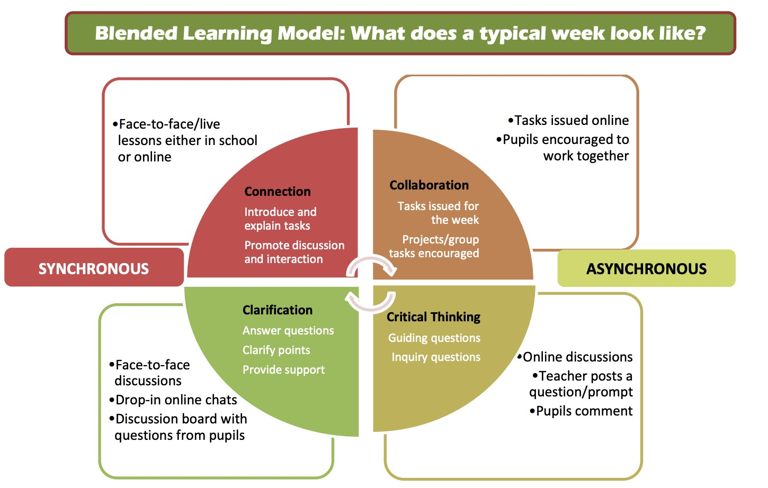

**Strategies and Approaches:**

Strategies for and approaches to learning and teaching are as relevant outside of a classroom as they are in, if not more so. Blended learning will consist of a range of approaches that can be broadly categorised as:

1. Face-to-face time with learners
   * Within our blended learning model, it has been agreed that face to face classroom time in school is best used to:
     + Maximise the use of direct teaching time;
     + Introduce new ideas and skills including independent learning skills.
     + Guide learners through new content and skills linking to previous learning where possible.
     + Assess and continue to ensure pupil progress in skills and knowledge.
     + Provide real time, particularly verbal, feedback to address initial misunderstandings. Use a range of models to show the learning destination.
     + Closely guide and teach the new route through the learning.
     + Within social distancing guidelines, enable pupils to engage with each other – collaborative tasks, discuss and plan learning, see each other’s work.
     + Improve engagement and ensure task completion through celebration and rewards as well as sanctions.
     + Maintain positive relationships with teachers and staff.
2. Online learning
   * Activities delivered online, e.g., through HWB
   * Recorded lessons
   * Use of Home Learning Platform
   * Live-streaming of lessons
3. Offline distance learning
   * For learners that are unable to effectively engage with online learning, teachers will plan and deliver direct teaching of the experiences, knowledge and skills the learners need to complete the tasks during face-to-face time. Learners then engage with these tasks at home without the need for further online instruction.
4. Flipped Learning
   * The Flipped Classroom model flips the traditional relationship between class time and homework. Learners learn at home via online work and direct teaching, and teachers use class time for teacher-guided practice or projects. This model enables teachers to use class time to personalise learning.

To facilitate the ‘online’ aspect of Blended Learning, we have ensured that all learners have access to their online learning platform (Hwb or Seesaw) and have a clear understanding of the following:

* + How to access material provided by the teacher
  + How to use the most appropriate online tools to complete any task set, including providing evidence of work completed away from a device, e.g.

photograph or video of physical and practical activities, where appropriate

* + How to submit any digital material to their teacher or how to access and respond to any feedback provided by their teacher.

Pedagogy, and the impact that it has on learning, is the driver for decision making. In considering the strategy or approach it is important that feedback is always considered so that learning, rather than simply provision, is taking place. The following table shows how we, as a school, scaffold thinking and school level discussions around which mode for learning is best suited to each approach or strategy according to learner age and curriculum area and the unique context of each school.

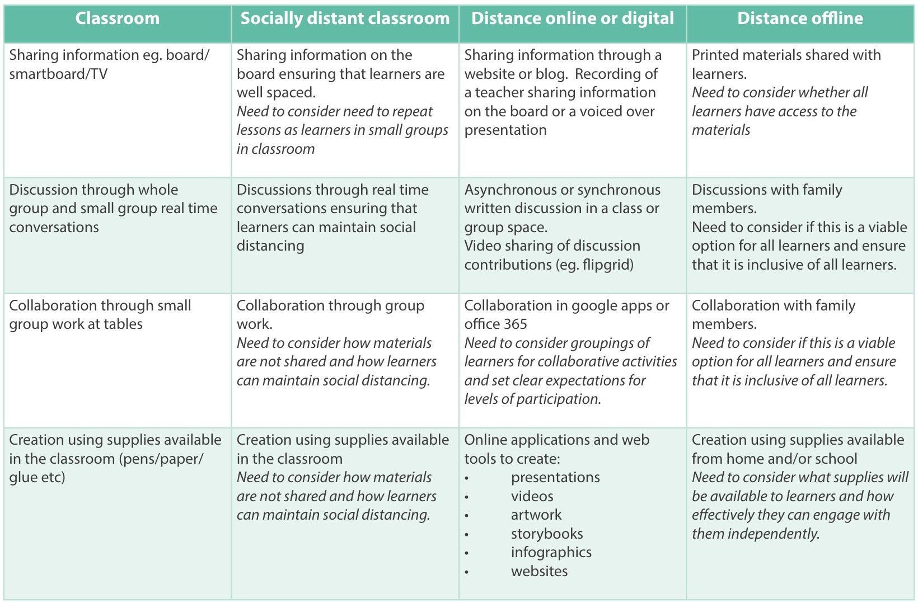

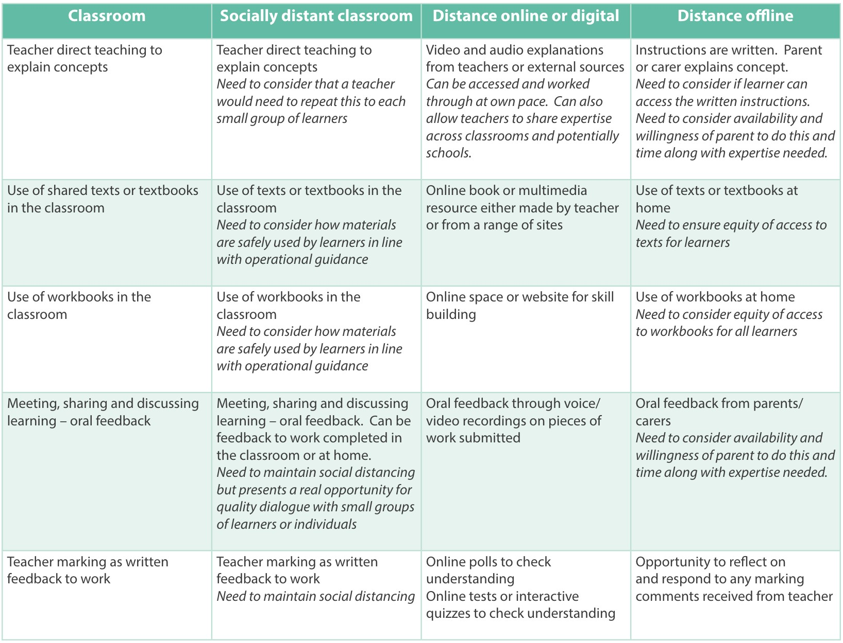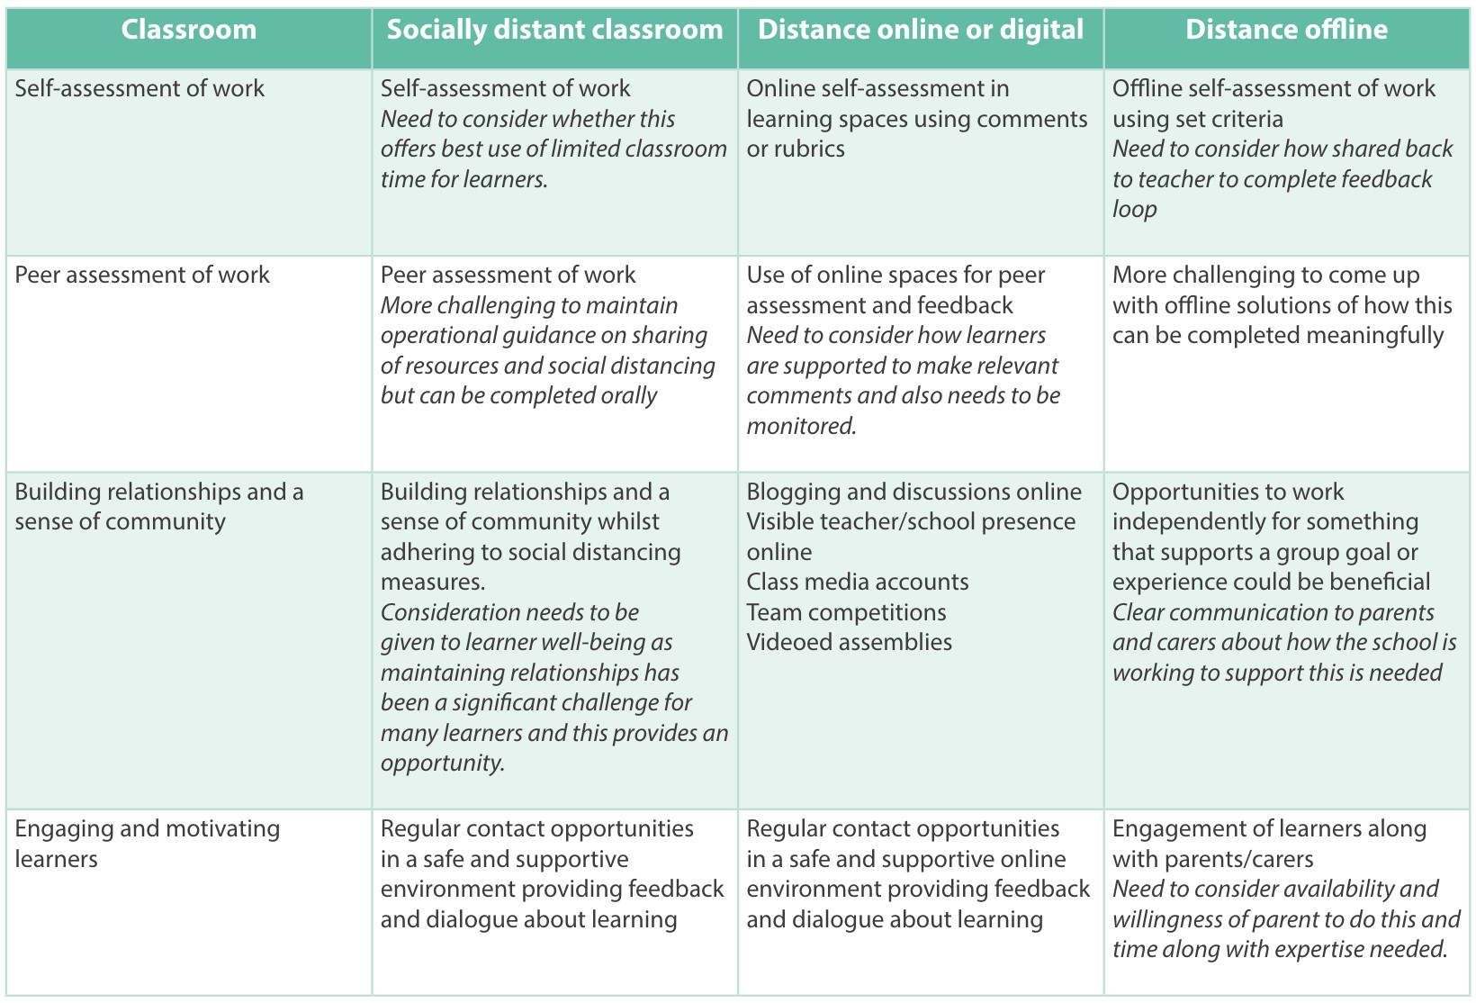

Blended Learning Guidance, CSCJES, July 2020

**Platforms used for blended learning:**

* 1. Google Classroom

Google Classroom is a collaboration tool within the Hwb platform for teachers and students. Teachers in KS2 have created an online classroom, invited students to the class can create and distribute assignments. Within the Google Classroom students and teachers can have conversations about the assignments and teachers can track the student's progress with “live marking” sessions and instant feedback

* 1. Seesaw

Used mainly in FP and Dosbarth Pearl, Seesaw is a simple way for teachers and students to record and share what's happening in the classroom. Seesaw gives students a place to document their learning, be creative and learn how to use technology. Each student gets their own journal and will have the ability to add photos, videos, drawings, or notes.

* 1. J2e

Used through the Hwb platform, Just2easy’s tools encourage differentiated learning, with JIT for the youngest learners through to j2e5 for the more advanced. Just2easy provides an easy to use digital learning environment, where teachers, pupils and others can learn and use technology in a way which enhances, rather than replaces, more traditional approaches.

**Online Delivery:**

It is important to use professional experience when allocating tasks online. Some tasks may require direct teaching and support and be more suited to face-to-face lessons. Tasks which do not require significant teacher input or that can be done offline, away from screens, are best completed at home. This may mean the order of course topics/units may need to be altered.

Teachers will already have resources such as presentations, videos and web links which can be shared easily using Google Classroom / Hwb. There are also many resources available online which pupils can access such as Scholar, BBC Bitesize, etc. These useful resources should be used as part of the blended learning model.

Paired and group work can continue during remote learning by using the collaboration tools on Google Classroom / Just2easy. This allows more than one person to contribute to documents or presentations.

Good practice when planning and organising online learning:

* Let pupils know when you will/will not be available, giving pupils chance for face to face contact at least four times per week (KS2) or twice a week (FP).
* Turn off notifications after you have finished working for the day.
* Any instructions need to be clear and specific.

Checking on pupil progress is important to monitor and track understanding and progression. Google Forms, Kahoot and Quizlet are just some of the tools that can be used to set up quizzes, polls and mini-tests. They are self-marking, allowing you to analyse results by class or individuals.

**Live Lessons:**

Live videos can be used within Google Meets to plug gaps in groups of pupil’s learning, play Helpwr Heddiw games, hold singing/story sessions and introduce new work. The teacher can share their desktop with pupils during a Google Meets meeting, allowing a presentation to be delivered, with the teacher talking to pupils. Wherever possible, another member of staff should be involved in this process to monitor the comments within the chat section, allowing the teacher to teach the lesson and comments to be discussed at the appropriate time. It also allows the chat area to be monitored for any inappropriate language/comments.

Pupils should switch their screens off and mute their microphones. Teachers can then invite pupils to speak, if they wish, by asking them to unmute their microphones. This cuts down on background noise which can inhibit others from hearing properly. Teachers can keep the webcam and microphone on, if they wish, but they can also just use the microphone on its own. If using the webcam, it is important to be aware of your surroundings and have no personal items in view. On the Google Meets desktop app, you can use screen blur or various backgrounds. You should also be mindful of what is on your desktop, with pop-ups and applications such as Twitter or Skype closed.

**Recorded Lessons:**

Being able to record lessons is a useful tool as these can be shared with pupils online and can also be used at a later date to remind pupils of prior learning. Below are a few ways to easily record lessons:

* PowerPoint to Video: Existing PowerPoint files can be converted to narrated videos or automatic PowerPoint shows. A step-by-step guide is available to help if using PowerPoint on the desktop.
* Record your iPad screen: If you have an iPad, you can record your screen by following the instruction guide.
* Online Screen Recording: There are free online screen recorders that can be used to capture your screen such as “Screencastify”(approved by Hwb via Google for Education). These have time limits to the length of video you can create.
* Google Meets: You can record video meetings for other people to watch later. To record a meeting, a G Suite administrator must turn on recording for your account. You can record if you’re the meeting organiser or you’re a teacher signed into your G Suite account but not a student. Recordings include the active speaker and anything that’s presented. Recordings are saved to the organiser’s Meet recordings folder in My drive. An email with the recording link is sent to the meeting organiser and the person who started the recording. The link is added to the Calendar event.

**Blended Learning and Wellbeing of Pupils:**

Moving to blended learning is a big adjustment for all shareholders at Adamsdown Primary School. Staff will ensure that regular calls / Class dojo messages are made to individual pupils who need to self-isolate, with immersion in lessons via Google meets where possible and where the child is feeling well.

In the case of a whole class / school closure, teachers and TA’s will regularly check in on pupils via:

* telephone calls,
* Class Dojo messaging
* Google Meet face-to-face “check in” sessions, where pupils can visit the online area to chat to a teacher about any problems they are having with work or just for a general catch up.

If staff are concerned about individual pupils, they should report concerns to the Head Teacher.

To ensure that pupils conduct themselves appropriately in online teaching sessions and to help online teaching be a positive experience for everyone, pupils have been given the following guidelines:

1. Be on time: 
   * Be at your device 5 minutes before the meeting is about to start;
   * Make sure your device is fully charged/

1. Chat responsibly: 
   * Mute your mic until it is your turn to speak;
   * 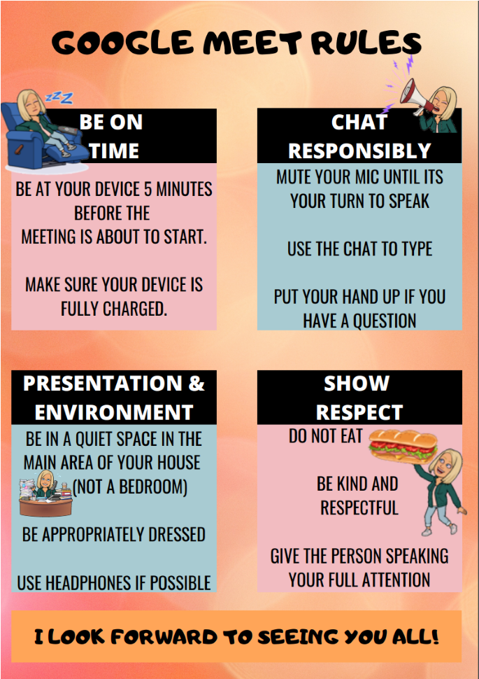Use the chat to type;
   * Put your hand up of you have a question.

1. Presentation and environment:
   * Be in a quiet space in the main area of your house (not a bedroom)
   * Be appropriately dressed; • Use headphones if possible.

1. Show Respect:
   * Do not eat;
   * Be kind and respectful;
   * Give the person speaking full attention.

At the start of the Class Closure, parents and pupils will sign a google form to say that they agree to the Google Meet Rules and before each Google Meet session, pupils are reminded of these rules.

**Blended Learning and Wellbeing of Staff:**

We understand that working from home as a teacher during lockdown means organising both work and family. As well as ensuring we provide quality home learning for students, staff possibly also must care for their own children or vulnerable family members. To ensure a positive culture of staff wellbeing, staff should keep the following factors in mind:

* + Let learners know when you will be available / not available
  + Turn off notifications after they have finished working for the day to give themselves down time.
  + Share activities for the day in a google classroom/seesaw post so that all the information is in one place. Twitter can also be used for reminders
  + Ensure that any instructions are clear and specific for remote learning, trying to keep to a similar format for all tasks so that students are clear on expectations.

# **Blended Learning at Adamsdown Primary School: Individual Pupil self isolation**

* Children who are isolating will be overseen by their class teacher and the Home Learning team.
* Work on the Home Learning Platform will be updated regularly, giving new activities should pupils be off for more than one period of self-isolation.
* Regular communication should be made with the pupil, and, if they are well enough, they should be invited to join certain lessons via Google Meets (this will be more prevalent in UKS2)

# **Blended Learning at Adamsdown Primary School: Whole Class isolation**

Nursery and Foundation Phase:

* Work will be displayed via the class pages on the school website and pupils will be given work packs to go home. These work packs will include reading resources, phonic work and fine motor skill activities.
* Work will be sent to the class teacher by parents.
* Communication will take place regularly via phone calls (nursery/reception) or Google Meets sessions (Y1/2) and Seesaw messaging, with any concerns being reported to the Head teacher.
* Support staff will aid in the making of phone calls and will be available during Google Meet Sessions. They will help to resource work when necessary.
* In Y1/2, activities will be based around Seesaw and work will be set using the homework tab of the programme.

Key Stage 2:

* Work will be displayed via the Home Learning Platform.
* Digitally deprived pupils will be identified, and relevant work packs will be sent home with those pupils as a hard copy.
* Set work will include daily English/Maths and a context activity. These will be handed in through the Google classroom Platform or seesaw for Dosbarth Pearl.
* The class teacher will send a daily message at the start of the day via the google classroom and twitter to inform the parents of the day's tasks.
* Communication will take place regularly via Google Meets sessions, with any concerns being reported to the Head teacher.
* Support staff will aid the class teacher during Google Meet sessions and with the marking and feedback of work.

# **Blended Learning at Adamsdown Primary School: Teaching Staff self isolation**

* Should a staff member need to self-isolate, and they are well, they will be expected to arrange various Google Meet sessions daily to check in with their class
* If a teacher has tested positive for Covid 19 and are too unwell to “check in” with the class, the supply teacher will be directed to the planning and SLT / other teachers in the department will work with the supply teacher to help arrange extra work should the planning reach an end.

**Useful Links for Practitioners:**

“How To” Guides:

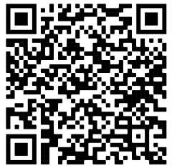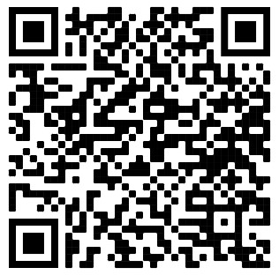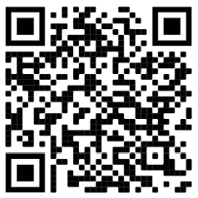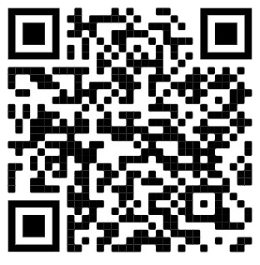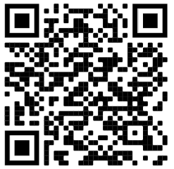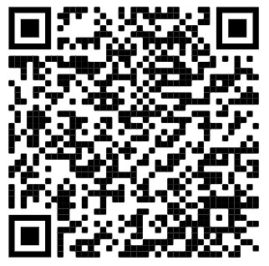

https://hwb.gov.wales/distance-learning/distance-learning-toolsthrough-hwb/practitioners/

Developing Approached to Support Distance Learning:

https://hwb.gov.wales/distance-learning/developing-approaches-tosupport-distance-learning/

Distance learning Resources Foundation Phase:

https://hwb.gov.wales/distance-learning/resources/foundationphase/

Distance learning Resources Key Stage 2:

https://hwb.gov.wales/distance-learning/resources/key-stage-2/

Live Streaming Guidance:

https://hwb.gov.wales/support-centre/hwb-services/live-streaming/

Supporting physical and mental well-being through distance learning:

https://hwb.gov.wales/distance-learning/supporting-physical-andmental-well-being-through-distance-learning/

**Useful Links for Parents and Carers:**

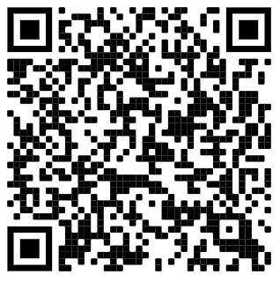Parent and Carer support:

https://hwb.gov.wales/distance-learning/distance-learning-toolsthrough-hwb/welcome-to-parents-and-carers-support/

**Appendix 1: Roadmap**

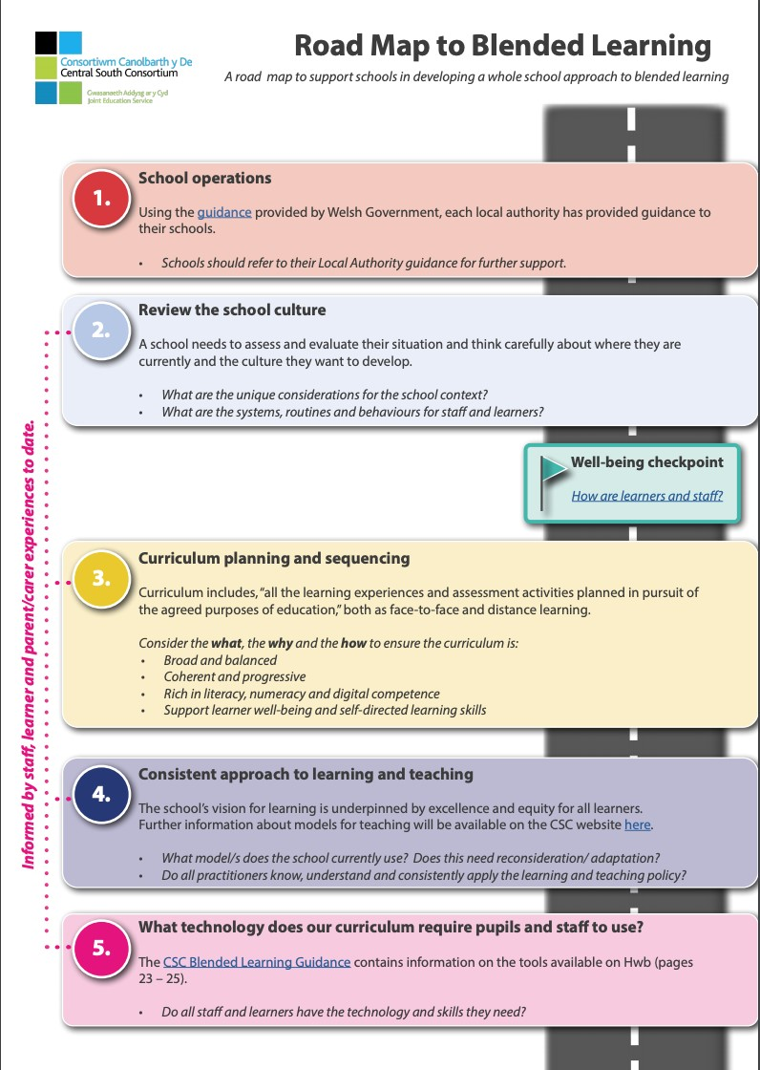

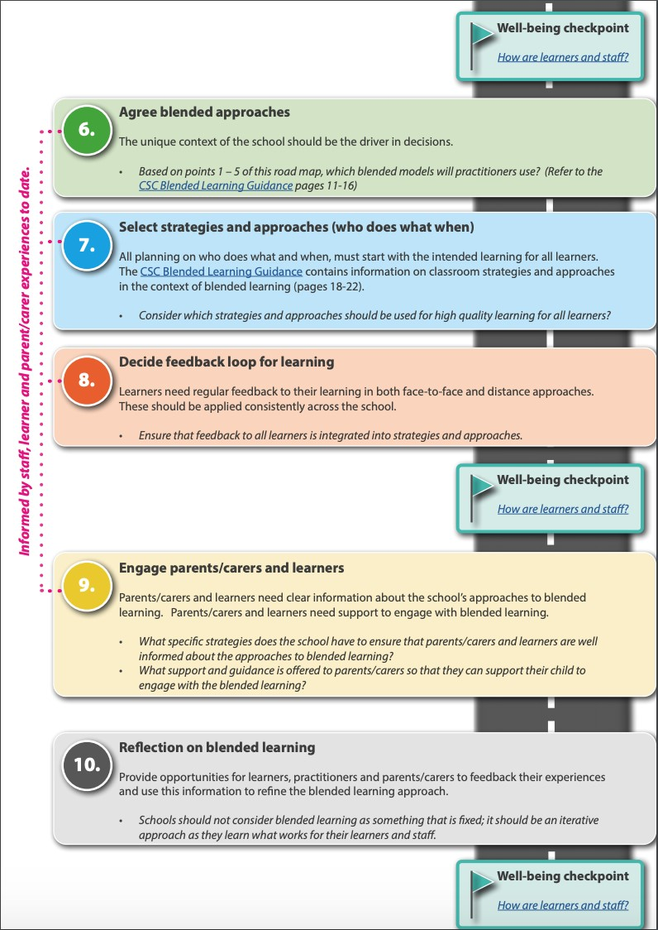

1. See Appendix 1