

**Annual Governor’s Report to Parents**

**Summer 2022**

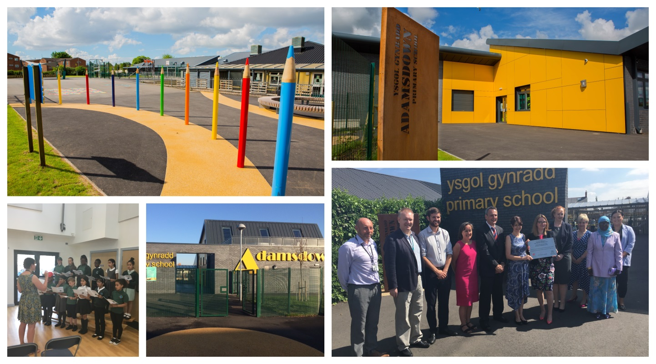

**Our school vision is:**

**To nurture kind, respectful children who show ambition.**

**For all pupils to progress through a range of meaningful experiences enabling them to learn and apply the skills needed for a successful future.**

**Aim High, Be Kind, Show Respect**

**Welcome from the Chair of Governors  
Councillor Owen Llewellyn Jones**

Dear all,

This is my first letter to you as Chair of Governors and I wanted to start it by voicing my gratitude to the previous Chair, Nigel Howells, for his years of dedication and commitment to our school. Nigel did a fantastic job and I will do all I can to continue his good work.

As we approach the end of the school year and we are able to all meet together in person, it is easy to forget the disruption the school has faced since September.  It is a huge testament to the staff, the pupils and yourselves as parents that schooling in one form or another continued throughout the most unprecedented of challenges and I thank everyone for their commitment to that.

The last few months have seen some return to normalcy and it has been wonderful to see school trips restarting, groups such as Rubicon Dance and No Fit State Circus visiting and fun activities and events such as the carnival, film production and the history exhibition happening once again. It was especially pleasing to see our pupils officially open the new ‘Railway Gardens’ community hub last month.  Adamsdown Primary is firmly part of the Adamsdown community - it is so nice to see pupils engaging with that community and to see the school returning to the welcoming hub that it was pre-pandemic.

That welcoming and inclusive spirit is a testament to the ethos of our school.  On behalf of my fellow governors, I would like to thank the staff for everything they have done over the past year. They have all strived so hard to make the school the safest and most friendly place for all pupils and it is clear to see how committed they all are to helping the children achieve their very best.

Those of you who follow the school’s many twitter accounts will no doubt be as impressed as I am at the quality and diversity of the education and related activities that our staff have delivered. Our school’s social media are a joy to see and I would certainly encourage to you to follow them if you can.

I am proud to chair such an able and committed governing body that has met throughout this year. We are continuously scrutinising school processes to ensure the children are always getting the best quality education and it so pleasing to have been able to restart our school walkabouts and to meet pupils first hand once again.

Mrs Thomas and her fantastic team are an inspiration; as your governors, we will always look to work constructively with them to ensure that everyone gets the most out of being a part of Adamsdown Primary, be that children, staff or parents. I thank everyone for all their efforts over the past year.

Diolch yn fawr,

**Cllr Owen Llewellyn Jones**

**The Governing Body**

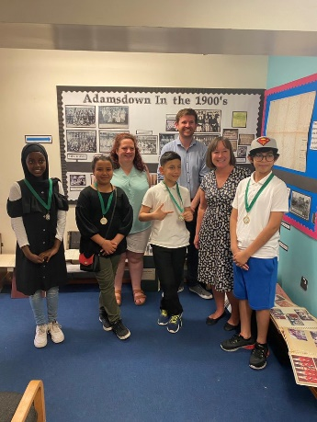

**Members of the Governing Body for 2020 – 2021**

Cllr Owen Llewellyn Jones Chair, Local Authority Governor

Mr Andrew Gallagher Vice Chair, Community Governor

Mrs Emma Thomas Head Teacher   
Mr John Dixon Local Authority Governor

Ms Grace Ferguson-Thorne Local Authority Governor  
Mr Joe Redmond Community Governor

Mr Ian Protheroe Community Governor

Mrs Salma Abdelquadir Parent Governor

Mrs Zainab Hassan Parent Governor

Mr Mujib Yahaya Parent Governor

Mr Charles Stead Parent Governor

Miss Tabitha Brunker Non-Teaching Governor

Mrs Amelia Harrison Teacher Governor

Clerk to GovernorsMrs Janice Knowles

**The Annual General Governor’s Meeting for parents is due to be held on Friday 7th October at 10am, to request an invitation please phone Miss Price in the school office.**

**School Context**

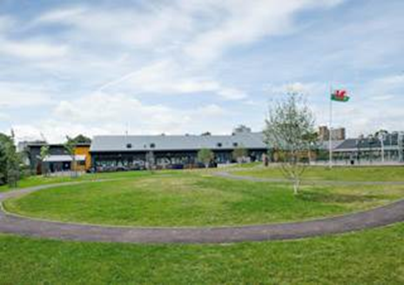

* Adamsdown Primary is in Adamsdown, Cardiff near the city centre.
* There are currently 420 pupils on roll aged 3 to 11 years old.
* We have an 80 place nursery.
* There are 15 classes altogether, 2 single-age reception classes and 12 mixed age classes.
* Currently, around 60% of pupils are eligible for free school meals, which is well above the national average.
* The school has identified around 15% of pupils as having additional learning needs, which is above the national average.
* Very few pupils are looked after by the local authority.
* Approx 70% of pupils speak English as an additional language. No pupils speak Welsh as a first language at home.
* The number of pupils joining or leaving the school at different times is very high and only four out of ten pupils have completed their education in the school.
* The Head teacher Mrs E Thomas has been in post since 2014 but has worked at the school for 20 years, Ms H Williams the Deputy Head teacher joined the school in 2015 and was appointed in 2017.

**Budget**

Formula funding is largely based on the number of children attending the school. Any significant change in that number would have major financial implications. Expenditure needs to be carefully monitored to ensure best value for money when buying resources or services. With this in mind, the Governors have a financial update each term, with the financial sub-committee prioritising resources as needed.

**Financial Statement**

No Governor claimed any travel or subsistence allowances during the past year.



**What have we achieved this year?**

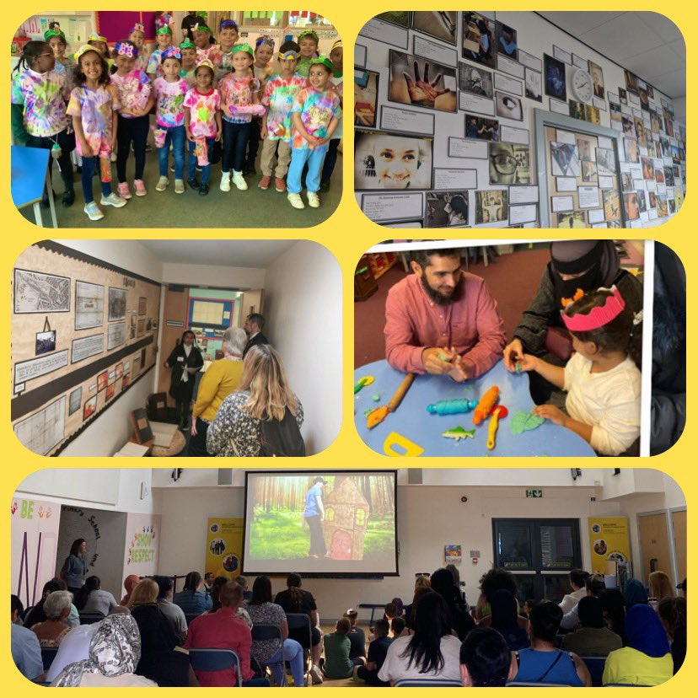

* This year we have enjoyed returning to some more usual practices in school such as using our dinner hall and inviting parent’s to attend events to showcase their children’s work.
* The school tracks the individual progress of all pupils and takes swift action to ensure all children receive targeted support.
* At every parent’s evening a child’s progress is discussed and targets for achievement set, we look forward to returning to face to face meetings in autumn 2022.
* Nearly all children achieve their annual targets and make accelerated progress through the year in relation to their starting baseline assessments.
* This year we launched our online reading scheme ‘Reading Eggs’.
* In the past year we have achieved the reaccreditation of our National Healthy Schools award, we are one of only a few Cardiff schools to hold this award, we have also re-accredited our Eco platinum award for the third time.
* We are proud to have achieved the Silver Rights Respecting Schools award this year.



**Attendance**

* For 2021 - 2022, we have achieved an attendance of 88%. We do however need to continue to improve with the aim of reaching the all Wales target of 95% and need your help!

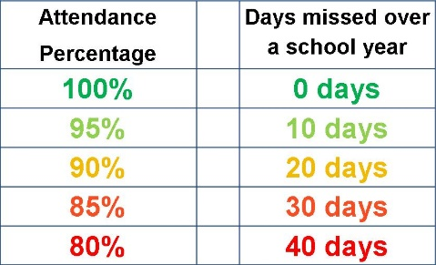

* Our school is supported by our Family Engagement Officer Mrs Foley and a Welfare and Attendance officer Mrs T Pearce who is based in Willows High School. Mrs Pearce supports us by completing home visits and hosting support meetings at the school.
* If you feel you need support to improve your child’s attendance please do not hesitate to contact the school office or Ms Williams for further information.

**Punctuality – be on time!**



Whilst we are pleased with attendance rates during the pandemic we are concerned about a growing number of families who are bringing their children to school after 8.55am.

When your child arrives in school late they are missing vital learning which starts promptly in class at 8.55am.

From September 2021 the following practices will continue:

**Late arrivals**

* This year we will be opening all gates at 8.45am and close them at 8.55am
* Parents who arrive after that will have to report to the front entrance.
* Class teachers to monitor punctuality and speak to parents directly.
* If there is no improvement the following steps will be worked through:

1. Formal letter will be issued outlining concerns and showing impact on education and well-

being.

2. Meeting with Deputy Head Teacher and Family Engagement Officer

3. Meeting with Head Teacher

4. Advice sought from Local Authority

**Admissions**

Arrangements for admission of all pupils are detailed in our school admission policy and in the school’s Accessibility Plan (which is part of the Strategic Equality Plan). Both are available in school for parents to see.

All new pupils will be offered an admission interview where you can meet staff and some simple assessments will be carried out to ensure we meet your child’s needs from day one!

**High School**

Our feeder high school is Willows High School which is based in Tremorfa, Cardiff. Many of our pupils also feed out to other High schools in Cardiff. We ensure all pupils have a successful transition with visits and open communication between schools, parents and children in the months leading up to year 7.



Willows High School

Willows Avenue

Cardiff

CF24 2YE

Tel: 029 2041 4243

Email: [contact@willows.cardiff.sch.uk](mailto:contact@willows.cardiff.sch.uk)



**School Prospectus**

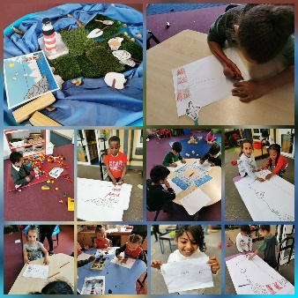

This is available to all parents of new pupils to the school. We also publish a special booklet for our Reception pupils. Both documents have recently been updated and revised additions are available for all parents upon request. Any changes to the document make reference to staffing changes.

**Information for Parents**

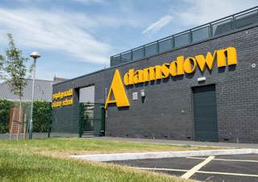

We use parentpay and SCHOOP for any upcoming events, important dates and to send any messages to parents. Details on how to access this is available from the school office.

Our twitter account @adamsdownprm is accessible via our school website [www.adamsdownprm.co.uk](http://www.adamsdownprm.co.uk)

The school also has a number of policies which parents/guardians may obtain from the school website or on request from the school office.

**Family Engagement**

Andrea Foley is your Family Engagement Officer.

My role is to offer support for parents, children and families if there are any concerns you wish to discuss and to help with any issues in relation to supporting your children, either at home or in school.

*Life is not always straightforward*

I am here to listen and help with any worry or query, large or small, that you may feel you need support with. I also have access to a number of agencies who provide advice and assistance.

I organise a range of free courses in The Cwtch, Family Engagement Room (old school building), for parents throughout the year.

Once covid restrictions are lifted you are welcome to come along to The Cwtch on Monday mornings for the

Chat & Chill coffee morning session between 9-10.30am for free refreshments and toast. It is an opportunity to meet other parents, sit and read a book or

find out about the free courses.

**Need advice or just a chat?**

Ask the office staff to contact me or come to see me when I am l at the main gate at beginning or end of the day.

**Our School Day**

* School Gates open at 8.45am
* All pupils need to be in class by 8.55am
* All classes have a morning play time
* Lunches are staggered all classes have time to eat in the main hall and then play outside
* School gates open at 2.55pm
* School ends at 3pm

**School Term and Holiday Dates for 2022 – 2023**

Autumn term Starts: Wednesday 04/09/2022

Half term: Monday 31/10/2022 - Friday 04/11/2022  
Ends: Friday 23/12/2022

**-------------------------**

Spring Term Starts: Tuesday 09/01/2023  
Half term: Monday 20/02/2023 - Friday 24/02/2023  
Ends: Friday 31/03/2023

**--------------------------**

Summer term Starts: Monday 17/04/2023  
Half term: Monday 29/05/2023 - Friday 02/06/2023  
Ends: Friday 24/07/2023​

**Curriculum**

2022 is an exciting time for all schools in Wales as we begin to embed a New Curriculum for Wales. This year we have been fully engaged in trialling new aspects and approaches to the New Curriculum

More information about the New Curriculum and our Curriculum Offer can be found here: <https://hwb.gov.wales/curriculum-for-wales/a-new-curriculum-in-wales-a-guide-for-parents/>

Or on our School website:



**Staff Development**



In order to keep abreast of developments, staff attended a wide range of courses and meetings appropriate to their responsibilities and the needs of the school. Each year schools must allocate 6 days to staff training (INSET).

Every teacher receives professional learning time to research, trial and implement different approaches that will benefit their class. This work is then shared with the whole teaching team.

Staff also link with other schools to develop areas of their practice.

The teachers meet every Monday after school for Inset. The topics of these meetings relate to the school improvement plan and other important educational developments.

**Additional Learning Needs**

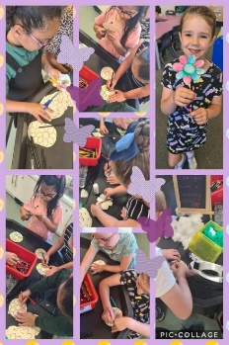

The named Governor for Additional Learning Needs is: Joe Redmond.

Some children have Additional Learning Needs (ALN) that can affect their progress in school.  Through careful observation and assessment, we can identify the difficulties and offer individual support.  In some cases we need to refer children to the Educational Psychologist or other agencies who will at some stage visit the school to see a child, evaluate their progress and offer the school support to help overcome their difficulties.  
 Parents and carers will be kept informed by the pupil's class teacher, Head teacher Mrs Thomas and Ms Williams the ALNCO (Additional Learning Needs Co-ordinator), who may invite you into school to discuss the situation.  We have a firm commitment to inclusive education and do everything we can to meet every child’s individual needs.

If a child requires Additional Learning Provision (ALP) which is different to their peers then an Individual Development Plan (IDP) will be developed. This plan will be formed following Personal Centred Meetings organised by the school. All professionals, parents and the child are invited to attend the meeting and share information and make decisions on next steps.

On occasions, after careful observation and testing, the Specialist Teacher or Educational Psychologist might recommend that a child has particular needs over and above that which the school can provide.  This simply means that the child could then be granted additional help either within their class at school, or in a special school or resource base, depending upon the child’s needs.  In these cases the Individual Development Plan (IDP) will be submitted to a panel in the Local Authority for them to consider and suggest/ offer ways forward. **Parents’ wishes at all time will be given strong consideration.**

There are links on the school website with further information for parents and pupils. 

Dr Laura Gates, the Educational Psychologist (EP), visits the school and gives advice to teachers and parents on how best to support children identified with ALN. **Please remember that we always want to work together with you, so that your children can achieve their full potential.**

**Report of her Majesty’s Inspectors (Estyn)**



Adamsdown was placed in to a category of ‘requiring significant improvement’ in May 2015. The Governing Body is pleased to say that in June 2016, when the Estyn team revisited the school was removed from this category:

* The head teacher has a clear vision for the school which all staff share.
* Leaders at all levels have clear roles and responsibilities that meet the needs of the school well in most respects.
* A greater number of staff now carry leadership roles, which contributes significantly to a more dynamic and collegiate approach to school improvement.
* Leaders work very well with one another, and this, together with effective communication across the school, has helped to develop a strong team ethos.
* The school has shown a commitment to improving all aspects of the post-inspection action plan.
* The Head teacher allocates resources appropriately towards meeting strategic goals.
* Senior and middle leaders monitor progress against school priorities regularly and effectively.
* This careful tracking, together with an improved use of pupils’ performance data, is helping leaders to become more strategic in their approaches.
* Through the various monitoring procedures, leaders hold staff appropriately to account.’

**School Improvement Plan**



All priorities have been identified by Senior Leaders and Governors as areas for focussed development across the year. Adamsdown Primary School aims to achieve and maintain high standards across all areas of school life.

We report on a termly basis to the Governing Body and also the School Improvement Officer who visits regularly.

**Priorities for 2021-2022**

**Priority 1: Continued implementation of the New Curriculum**

**Priority 2: To ensure that many pupils make accelerated progress in reading**

**Priority 3: To increase parental engagement with pupil’s learning**

**Equalities**

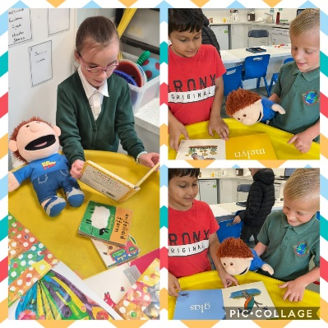

Our previous Race Equality Policy and Disability Equality Scheme has been replaced with a cohesive Single Equality Scheme covering all of the Equality Strands referred to as protected characteristics in the Equality Act 2010.

The protected characteristics include: Race, Disability, Gender, Sexual Orientation, Religion and Belief, Age, Gender Reassignment, Marriage and Civil Partnership, Pregnancy and Maternity.

**Disability**

We are an inclusive school and the Governing Body ensures action will be taken to ensure that disabled people are treated fairly and all reasonable adjustments will be made to give more favourable treatment where appropriate. The school has an Access Plan and a Disability Equality Plan.

**Community Links**

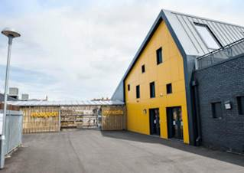

We have many community links which support our pupils in school for example:

* Cardiff City Football Club carry out weekly sessions for PE
* Rubicon Dance School join us every week to work with all classes across the year
* No Fit State Circus and Upbeat Music help us with creative projects
* Close links with many departments from Cardiff University and the University of South Wales
* We fundraise for national and local charities every term
* We utilize our great position of being one of the most central schools in the city with regular visits to the museum and castle!
* We have close links with the local police who support our work to ensure safe access to school and a safe working environment for all staff and children.

Our community links are co-ordinated by the teachers and links are made to the 4 core purposes of the new curriculum to ensure that all children have an opportunity to become:

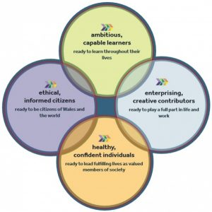

**Health and Safety**



The Governing Body works with the school staff to ensure all aspects of this important area are complied with in school. Health and safety is reviewed on a termly basis. If parents/guardians have any comments regarding Health & Safety, they are encouraged to pass them on to the Head teacher.

The local authority has made a commitment to all Cardiff schools to provide enhanced support through the services of Health and Safety Officers. Hazel Sweeney is assigned to Adamsdown and rapid work has commenced to ensure all outstanding maintenance from our buildings work and repairs are prioritised. Working with the Head teacher it is hoped that all major repair work will be completed by the end of the academic year.

**School Security Arrangements**



All visitors are to report to reception on arrival where they will sign in and be issued with a visitor’s badge. Access to the school is by key fob which is operated on all external doors. An emergency evacuation plan is in place. A colour CCTV is functional and used to maintain safety. All staff wear identity lanyards and also whistles so that if an emergency arises support can be called.

**Food and Healthy Eating in School**



In spring 2016 the school won the National Quality Award for healthy Schools. We have now renewed this aware twice and are regarded as a sector leading school in healthy schools’ education. We follow the Healthy Eating Agenda in school and the school kitchen serves food that is both nutritious and healthy, following the LA menu. Free milk is offered to all Foundation Phase children and chilled fresh water is freely available to all children. We run a Welsh Government Free School Breakfast Club that meets the requirements of the scheme. Approximately 100 children access this club.

**Toilet Facilities**



There are separate boys and girl’s toilet facilities for our Nursery pupils and our Reception, Year 1 and Year 2 pupils. There are also separate boys and girls toilet facilities for our Key Stage Two pupils.

All facilities are cleaned daily by the cleaning staff employed by the Local Authority.

**Sporting Achievements**

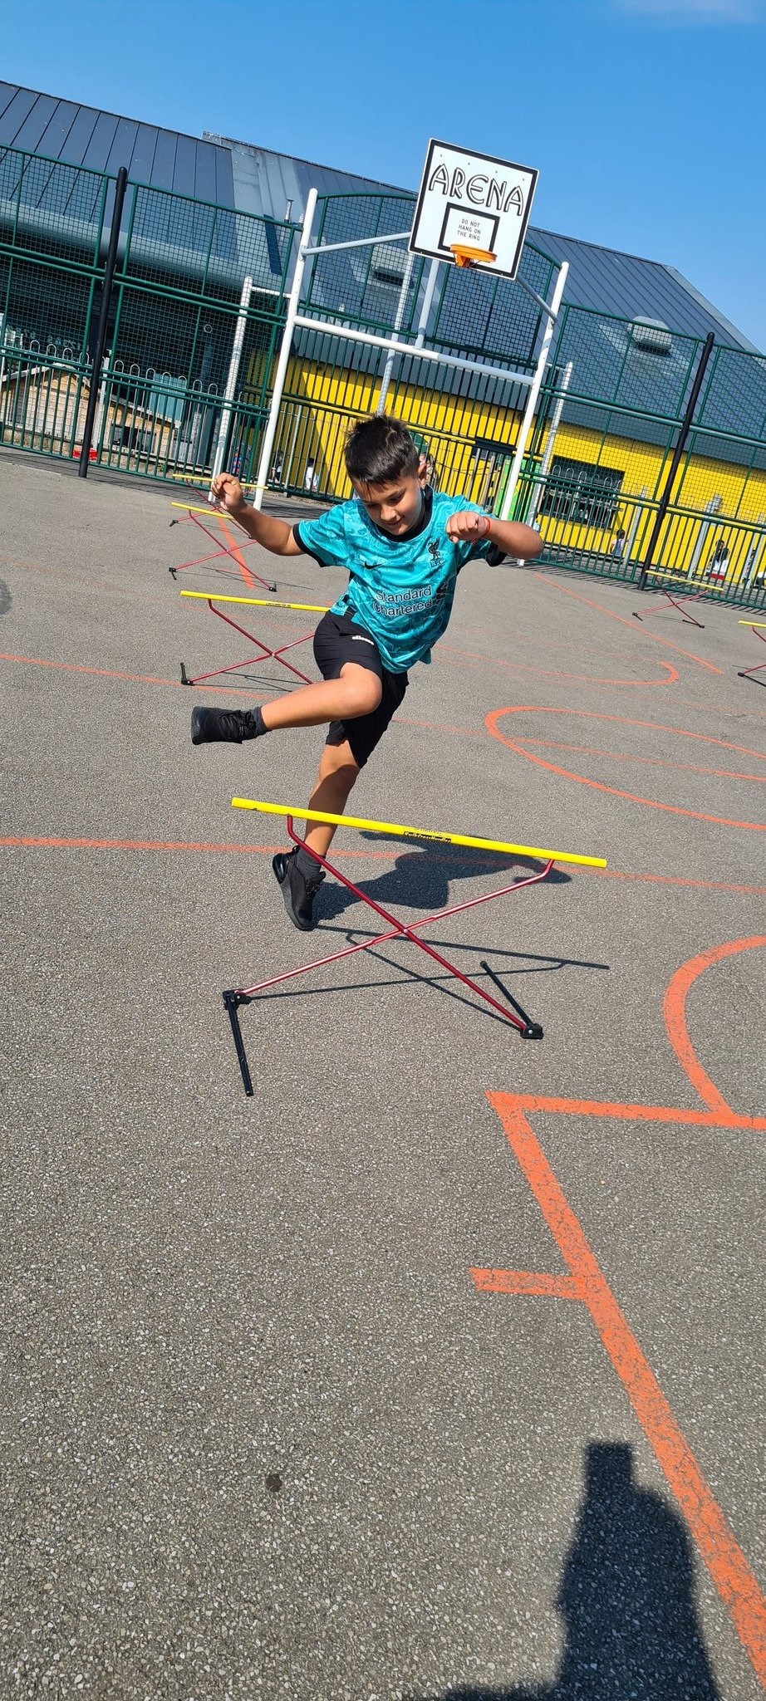

We aim to promote an understanding of the need for a healthy and active lifestyle. All children have P.E lessons each week where they do gymnastics, dance, games, athletics or outdoor activities. As part of the P.E curriculum there are four broad areas of experience:

• Health, fitness and well-being activities

• Creative activities

• Adventurous activities

• Competitive activities

To further develop our P.E we have close links with Rubicon Dance School and Cardiff City Football Club. We run a serious of after school clubs depending on the season. Your child will bring home letters about this at the time the clubs are due to run including football, rugby, street dance and netball.

**Award Winning**

**Only the 4th school in Cardiff to win the National Quality Award for healthy Schools**



**Bronze and now Silver Award winning school for recognising and celebrating children’s rights**

 

**We have won an award for the peer mediatoin programme run in our school and local cluster primary schools**



**We are a platinum award winning Eco School**



**We are a Bronze Cymraeg Campus school for learning Welsh**

[](https://forms.office.com/Pages/ResponsePage.aspx?id=Ug4_TzS3ZEGUCRtgHRR5kzS8Ugh-2_NErhNIB7uWahJUMkgyTTRITEVVOFVCUUkyMUFSWUFRRkNUSS4u)

**We are only the 2nd school in Cardiff to achieve the School of Sanctuary award**





**Our school vision is:**

**To nurture kind, respectful children who show ambition.**

**For all pupils to progress through a range of meaningful experiences enabling them to learn and apply the skills needed for a successful future.**

**Aim High, Be Kind, Show Respect**

**Adamsdown Primary School**

**System Street**

**Adamsdown**

**Cardiff**

**CF24 0JF**

**Tel: 02920493600**

**Email:** [**adamsdownprm@cardiff.gov.uk**](mailto:adamsdownprm@cardiff.gov.uk)

**Website:** [**www.adamsdownprm.cardiff.co.uk**](http://www.adamsdownprm.cardiff.co.uk)

**Twitter: @adamsdownprm**