Nursery Home Learning – Summer term Our topic is called ‘Are we there yet?’ It’s all about transport and journeys.
Maths  Practise recognising numbers 0-5 moving on to 0 to 10 when your child is ready.  Learn the 2D shapes -Circle, Triangle and rectangle. Find objects around your home that are these shapes  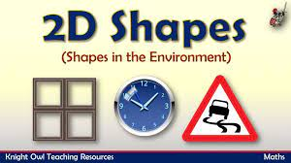  Shapes song for kids | The Singing Walrus - YouTube | Home Learning  The website below has numerous lovely activities to do with Nursery & Reception aged children at home.  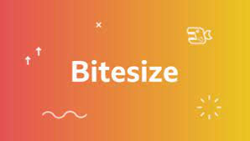  Early years resources for learning at home - BBC Bitesize | Floating and Sinking  Can you find some objects around your home that might float or sink?  Try them out in the bath or in a bowl of water.  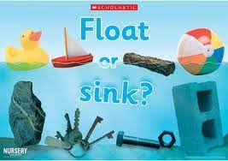
Creative  Can you make a vehicle out of recycled packaging?  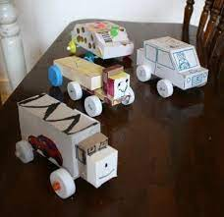  Let’s sing!  Transport themed songs - Five Little Men in a Flying Saucer. The wheels on the bus, Row , Row, Row, your boat, The Big Ship Sails, Down at the station  Nursery Rhymes and Songs - A to Z - BBC Teach | Feelings  We have been learning to talk about our feelings and also understand how other people might be feeling.  Learn the welsh song all about feelings  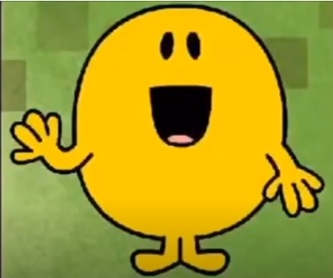  Mr Hapus ydwi i  ttps://www.youtube.com/watch?v=lGozXPt9M-Y | Story Time  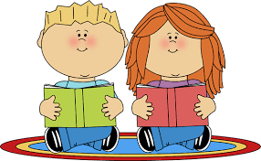  Our Stories for this half term are  TheTrain Ride  Mr Gumpy’s Outing  The Journey  Cars, and Trucks and Things That Go  or  Choose a story from the link below to listen to with your child  Story Time - Stories for kids - CBeebies - BBC

