Nursery Home Learning

Week Beginning 30.11.20

Language, Literacy & Communication  Our Story this week is  ‘That’s not My Reindeer’.  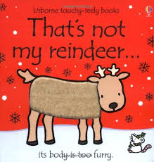 | Maths and Numeracy  Continue to practice recognising and writing the numbers 0, 1, and 2. Introduce number 3  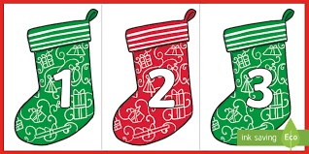  Find 3’s of different objects. E.g. 3 cars, 3 cups etc
Expressive Arts  Can you learn the song  ‘Rudolph the Red Nosed Reindeer’  Rudolph the Red Nosed Reindeer | Christmas Song For Kids | Merry Christmas - YouTube | Maths & Numeracy  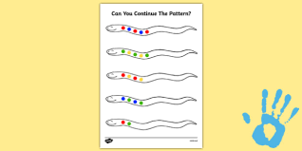  Can you copy a 2 colour pattern?

Health & Wellbeing  Join with Cosmic kids yoga Christmas special    Christmas Special | A Cosmic Kids Yoga Adventure! - YouTube | Science and Technology  Find out about reindeers in andy’s Secret Hideout - Reindeers    CBeebies | Andy's Secret Hideout | Reindeer - YouTube

