Nursery Home Learning- week beginning 23.02.21

On March the 1st it is St David’s Day. Here are a few tasks you can do at home to help celebrate. Please send us some pictures on email or via Twitter to show us what you do..

St David’s Day  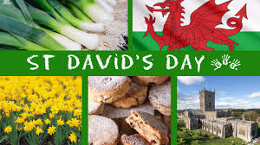  Watch the video below to see how St David’s Day is celebrated.  https://www.youtube.com/watch?v=awy4whEQt4A  This year it will be celebrated differently but people will still wear red and wear welsh symbols (daffodils and leeks). They will also eat traditional Welsh food.  What do you think is the best part about the celebrations? | Arts and Crafts  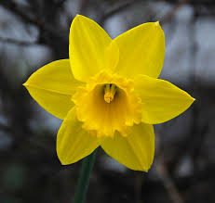  Can you make a daffodil?  You can make a model from recycled materials or even paint a picture.  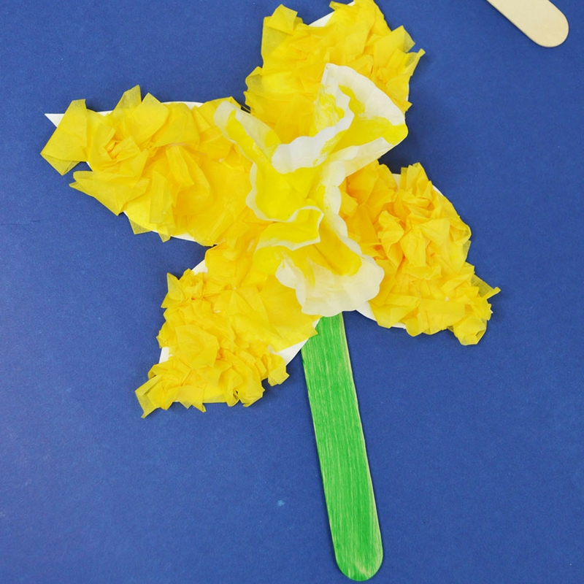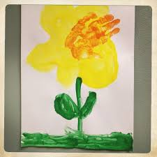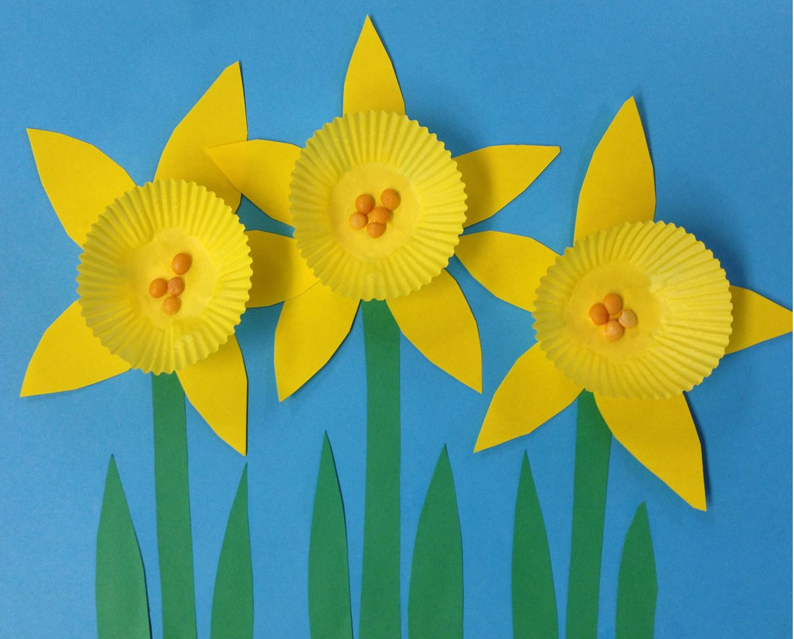 | Cooking  Can you make some traditional Welsh food?  Below are some links to some delicious recipes you could try:  Vegetable Cawl  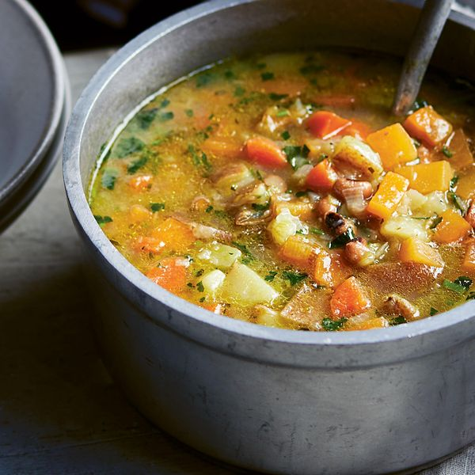  https://thehappyfoodie.co.uk/recipes/cawl  Welsh cakes  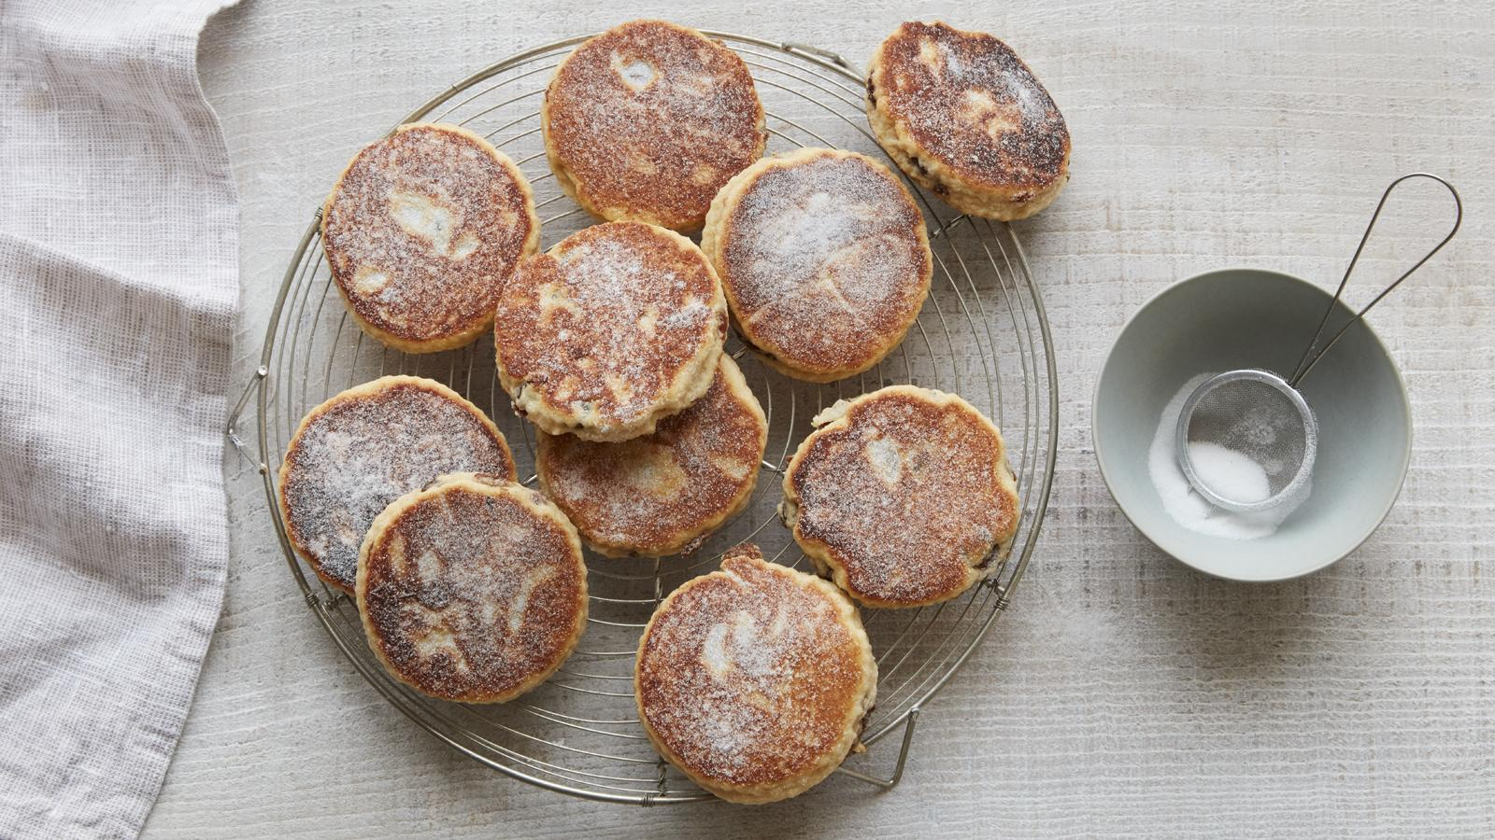  https://www.bbc.co.uk/food/recipes/welshcakes_6726
Number  Enjoy counting, recognising and sequencing numbers with these lovely fun games  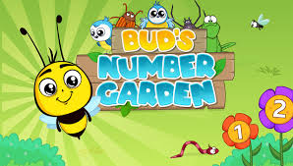  [IVOR] Bud's Number Garden (bbc.co.uk) | Planting  Can you grow an egg cress head?  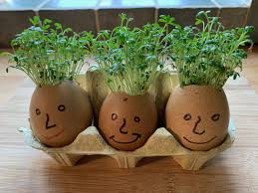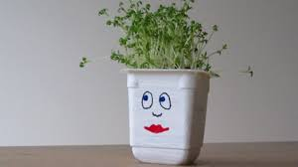 | Storytime  Jez Alborough Reads Six Little Chicks - YouTube