Nursery Home Learning

Week Beginning 16.11.20

Language, Literacy & Communication  Our Story this week is ‘Dear Zoo’.  If you have a copy of the book at home read the story together.  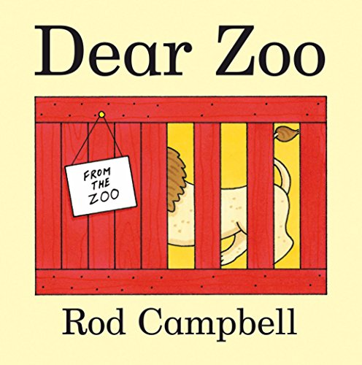  If not Watch Justin Fletcher read the story on cbeebies bedtime stories  https://m.youtube.com/watch?v=A9Jr4jO0P9c | Maths and Numeracy  Continue to practice recognising and writing the numbers 0, 1, and 2. Introduce number 3    Find 3’s of different objects. E.g. 3 cars, 3 cups etc
Expressive Arts  Our story this week is ‘Dear Zoo’  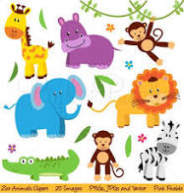  Can you draw a picture or do a painting of your favourite animal? | Maths & Numeracy  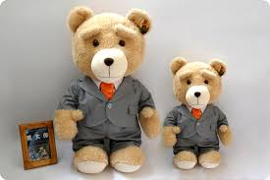  Can you find some big and small objects in your house?  Can you draw a picture of a big and small bear?

Health & Wellbeing  Join with Cbeebies Andy’s Wild workouts African Savannah  https://m.youtube.com/watch?v=40RvOOVgCv8 | Please don’t forget to tweet us any pictures!    @AdamsdownNur

