Nursery Home Learning Week Beginning 01.11.20

Story Time  Can you watch the  Cbeebies bedtime story with someone from your family every evening?  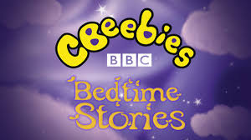  At the end of the week let me know which was your favourite story and why? | Maths and Numeracy  Can you recognise any of the numbers on a clock?  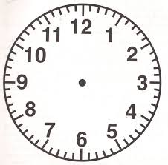  What time do you go to bed? | Health & Wellbeing  Try one of the cosmic kids yoga for bedtimes. There are a few different ones to choose from  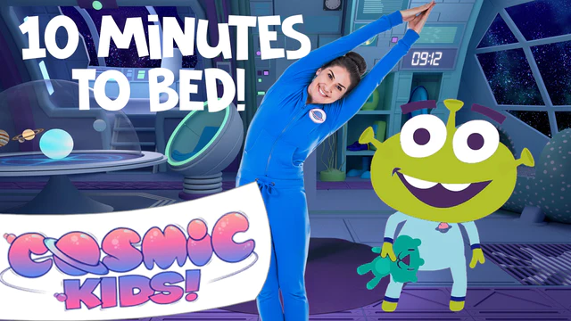  Bedtime Kids Yoga with Bop the Alien (app preview) | Cosmic Kids - YouTube | Bedtime Routines  Can you tell me about your bedtime routine?  If you have a printer you can print the bedtime routine cards and put them in your order.  Or, even better find some objects from around your house and take a photo of the order you do things. For example-  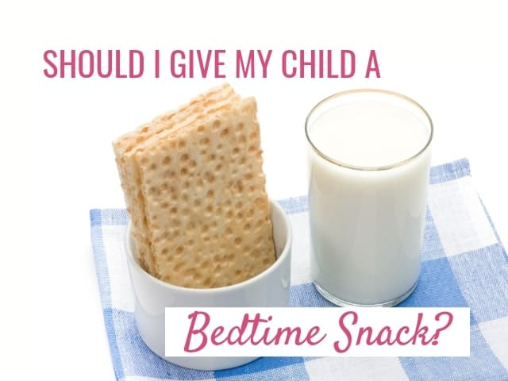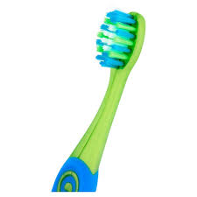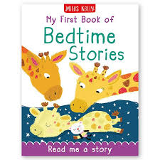
Creative  Do you have a favourite toy you take to bed?  Do they have a name?  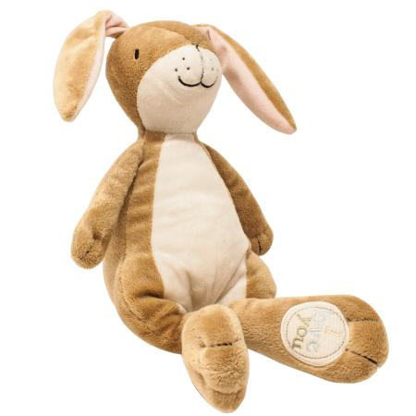  Can you draw a picture of your toy? | Exercise  It’s hard to get to sleep when we are stuck at home all the time!  Try to get some exercise  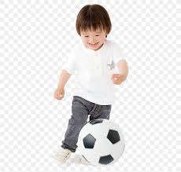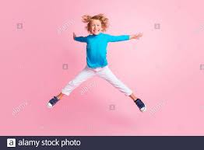  Look on the activity cards for some ideas  Can you make up some of your own? | Mark making  Can you practice writing the  first letter of your name?  Try to spot this letter 10 times in other places around your home  eg. books or magazines, food packaging etc.   | Please tweet or email me any work that you do!   Thank you!  See the table below for activities you could try every day.

Things that you can do everyday with your child throughout the day:
Exercise time    It’s really important to keep our bodies moving while we are at home.  Can you choose a different workout video to complete everyday? Click on one of the links below.  CBeebies - Andy's Wild Workouts (bbc.co.uk)  Cosmic Kids Yoga - YouTube | Reading    Oxford Owl for Home: help your child learn at home | Oxford Owl  Story Time - Stories for kids - CBeebies - BBC | Numbers  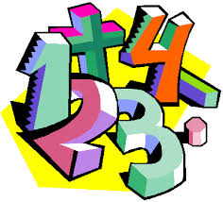  Learn to Count up to 10 with Underwater Counting Maths Game (topmarks.co.uk  Shape Monsters - 2D Shapes Matching Game (topmarks.co.uk)  Ladybird Spots - Counting, Matching and Ordering game (topmarks.co.uk) | Sing along  Sing some of our favourite songs from class with your family.  Let's Count up to Ten - Counting Song - YouTube counting to 10 forwards and backwards  https://www.youtube.com/watch?v=cSPmGPIyykU - exercise and rhyme  https://www.youtube.com/watch?v=u4_L7CM46M4 - 5 little fish  https://www.youtube.com/watch?v=L3DW45WIXgY - pwy wyt ti?  https://www.youtube.com/watch?v=OEbRDtCAFdU - 2D shape song

Early years resources for learning at home - BBC Bitesize - website with links to every subject and lessons.

