Nursery Home Learning

Week Beginning 05.01.21

Language, Literacy & Communication  Our story this week is  ‘The Colour monster’.  It is a story about feelings  Click on the link below  The Colour Monster - Read by Sherry - YouTube | Maths and Numeracy  Continue to practice recognising and writing the numbers 0, 1, and 2. Introduce number 3  Find 3’s of different objects. E.g. 3 cars, 3 cups etc
Expressive Arts  Can you draw a picture of a colour monster? It doesn’t need to look the same as the one in the story, you could make up your own  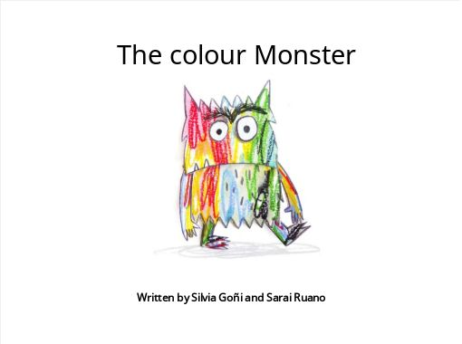 | Physical Development  Go out for a walk and do a scavenger hunt.  See if you can spot something for each of the colours from the colour monster.    When you go out for a walk practise putting your coat on by yourself. Can you do up the zip?

Health & Wellbeing  Join with Cosmic kids yoga  Winter Wonderland  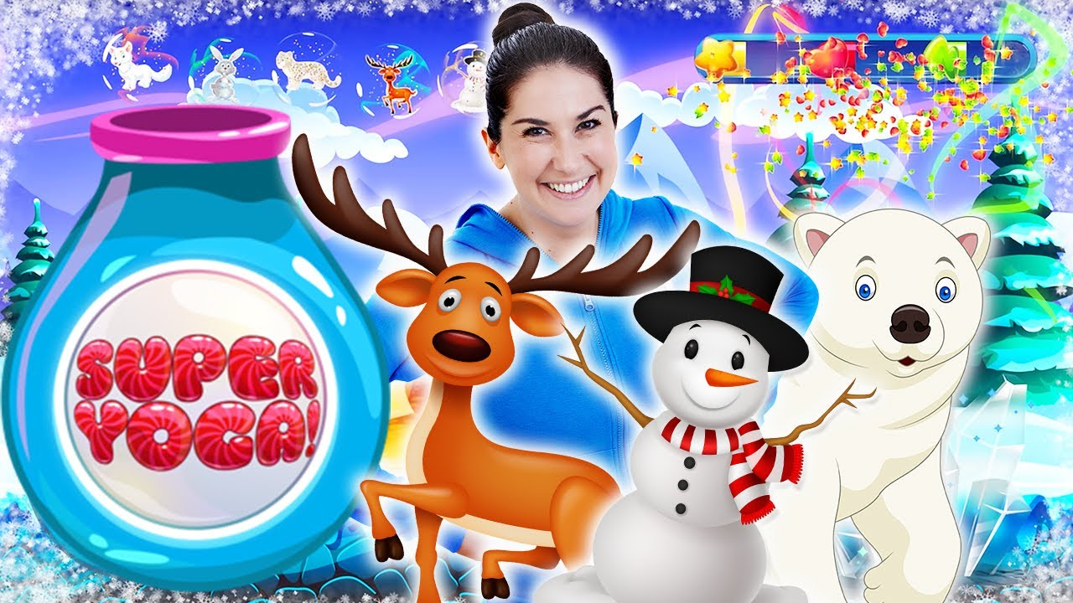  Click on the link below  Winter Wonderland (Super Yoga) | Cosmic Kids - YouTube | Health & Wellbeing  The ‘Colour Monster’ was yellow, blue, red, black and green  Can you make a healthy snack using some of these coloured foods?  