This homework has been split into Year 1 and Year 2 activities to support you at home as you work with your child. I have tried to indicate as much as possible what skills are expected throughout the activities. Feel free to attempt any activities to match the ability of your child.

Spellings

Practise your high frequency words to help your reading and writing by recognising the sighties (year 1 children)

<https://www.teachyourmonstertoread.com/teachers-area/classroom-toolkit/high-frequency-sight-words>

Play the tricky word game to help your reading and writing (year 2 children)

<https://www.phonicsbloom.com/uk/game/list/phonics-games-phase-5>

Phonics

Work your way through the phase 3 sounds (year 1 children)

<https://www.bbc.co.uk/bitesize/topics/zvq9bdm>

Work your way through the grid to practise the difference digraphs needed to help your reading and writing (year 2 children)

<https://www.ictgames.com/mobilePage/tellATRex/index.html>

Reading

<https://www.bbc.co.uk/newsround> use this link to read or hear about what is happening in the news.

Join Oxford Owl to access lots of free reading material

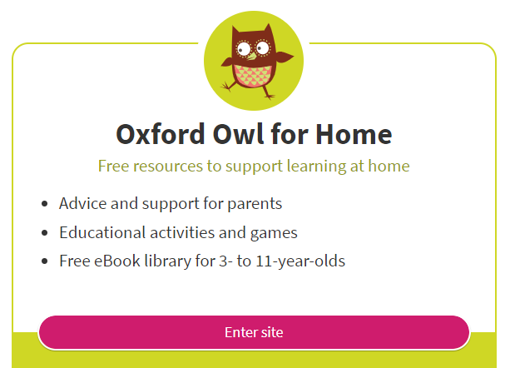

Read a book at home.

Answer these questions, you could record your answers.

What happened?

Who are the characters in the story?

Where is the story set?

What happened in the beginning?

How did the story end?

How did the story make you feel?

What was your favourite part?

Draw a picture about your favourite part of the story.

Writing

Year 1 - draw a story map with beginning, middle and end.

Write about your pictures using capital letters and full stops. Can you include describing words to make your story more exciting.

You might start it like this.

*A long time ago, there lived a very kind knight. He lived with his mum and dad in a giant castle...*

Year 2 - Write a story about a dragon, princess, knights etc

Draw a story map to help think of your ideas.

Can you start your story in an interesting way? Include ordering words next, then, later on, after, soon, in the end.Make it more exciting by adding adjectives, similes, 2A sentences. Use capital letters and full stops.

*Many, many years ago, there lived a very friendly, helpful princess who loved helping people. She lived in a huge, stone castle with her very kind,loving parents…*

*Use pairs of 2A sentences to improve your writing.*

Complete writing using google docs and then you can share your stories with me so that I can suggest ways to improve it.

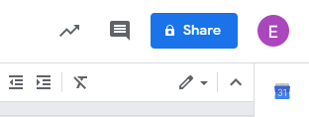

The share tab is in the top right hand side of google docs. My hwb account is [TurnerE42@hwbcymr](mailto:TurnerE42@hwbcymru.net)u.net

English activities

<https://www.bbc.co.uk/games/embed/small-town-superheroes?exitGameUrl=http%3A%2F%2Fbbc.co.uk%2Fbitesize%2Farticles%2Fzncgvk7>

Help the superhero’s.

Click on punctuation.

Year 1 - Capital letters, full stops,

Year 2 - capital letters, full stops, question marks, exclamation marks, commas then all punctuation.

Click on sentences

Choose between easy and hard.

Use your hub account and choose JIT to write your own story and draw a picture to match it.

Make a google slides presentation on a hobby. Add slides, add a title, find pictures, include information about your hobby.

Maths

Year 1 children - focus on numbers between 1-20

Year 2 children - focus on numbers up to 100 and beyond

If you find the activities too easy, challenge yourself.

Recap tens and units using <https://www.bbc.co.uk/bitesize/topics/z8sfr82/articles/zw4g2nb>

Choose a number challenge

<https://www.topmarks.co.uk/learning-to-count/blast-off>

Develop your place value skills, learn about tens and units

<https://www.topmarks.co.uk/learning-to-count/place-value-basketball>

Play these one more, one less games

<https://www.topmarks.co.uk/learning-to-count/chopper-squad>

Choose between the add, subtract, multiply and divide games

<https://www.topmarks.co.uk/maths-games/mental-maths-train>

Time/ clocks

Year 1 - make o’clock with the clock face and digital clock

Year 2 - make o’clock, quarter past, half past and quarter to on both clocks

<https://www.topmarks.co.uk/time/teaching-clock>

Money

Year 1 - pay for items up to 20p and give change

Year 2 - pay for items up to £1.00 and give change

<https://www.topmarks.co.uk/money/toy-shop-money>

Practise your times tables

Year 1 - 2x, 5x, 10x

Year 2 - 2x, 3x, 4x, 5x, 10x

Data Handling

Use your hub account to create a block graph, pictogram. Collect your data and then make your chart. Can you make a tally chart?

<https://www.softschools.com/math/data_analysis/tally_chart/> play the tally chart game to answer the questions. A grown up might need to help you read the questions.

Use your hub account to make the turtle move. Make sure you put the pen to program the sprite. Can you use the words clockwise and anti-clockwise to write about where the sprite went.

Welsh as a second language

Use <https://www.bbc.co.uk/bitesize/subjects/zqsv7p3> to watch the videos to help you use your welsh at home.

Science

Learn about light and sound.

<https://www.bbc.co.uk/bitesize/topics/z3hhvcw>

Draw and make a list of all the light sources and sound sources in your home.

Think about outside, what light source and sound sources can you think of?

<https://www.bbc.co.uk/bitesize/topics/zkvv4wx/articles/zcx3gk7>

Find out more about the seasons. Draw the 4 seasons and match to the months. Draw pictures to match the seasons.

ICT

Here is a list of all the children in your class and their hwb addresses.

Send them emails using microsoft365. Ensure you type the correct hwb address. You can communicate with your friends while we are not in school.

Remember, be kind and see how many new things you can find out about them.