Just2easy Guide (1) – Lower Team

We have made this document to help you support your child with their home learning. If you have any questions, please email or speak to your teacher next time she calls.

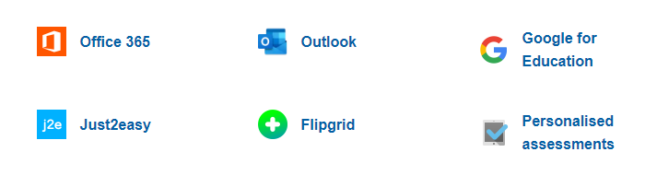

Log in to your hwb account

and click on just2easy.

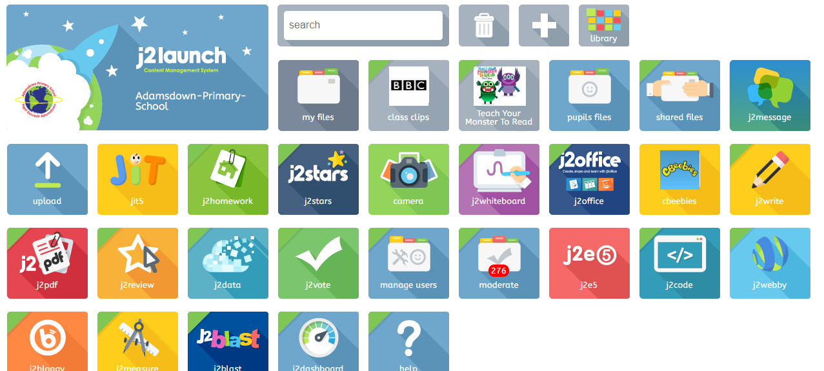

Each tile in just2easy allows you to do different things.

This tile contains, write, paint, turtle, chart, pictogram. Animate, branch. Mix.

The children are familiar with using these in school.

This tile is where teachers can reward children for all their home learning.

Choose your class and see how many j2stars you have. You can check this whenever you like.



This tile allows the teacher and children to chat safely online. You can ask questions and or chat to your friends in your class.

This tile allows the children to see what work they have completed on just2easy and the teacher to give feedback. Look out for red speech marks, the children can then respond to the teacher.

This tile allows you to upload work that you have completed at home, it could be a photo, piece of artwork, video. This is another way to communicate with us.

Please try out these features with your child to support their home learning.

Diolch

Lower Team teachers 😊