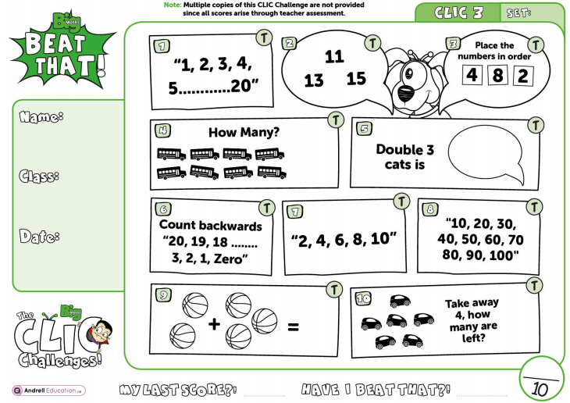The ‘T’ on each questions means ‘Talk’ q1=count to 20 q2=read the numbers q7=count in 2s q8=count in 10s

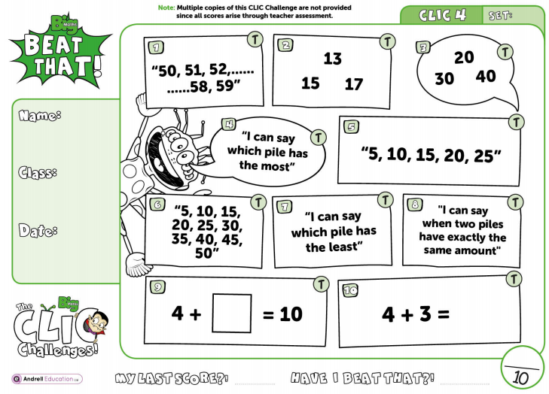The ‘T’ on each questions means ‘Talk’ q1=count from 50-60 q2=read the numbers q3=read the numbers q4=make piles of something. Q5=count in 5s q6=count in 5s

The ‘T’ on each questions means ‘Talk’ q1=read the numbers q2=read the question q3=read the numbers q4=write a 2 digit number and ask what is the value of each digit. Q5=double 10, double 20, double 30, double 40 q7= write 3 + 4 = 7, child needs to write the other facts (2 add, 2 subtract) q8=read the numbers

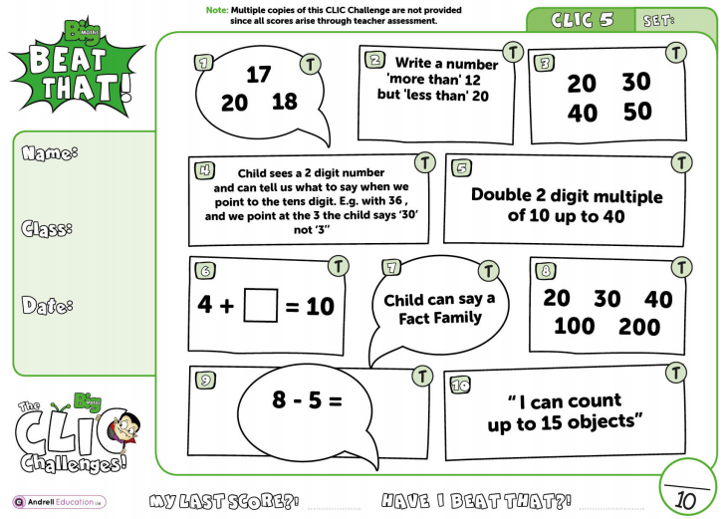

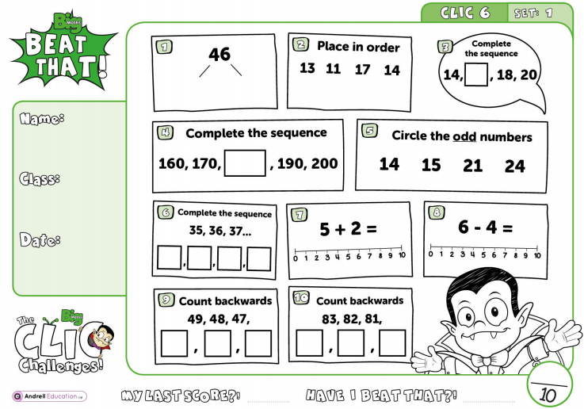Children completely independently from here.

