30.03.20 I have put activities into a daily table to make it easier to access. Do as much as you able and don’t stress if you don’t complete all the activities. I will try and add more fun activities on twitter. Miss Chichester 😊

|  |  |  |  |  |
| --- | --- | --- | --- | --- |
| Monday | Tuesday | Wednesday | Thursday | Friday |
| Practise your handwriting.  Look at the next page to correctly form each letter. These posters show children how to form each letter and their starting place.  Practise your key words. Look at the lists below and see which words the children need to practise to read and write independently. | Use [www.phonicsplay.co.uk](http://www.phonicsplay.co.uk) username: march20 password: home  Spidey group – recap and learn phase 3 phonics  Pluto group – phase 4 phonic  Super group – recap phase 5 phonics  These are either digraphs (2 letters that a sound, or trigraphs, 3 letters that make a sound)  The children know which groups they are in. Play a few games. | Sentence starter  I found a trapdoor under the sofa. So I went inside…  Write a story about what happened next. Remember finger spaces, capital letters and full stops | Write a poem about Spring. You could use the letters of SPRING to help you write the sentences. Can you add adjectives or similes to make the sentences better?  OR make a collage of pictures about Spring and write sentences about your images or drawings. Don’t forget capital letters and full stops. | Choose a new book to read from Oxford Owl website. Write sentences about what happened. Draw a pictures of your favourite part and write about it. |
| Using JIT, create a pictogram of favourite pets  This is your data  cats III  fish IIII  dogs IIII III  hamster I  rabbit IIII  Can you find your own pictures? | Reading and writing numbers  Make your own 100 square like this | Ordering Numbers  Challenge – now use bigger numbers! | Practise your learn its! All children need to know these number facts by quick recall.  Make a poster, play games, make flashcards, any way to learn the facts quickly without counting on their fingers. | Learn about halves    Make halves, draw or paint food to cut in half. Find half of a number  Half of 2  Half of 4  What is the biggest half you can find? |
| Make a crafty toilet roll like this… | Visit Edinburgh zoo website and go on a virtual tour. Write about the animals you saw and describe them. | Complete a lego daily challenge and write about what you did.  Tweet a picture of what you make. | Make or paint a rainbow for your window as a sign of hope for anybody passing by. | What’s in your house?  Find 5 things in you house. What are they made from? Can you name their properties? Hard, soft etc |

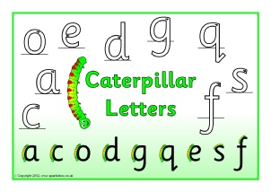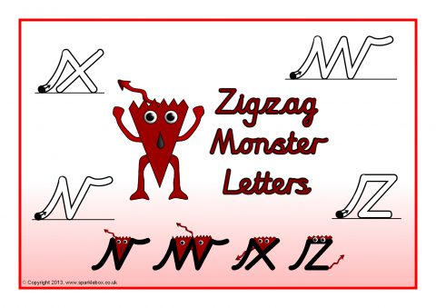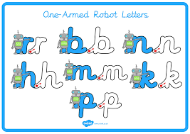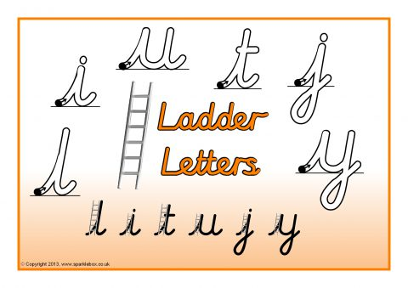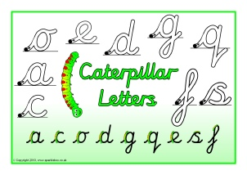 Step 1 - Ensure children can form all of these letters correctly in the correct starting place.

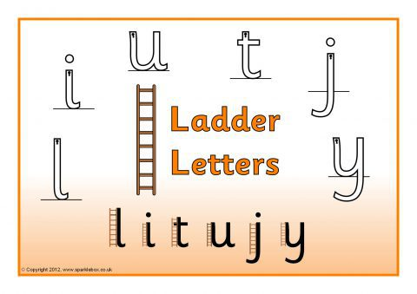

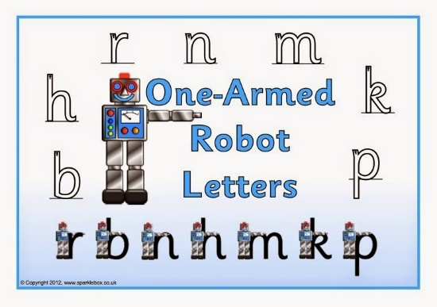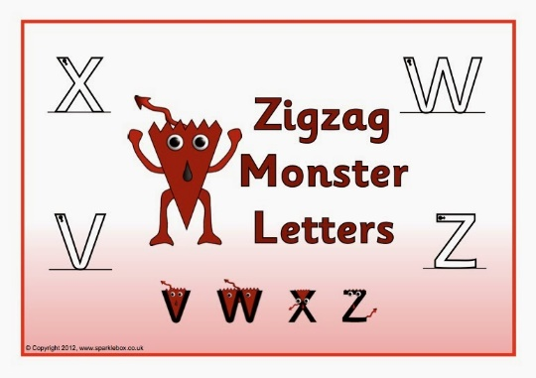

Step 2 – Only start joining letters together, once children can correctly form all their single letters correctly.