20.04.20 Complete as much as you can and don’t forget to check google classroom for more activities online. Hope you are all safe and well.

Miss Chichester 😊

|  |  |  |  |  |
| --- | --- | --- | --- | --- |
| Monday | Tuesday | Wednesday | Thursday | Friday |
| Practise your handwriting.  Copy out the poem ‘The Easter Bunny’ on the next page.  Make sure you form each letter correctly.  Look at the 100 HFW lists in the resource section of my class page. Practise the words the children are unable to read to spell to help with their reading and writing. | Use [www.phonicsplay.co.uk](http://www.phonicsplay.co.uk) username: march20 password: home  Spidey group – recap and learn phase 3 phonics  Pluto group – phase 4 phonic  Super group – recap phase 5 phonics  These are either digraphs (2 letters that a sound, or trigraphs, 3 letters that make a sound)  The children know which groups they are in.  Play a few games. | Sentence starter  A rabbit just appeared in my garden….  Write a story with a beginning, middle and an end.  Remember finger spaces, capital letters and full stops.  Can you include describing words, similes and different ways to start a sentence (see next page for ideas) | Choose a new book to read from Oxford Owl website.  Write a book review, answer these questions.  What was the book about?  What did you like about it?  What was your favourite part? Why?  Describe your favourite character.  How did the book make you feel? Why?  Star rating ___/10 | Create an Easter egg with a repeated pattern or using a line of symmetry = same on each side. |
| Make a chick using your handprints. | Play an Easter egg maths hunt.   1. Cut egg shapes and write numbers on them. 2. Hide them around room. 3. Children to find 2 or 3 at a time. 4. Add numbers together. 5. Re-hide, repeat.   How many different combinations can you add together. | Practise your measuring skills using centimetres (cm)  <https://www.topmarks.co.uk/maths-games/measuring-in-cm>  Look for things to measure around the house. Can you put them in order from the shortest to the longest?  Use the same lego bricks if you don’t have a ruler at home. | Draw or paint a spring flower picture. Look at images on the internet for inspiration. How many different flowers can you paint? | Big Maths  CLIC test, Learn its and Safe tests are in the resources section of my class page. |
| Well being  Talk about something you are proud of and share with me on twitter/google classroom if you can. | Wellbeing  Listen to your favourite songs, dance, sing or rock out! Have some fun. | Wellbeing  Write down any worries or negative thoughts you may have and rip them up and throw in the bin! | Wellbeing  Get some fresh air safely. What can you hear? Go on a sound walk. Make a list of the sounds you hear. | Wellbeing  Have an egg and spoon race with someone in your house or complete a fun obstacle course |

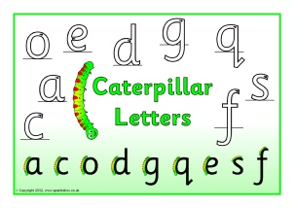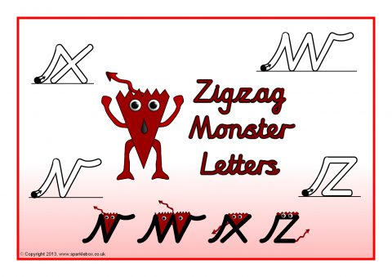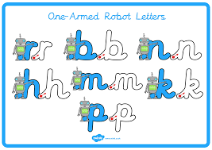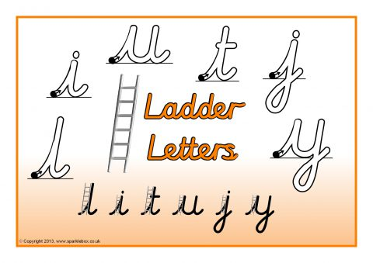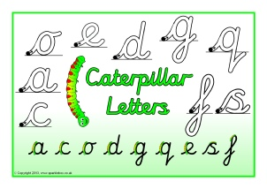 Step 1 - Ensure children can form all of these letters correctly in the correct starting place.

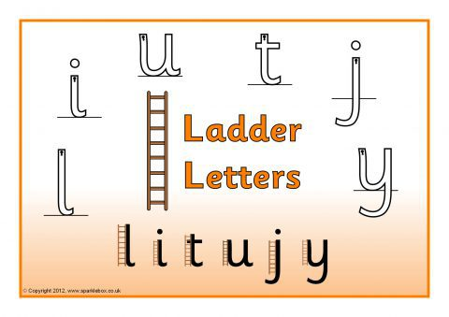

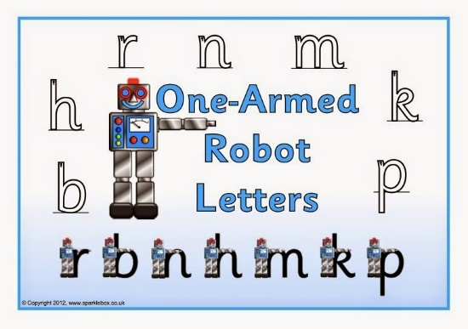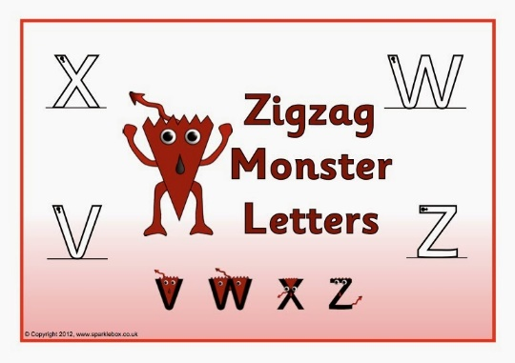

Step 2 – Only start joining letters together, once children can correctly form all their single letters correctly.

Handwriting Practise Ideas to support children when writing a story

