18.05.20 This week we will be reading Dear Greenpeace. You are all doing an amazing job and I love seeing all the things you are learning and making at home. Hopefully the issue with emails has now been resolved so if you would like to send me an email, use google classroom to do this. My hwb account and details are all there. Next week 25.05.20 is half term so there will be no activities set. Miss Chichester 😊

|  |  |  |  |  |
| --- | --- | --- | --- | --- |
| Monday | Tuesday | Wednesday | Thursday | Friday |
| English  Practise your handwriting.  Read the ‘The Whale Watch’ and then copy it for handwriting this week.  Remember to form all letters in the correct place.  Practise your phonics  Year 1 children – 2 letters that make a sound ‘oa’ as in ‘goat’  Year 2 children – split digraph  i_e The ‘e’ at the end of the word make the vowel ‘i’ change from it’s sound to it’s name as in dice.  Stretch  Find things in your house that have these sounds in them, take pictures, draw them or write a list.  Some sounds will be harder than others. | English  Asking open questions  Listen to the story Dear Greenpeace  <https://www.youtube.com/watch?v=IJbEtAthaPk>  We can ask 2 kinds of questions, open and closed questions.  Closed questions = 1 word answers  Do you like apples? Yes  Open questions = allow the person to answer in more detail  Why did you jump into the pool? It was hot and I love water.    Can you think of your own questions to ask the whales?  Use question words  What How  When Why  Where Which | English  Letter comprehension  Letters need to set out in the correct way.  Look at the letter at the bottom of the page and find the answers to these questions.  What is the address?  Who is the letter to?  Can you find 2 words to describe the bear in the letter?  When is the bear’s birthday?  What food will be at his party?  Why do you think he is lonely?  Stretch  Can you write a reply to the bear? | English  Planning your letter  When you write a letter, it is good to organise your writing into sections  Use this plan to help you think about your letter for Friday.   |  | | --- | | Address | | Who is your letter to? | | 1st section  arts and crafts | | 2nd section  cooking | | Who is your letter from? |   *you could write about family, hobbies, sports, toys, whatever you like to  Stretch  Include more sections for your writing. | Creative writing  Writing your letter  Look at the features of a letter.  Can you write a letter to someone in your family or Miss Chichester?  **WAGOLL (What a good one looks like)**  Your address in the correct place  Who it is to?  Information about yourself and what you have been doing  Questions to the person you are writing to  Who it is from?  Stretch  Include lots of open ended questions  Include paragraphs to organise your letter  Type your letter and send it! |

|  |  |  |  |  |
| --- | --- | --- | --- | --- |
| Maths  This week we can focusing on data handling | | Maths  Pictograms  <http://toytheater.com/fishing/>  Catch the fish with the fishing rod and then answer the questions about the fish you have caught.  Watch out for the jellyfish! | Maths  Tally chart game  <https://www.softschools.com/math/data_analysis/tally_chart/>  Stretch  Make your own tally chart on items in the fridge or tins in the cupboard or toys in your bedroom | Maths  Tables and charts  Click on the 2 links, watch the videos and then complete the online activities  <https://www.bbc.co.uk/bitesize/topics/zg6tyrd/articles/zgg9pbk>  <https://www.bbc.co.uk/bitesize/topics/zv2mn39/articles/z3c2gdm>  Stretch  If you have the resources try and make your own chart from one you have completed this week. |
| Knowledge and Understanding  When thinking about our world, we can sort them into natural features (that come from the ground) or man-made features (made in a factory by humans) Can you sort these features into natural and man made? You can draw/write or find your own pictures and complete using your hwb account. | Creative Development  Look at photographs of different whales and choose one you like, you may choose a humpback, blue, beluga and sketch it from the photographs.  Remember when you sketch you press lightly with your pencil and don’t need to use a rubber. Draw the shape until you are happy with your whale.  This video shows you how to sketch correctly.  <https://www.youtube.com/watch?v=SlToLklthes> | Knowledge and Understanding  <https://www.youtube.com/watch?v=7k8CcAU2Lt0>  Watch the video about endangered animals and choose an endangered animal to make a fact file about.  Use these headings  Name  Description  Habitat  Eats  Special feature  Why is it endangered?  OR  find out what endangered means and make a list of animals you think are endangered in our world. | Personal and Social Development  #article12 you have the right to be listened to  Can you complete the survey to let the children’s commissioner your opinions about how she can help at this time.  <https://www.childcomwales.org.uk/coronavirusandme/>  There is an option to take the survey with pictures to help with reading, choose the 2nd options.  Please try and complete with your child | Personal and Social Development  Today is international endangered species day!  <https://www.nwf.org/~/media/PDFs/Be%20Out%20There/National-Wildlife-Week/2011/Wonderful-Whales-K-4.pdf>  Using this link, choose an activity about whales  OR  choose an endangered animal and make a poster to tell people why it is important to take care of endangered animals. what will happen if we don’t help endangered animals? |
| Wellbeing  Try a Joe Wicks daily workout | Wellbeing  Try some cosmic yoga  <https://www.youtube.com/user/CosmicKidsYoga> | Wellbeing  Why not try a dance lesson with Oti Mabuse on youtube or facebook. | Wellbeing  Try out a dough disco with Shonette Bason Wood on twitter or youtube. | Wellbeing  Start the day with some exercises on cbeebies  <https://www.bbc.co.uk/cbeebies/grownups/fun-exercises-to-do-at-home-with-kids> |

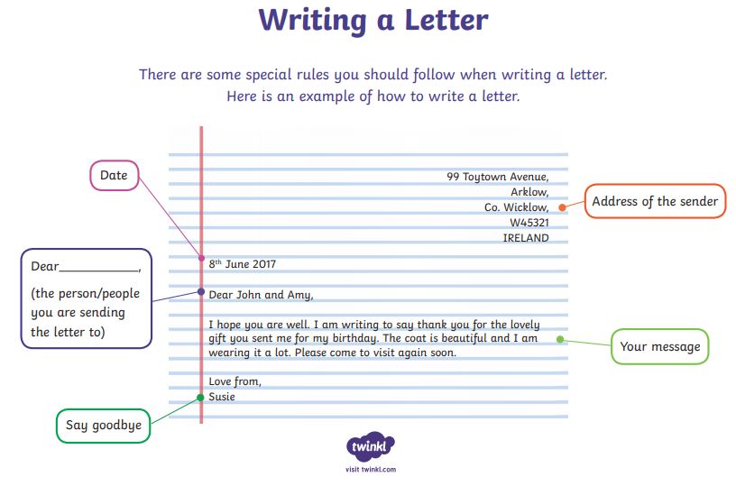

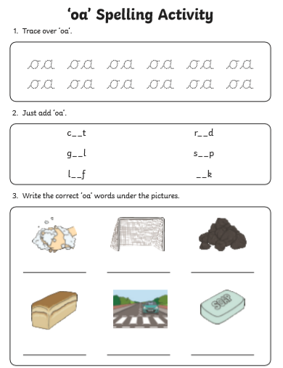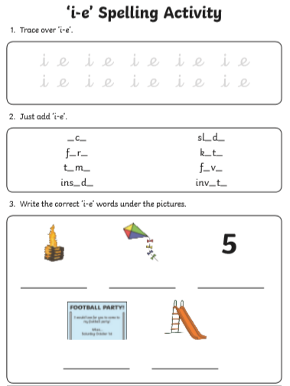

The Whale Watch for handwriting Letter comprehension 