13.07.20 This is the last week of school before the summer holidays. I have added on the other page a little momento for the children to keep in this extraordinary year of lockdown. I have loved teaching your children and wished we had had the whole year together. They are great little characters and wish them every success for the future. Relax, rest and enjoy the summer holidays and keep in touch.
Miss Chichester 😊

Monday | Tuesday | Wednesday | Thursday | Friday
English  Practise your handwriting.  Read the ‘When I Grow Upl’ and then copy it for handwriting this week.  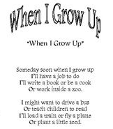  You can also practice spellings in the j2blast tile in just2easy using their hub account. | English  https://www.youtube.com/watch?v=mOIS3wOGroI  Listen to the story of When I Grow Up by Tim Minchin.  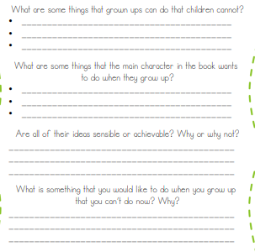 | English  Alliteration is when you use words that begin with the same sound.  A fighting fit firefighter.  A beautiful, bouncy ballet dancer.  A rocking rock star!  Can you use alliteration to think of different jobs you COULD be when you grow up?  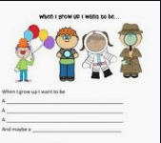 | English  Can you complete these sentences and fill in the missing word?  Can you complete these sentences in just2easy?  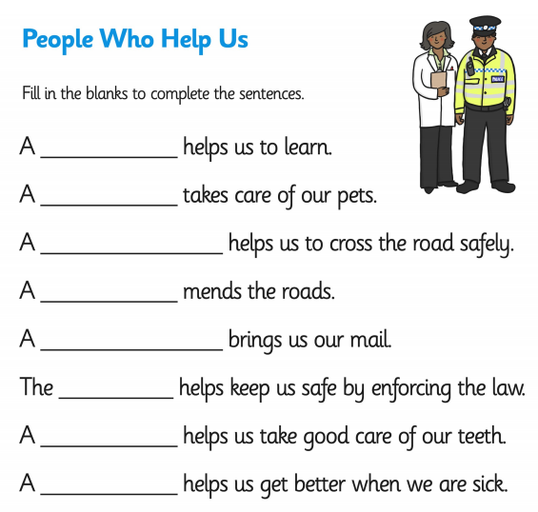 | Creative writing  Write your best ever story!  Can you complete it using write on just2easy?
Maths  This week we are looking at number patterns and sequences.  https://www.bbc.co.uk/bitesize/topics/znj7hyc/articles/zkwkpg8  use this bbc bitesize clip to show you how to work a number pattern and try the quiz.  https://www.bbc.co.uk/bitesize/topics/zjkphbk/articles/zd4b382  Play this game to practise sequences and counting. | Maths  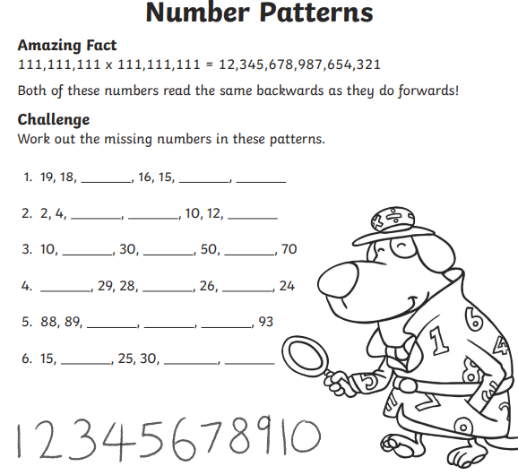  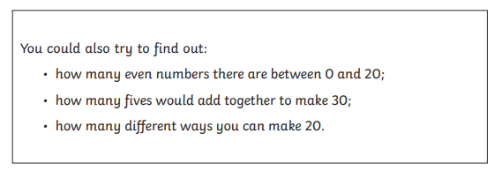 | Maths  Once you have added the missing numbers can you write a sentence to explain the rule? eg the rule is add 2 each time, the rule is times by 3 each time etc  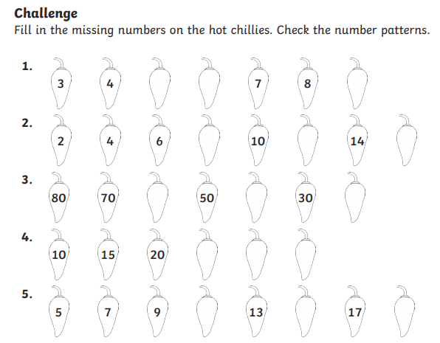 | Maths  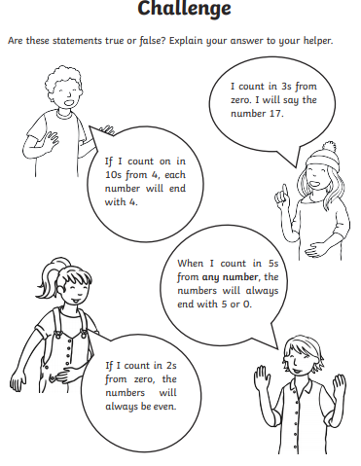  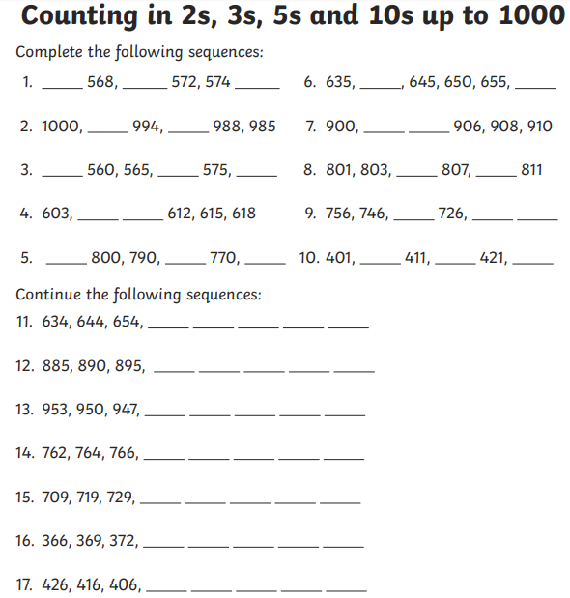 | Big Maths  CLIC test, Learn its and Safe tests are in the resources section of my class page.  If the children get 10/10 3 times in a row in CLIC and SAFE then they can move up to the next test 😊
Personal and Social Development  All about me!  Can you write a list all about you that you would want your new teacher to know.  Name  Age  Who’s in your family?  Friends  Favourite thing about school  Least favourite thing about school  Things you would like to get better at.  Hobbies | In school/Home task  https://www.youtube.com/watch?v=hp0h_1ZI_UM  Listen to the story and think about what you want to be when you grow up. Can you write about what you want to be or draw a picture?  OR  Can you plant a seed to see what it will grow into.  You’ll need a pot, a seed, soil and a label. | Personal and Social Development  Can you make a hope jar? add a label and decorate it. Can you add hopes for the future and put them inside your jar?  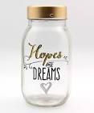 | Knowledge and Understanding  Can you make a natural kebab?  Go outside and look for natural things. Thread them on a stick to make a beautiful nature kebab.  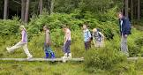 | As it is the officially the last day before the summer holidays. Can you dress as a pirate and have a pirate party! Oooo argh!!!!
Wellbeing  Try a Joe Wicks daily workout | Wellbeing  Try some cosmic yoga  https://www.youtube.com/user/CosmicKidsYoga | Wellbeing  Why not try a dance lesson with Oti Mabuse on youtube or facebook. | Wellbeing  Try out a dough disco with Shonette Bason Wood on twitter or youtube. | Wellbeing  Start the day with some exercises on cbeebies  https://www.bbc.co.uk/cbeebies/grownups/fun-exercises-to-do-at-home-with-kids

