11.05.20 This week we will be reading The Lighthouse Keeper’s Lunch. Have a good week, do what you can but most of be safe. I will add new activities on google classroom too! Miss Chichester 😊

|  |  |  |  |  |
| --- | --- | --- | --- | --- |
| Monday | Tuesday | Wednesday | Thursday | Friday |
| English  Practise your handwriting.  Read the ‘What is a Lighthouse?’ and then copy it for handwriting this week.  Remember to form all letters in the correct place.  Practise your phonics  Year 1 children – 2 letters that make a sound ‘igh as in light’  Year 2 children – split digraph  o_e The ‘e’ at the end of the word make the vowel ‘o’ change from it’s sound to it’s name as in bone.  Stretch  Find things in your house that have these sounds in them, take pictures, draw them or write a list.  Some sounds will be harder than others. | English  The Lighthouse Keeper’s Lunch (you may have a copy at home)  <https://www.youtube.com/watch?v=46wCRq50Wwg>  Listen to the story.  Write a list of food you would like to buy at the supermarket for the most delicious picnic with your family.    Stretch  Write your list using a comma between each item until the last but one thing e.g  cupcakes, bread, butter, cheese and tomates. | English  Write sentences about the story using ordering words (also known as time connectives)  Choose from this list    Stretch  Choose the words from the blue list    Example  **Next** she packed the picnic basket and attached to the wire.  **After that** the seagulls swooped down to get the food. | English  Bossy verbs (imperative verbs) tell someone what to do.  They are really useful when writing instructions.  Using the list at the bottom of the pages, can you write sentences using bossy verbs to show Mr or Mrs Grinling how to make your favourite cake!  Example  **Put** the chocolate chips in the bowl.  **Mix** the sugar and the butter together.  **Place** the ingredients in the oven.  Stretch  Add adjectives to describe your nouns (name of things)  Put the smooth chocolate chips in the plastic bowl. | Creative writing  Make your favourite sandwich with the help of a grown up. Write the instructions so I can follow them    WAGOLL (What a good one looks like)  Use capital letters and full stops  Use Finger spaces  Use neat handwriting  Use bullet points or numbers for each step  Start each sentence with an ordering word then a bossy verb eg  ***2. Next, spread the butter etc***  Stretch  Reread your work and ensure it makes sense. Have you included everything from the WAGOLL? |
| Maths  This week we were focusing on addition. The children are all at different stages and it is impossible to differentiate for all of them.  The work set out this week will show you the strategy they need and examples. If the work is too difficult or easy, change the questions (numbers to 20 or numbers bigger than 100) 😊 | Maths    Adding 10s numbers. Use your knowledge of bonds to 10 to help you work these out.  40 + 40 =  You know that 4 + 4 = 8  so 40 + 40 = 80 | Maths    Spidey group    Spidey group can try these when they are confident with the above 😊  Pluto and Super group   1. 14 + 3 = 2. 2 + 27 = 3. 33 + 5 = 4. 65 + 3 = 5. 3 + 39 = 6. 23 + 5 = 7. 49 + 1 = 8. 5 + 34 = 9. 52 + 7 = 10. 3 + 91 = | Maths  Only move onto this step when the children are confident on the other steps. It is better to repeat the other steps so they are secure on them before moving on. | Big Maths  CLIC test, Learn its and Safe tests are in the resources section of my class page.  If the children get 10/10 3 times in a row in CLIC and SAFE then they can move up to the next test 😊  Your child will know which test they are on.  I have added an extra step for really confident children |

|  |  |  |  |  |
| --- | --- | --- | --- | --- |
| Knowledge and Understanding  Water surrounds a lighthouse.  Can you make a raft that floats on water? Here are some ideas to help you.    OR  Can you find things in your house that float or sink in water?  Make a list | Creative Development  Make a blue crab    If you do not have paints, draw or design your own 😊 | Knowledge and Understanding  Oh no! Mr and Mrs Grinling have lost their way! Can you make them a new lighthouse? You could use toilet rolls or a pringle tube. Don’t forget it’s needs stripes. Can you make a repeating pattern? Can you add a light? | Personal and Social Development  Can you draw a heart? Draw all the things that you love inside the heart. | Welsh development    Draw, print out or copy the sea creatures. Colour them in the correct colours? |
| Wellbeing  Try a Joe Wicks daily workout | Wellbeing  Try some cosmic yoga  <https://www.youtube.com/user/CosmicKidsYoga> | Wellbeing  Why not try a dance lesson with Oti Mabuse on youtube or facebook. | Wellbeing  Try out a dough disco with Shonette Bason Wood on twitter or youtube. | Wellbeing  Start the day with some exercises on cbeebies  <https://www.bbc.co.uk/cbeebies/grownups/fun-exercises-to-do-at-home-with-kids> |

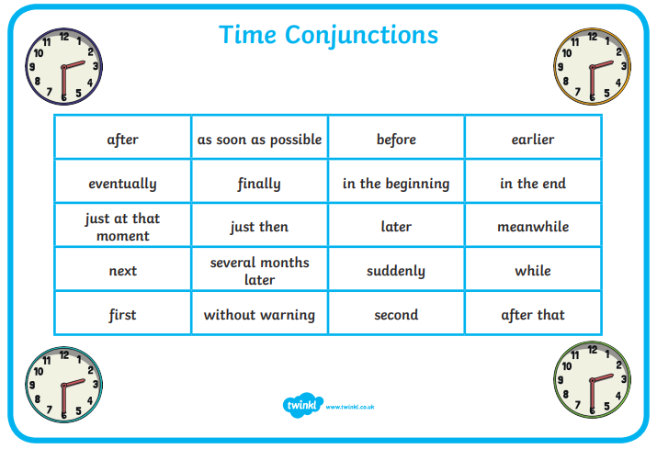

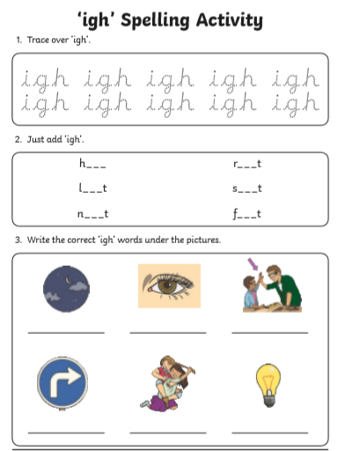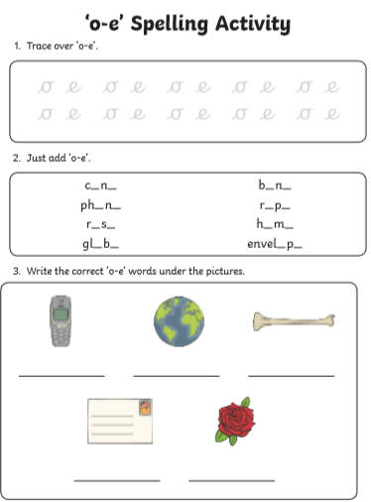

What is a Lighthouse poem for handwriting

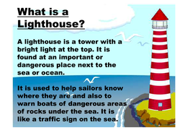

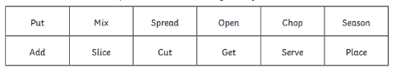

Bossy verbs for Thursday