04.05.20 What a great start to our new context. Lots of you have been busy working at home so well done! This week we will look at creatures that live in water. Have a good week but most of all stay safe. I will add new activities on google classroom too! Miss Chichester 😊

|  |  |  |  |  |
| --- | --- | --- | --- | --- |
| Monday | Tuesday | Wednesday | Thursday | Friday |
| English  Practise your handwriting.  Read the ‘In the Sea’ poem and then copy the poem.  Remember to form all letters in the correct place.  Practise your phonics  Year 1 children – 2 letters that make a sound ‘ee as in bee’  Year 2 children – split digraph  e_e The e at the end of the word make the vowel change from it’s sound to it’s name as in theme.  Stretch  Find things in your house that have these sounds in them, take pictures, draw them or write a list.  Some sounds will be harder than others. | English  The Snail and the Whale (you may have a copy at home)  <https://www.youtube.com/watch?v=x887mPO9X9c>  Listen to the story.  Choose from  Can you write sentences to describe what happened in the story.  Can you write 10 sentences to retell the story in the correct order.  Stretch  Write sentences to explain what problems the snail faced in the story | English  Can you think of rhyming words to match these words.  Remember the sound at the beginning of the word needs to change  Eg cat, hat, mat, sat    Stretch  Can you think of your own rhyming pairs?  House – mouse | English  I would like the children to plan a poem similar to the poem they used for handwriting.  Plan  Dolphin  swims  jumps  flippers  Using a plan like the above, can the children think of 3 different creatures that live in the sea? draw them, write their name and think of words to describe what they do, how they move etc  These ideas will help with their poem for Friday. | Creative writing  Write a poem using the scaffold frame below.  In the Sea  I wish I was a _______in the sea.  I’d ________________________  I’d__________________________________________________  I wish I was a ______ in the sea.  WAGOLL (What a good one looks like)  Use capital letters and full stops  Use Finger spaces  Use Neat handwriting  Add adjectives to describe the creatures  Add verbs to describe how they move  Include similes  Write 3 verses using your plan from Thursday.  Stretch  Add more verses to your poem  Can you make some lines rhyme? |
| Maths  We are looking at length this week.  You will need a ruler or tape measure, if you do not have a ruler, you could use lego bricks or non standard units as long as they are the same size.  <https://www.bbc.co.uk/teach/supermovers/ks1-maths-length-height/zdrx92p>  We measure length using the symbol cm. (centimetres)  We measure from the 0cm at the start of the ruler.  Find items in your home and complete this table.  Estimate first and then measure, it doesn’t matter if their guesses are wrong!   |  |  |  | | --- | --- | --- | | item | Guess  (estimate) | Measure | | pencil | cm | cm | | fork |  |  | | apple |  |  | | phone |  |  | | dvd |  |  |   Stretch  Add more items to the table.  Put them in order from shortest to longest. | Maths  <https://www.topmarks.co.uk/maths-games/measuring-in-cm>  Use the link to practise your measuring skills  Pick a level | Maths  Today you are going to be measuring yourself!  Try and encourage the children to use the word centimetres (cm) when estimating and measuring   |  |  |  | | --- | --- | --- | | item | Guess  (estimate) | Measure | | A finger |  |  | | The length of your arm |  |  | | A toe |  |  | | A foot |  |  | | A leg (from thigh to ankle) |  |  | | An ear |  |  | | your height |  |  |   Stretch  Put in order from longest to shortest | Maths  Length word problems  Remember to..  1 - Work out whether the question is an add or subtract question.  2- Circle the numbers in the question.  3 - Show your workings out.  Choose from the 2 grids. Ask a grown up to help you read the questions.  Stretch  Write some length word problems for Miss Chichester to work out, share them with me on twitter or your hwb accounts. | Big Maths  CLIC test, Learn its and Safe tests are in the resources section of my class page.  If the children get 10/10 3 times in a row in CLIC and SAFE then they can move up to the next test 😊  Your child will know which test they are on. |

|  |  |  |  |  |
| --- | --- | --- | --- | --- |
| Knowledge and Understanding  Watch the clip and find out about different creatures that live in the sea.  <https://www.bbc.co.uk/bitesize/clips/zmxqxnb>  Choose 5 different sea creatures and find out facts about them.  Draw the sea creature  What is it’s name?  What does it eat?  What does it look like?  Where does it live?  Stretch – add these  Are they a predator or prey?  Special feature | Creative Development  Make a paper whale  <https://www.panmacmillan.com/blogs/books-for-children/snail-and-the-whale-kids-activities>  This is the link, if you cannot read the instructions | Knowledge and Understanding  Learn about animals and their habitats.  A habitat is live an animal lives.  Watch the clip of an ocean habitat  <https://www.bbc.co.uk/bitesize/topics/zx882hv/articles/zsfkd2p>  Complete the online activities  OR  Make a poster to match animals to their habitats.  Stretch  Can you explain why they live there? | Personal and Social Development  This month our new right of the month is Article 31 ‘Every child has the right to relax, play and take part in a wide range of cultural and artistic activities’  Why not play a game, try cosmic yoga or make something new. Make a cake or cupcakes to share with your neighbours for VE day.  Don’t forget to share it with me 😊 | Today is VE day  It is 75 years since World War 2. We remember all the people who died in the war for us.  Make a union jack flag or some bunting for your window. |
| Wellbeing  Try a Joe Wicks daily workout | Wellbeing  Try some cosmic yoga  <https://www.youtube.com/user/CosmicKidsYoga> | Wellbeing  Why not try a dance lesson with Oti Mabuse on youtube or facebook. | Wellbeing  Try out a dough disco with Shonette Bason Wood on twitter or youtube. | Wellbeing  Start the day with some exercises on cbeebies  <https://www.bbc.co.uk/cbeebies/grownups/fun-exercises-to-do-at-home-with-kids> |

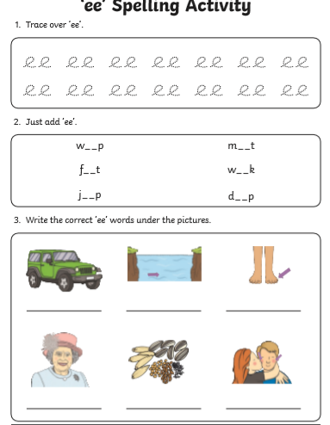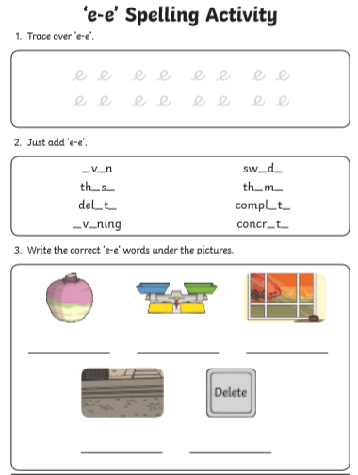

Length word problems for Thursday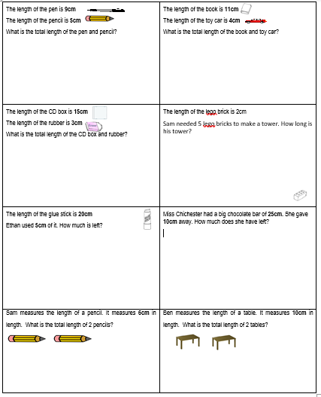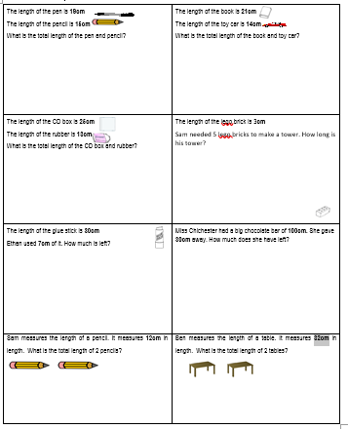

In the Sea poem for handwriting

