01.06.20 I hope you all had a happy half term. This term we will be learning about pirates. We will be reading How to Become a Pirate. I have tried to make this week’s tasks open so you can complete them on paper, or use google classroom or even JIT using your hwb account. I can now see what you are doing on JIT so make sure you check in ‘my files’ for speech bubbles for verbal feedback. Maths is subtraction this week, only move on to a new strategy when you are happy your child can complete each step. 😊

|  |  |  |  |  |
| --- | --- | --- | --- | --- |
| Monday | Tuesday | Wednesday | Thursday | Friday |
| English  Practise your handwriting.  Read ’the Pirate Poem’ and then copy it for handwriting this week.  Remember how to form your curly caterpillar letters.  c a d g o e - they all start the same way as a ‘c’’  Practise your phonics  Year 1 children – 2 letters that make a sound ‘long oo as in moon’  Year 2 children – split digraph  u_e The ‘e’ at the end of the word make the vowel ‘u’ change from it’s sound to it’s name as in tube.  Stretch  Find things in your house that have these sounds in them, take pictures, draw them or write a list. | English  <https://www.youtube.com/watch?v=y4m_BW5yddU>  Listen to the story of How to Become a Pirate  Write a description of Grey Beard the leader of the pirates.  Can you describe what he looks like?  Can you describe his personality?  can you describe how he feels?  Stretch  Use 2a sentences  The big, jolly pirate.  Use a list sentence  He had a red, fuzzy and dirty beard.  Use similes  The pirate’s hat was as black as the night. | English  A verb is a doing word. E.g playing, eating  Write sentences about the story using verbs.  I was making a sandcastle.  How many different verbs can you use? Don’t forget capital letters and full stops.  Stretch  Write sentences using 2 verbs and join them together with a connective.  The boy learnt to be a pirate because he followed them onto the boat.  Red words verbs  Blue word connectives – you could also use and, so, but, yet, or | English  Today I will be on J2messages between 1 – 2pm for a chat.  We can chat or you can ask me questions. I am hoping that lots of the class can join in, so we can chat together. Please join me 😊 | Creative writing  Design a wanted poster for a mean and nasty pirate.  Wanted posters where created to catch bad pirates as there was no electricity or the internet!!    Use these headings  Name  Age  Description  Crime  Reward |
| Maths  This week we were focusing on subtraction. The children are all at different stages and it is impossible to differentiate for all of them.      If this is tricky, use a 100 square.  Stretch  140 – 9 =  180 – 5 =  210 – 7 =  280 – 4 =  340 – 6 = | Maths  Subtraction **without** crossing the 10.    Here the children are developing their knowledge of counting back. Try and work out the answers in your head.    Stretch  49 – 7 =  110 – 9 =  67 – 5 =  130 – 8 =  150 – 6 = | Maths  Subtraction **crossing over** the 10.  Show children when you subtract these numbers you need to count back through the 10.    Use a 100 square to help you if you need to.    Stretch  136 – 9 =  125 – 7 =  143 – 5 =  152 – 4 =  283 – 8 = | Maths  Repeat step 18 - subtraction crossing over the 10.    OR try these subtraction word problems - on the next page | Big Maths  CLIC test, Learn its and Safe tests are in the resources section of my class page.  If the children get 10/10 3 times in a row in CLIC and SAFE then they can move up to the next test 😊  Your child will know which test they are on. |

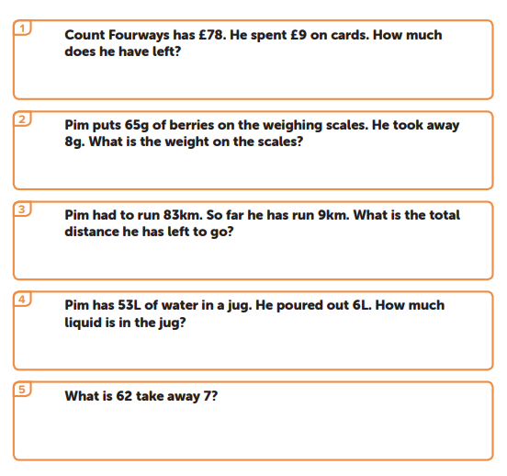

|  |  |  |  |  |
| --- | --- | --- | --- | --- |
| Knowledge and Understanding    Work out your pirate name and research and find out more facts about pirates. There is a powerpoint on google classroom or you can find your own facts.  How many cool facts can you find?  Links  <https://learnenglishkids.britishcouncil.org/word-games/pirates>  Stretch  <https://kids.britannica.com/kids/article/pirate/353633>  <https://www.dkfindout.com/uk/history/pirates/> | Creative Development  <https://learnenglishkids.britishcouncil.org/sites/kids/files/attachment/craft-pirate-masks.pdf>  Make a pirate mask using the above OR design your own pirate mask.  OR  You could design and draw your own pirate. | Knowledge and Understanding  Pirates sail across the sea. The sea is filled with salt water.  Make a salt crystal  <https://www.youtube.com/watch?v=9zoh-COQAQM>  Watch the clip and set up the experiment.  Record your observations( what do you see changing?) each day.  Day 1 – no change  Day 2 – no change  Day 3 –  Day 4 –  Day 5  Can you describe what happens to the water? What happens to the string? What is happening to the salt in the water?  Stretch  Why do you think it happened? | Personal and Social Development  Eid is a special time for Muslims  During the holidays, lots of our friends celebrated Eid. If you celebrated, can you write about what you did?    If you do not celebrate Eid, can you make this cool mobile? | Welsh development  Use 2 of your favourite teddies or toys and have a conversation.  How many different questions can you ask and answer?  Bore da/Prynhawn da  Pwy wyt ti?  _________ ydw i.  Sut wyt ti?  Dw i’n ____________  Beth wyt ti’n hoffi?  Dwi’n hoffi ________  Beth wyt ti eisiau?  Dw i eisiau ________  Hwyl fawr  All of these sentence patterns we have practised in school. The children might be able to add more sentences to their conversations.  You could record the conservation and share with me on twitter or google classroom. |
| Wellbeing  Try a Joe Wicks daily workout | Wellbeing  Try some cosmic yoga  <https://www.youtube.com/user/CosmicKidsYoga> | Wellbeing  Why not try a dance lesson with Oti Mabuse on youtube or facebook. | Wellbeing  Try out a dough disco with Shonette Bason Wood on twitter or youtube. | Wellbeing  Start the day with some exercises on cbeebies  <https://www.bbc.co.uk/cbeebies/grownups/fun-exercises-to-do-at-home-with-kids> |

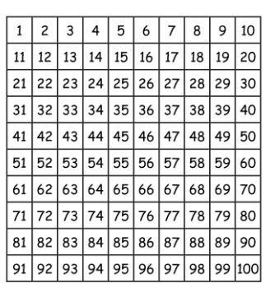

Pirate poem for handwriting on Monday 