30.03.20 BUTTERFLY WEEK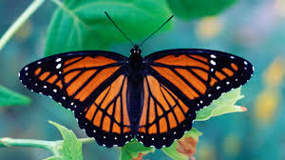 I have put activities into a daily table to make it easier to access. Do as much as you are able to and don’t stress if you don’t complete all the activities. I will try and add more fun activities on twitter. Mrs Goodwin 😊

|  |  |  |  |  |
| --- | --- | --- | --- | --- |
| Monday | Tuesday | Wednesday | Thursday | Friday |
| Practise your handwriting.  Look at the next page to correctly form each letter. These posters show children how to form each letter and their starting place.  Use spellings words below (on page 3) to write in best handwriting. | Practise your spellings. Look at the lists below and see which words the children need to practise to read and write independently. Write a sentence to go with each word. Sentences must have a capital letter, finger spaces and a full stop. Groups 1 - 4 should also have a connective to extend the sentence (and, so, but, because)  Play on phonics games on BBC bitesize and Phonics Bloom. Find the sound you are on and practice. | Can you find out about the life cycle of a butterfly? Use Google or Hwb Encyclopedia Britannica.  Groups 1& 2 write the life cycle of the butterfly in 5 or 6 sentences using time sentence starters.  First…  Then…  Next….  After that…  Finally….  Groups 3&4 as above but draw the pictures instead of writing sentences. | Can you write some sentences about butterflies?  Don’t forget to use describing words. Read your work back to see if it makes sense and Year 2’s MAKE SURE THE FULL STOPS ARE WHERE YOU TAKE A BREATH! | Can you write a story about a little butterfly who got lost?  Once upon a time there was a beautiful little butterfly. He woke up one morning to find... |
| Using JIT, create a pictogram of favourite minibeasts  This is your data  ants l l l  bee l l l l l l  butterfly l l l l l l l l l l  caterpillar l l  fly l  ladybird l l l l  slug 0  snail l l l l l l  spider l l l l l l l | Reading and writing numbers    Make your own 100 square like this | Ordering Numbers  Challenge – now use bigger numbers! | Practise your learn its! All children need to know these number facts by quick recall.  See pages below for Learn IT’s  Make a poster, play games, make flashcards, any way to learn the facts quickly without counting on their fingers. | Learn about symmetry  Draw a butterfly.  Put some different colour spots on one side.  Now match it to the other side. See below page 4 for ideas.  Can you draw some more butterflies to practice your doubles?  Like this: |
| Can you draw/ paint or chalk a beautiful butterfly?  Pictures on Twitter PLEASE. (I miss you guys) | Log into Hwb. Go into Resources. Go into Encyclopedia Britannica and search Butterflies. | Can you look for some butterflies in the garden? If not, look for some images on Google. | Make a huge butterfly in your living room out of sheets and pillow. | Log into hwb, go into Jit 5, Go into ‘Turtle’ then choose the flower garden. Can you direct the butterfly around the garden? |

Step 1 - Ensure children can form all of these letters correctly in the correct starting place. 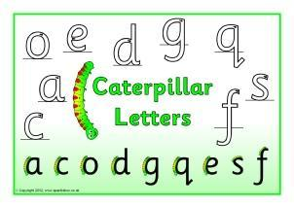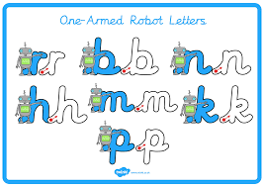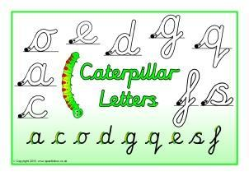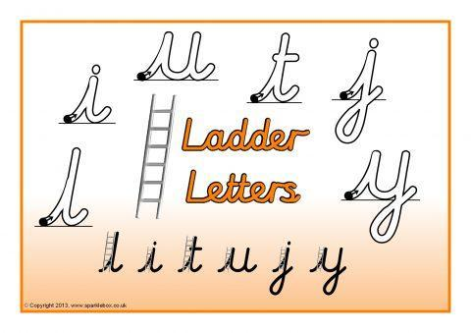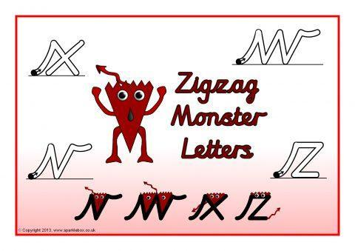

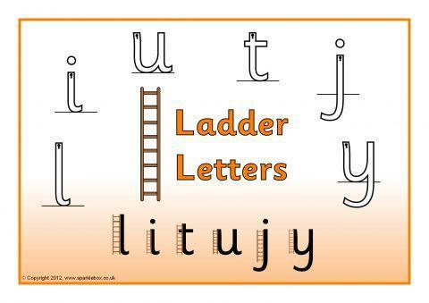

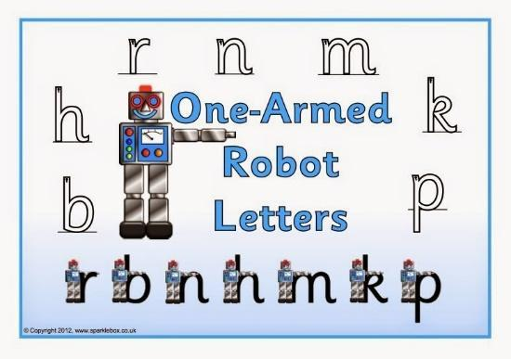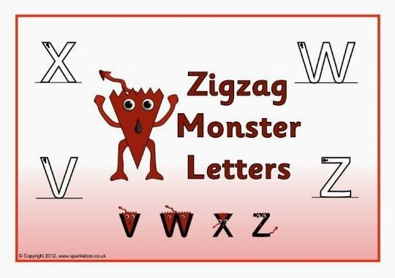

Step 2 – Only start joining letters together, once children can correctly form all their single letters correctly.

Spellings (your child should know what group they are in.)

Group 1 Group 2 Group 3 Group 4 Group 5 Group 6

stand dear high ring quit sick

crisp hear light sing quiz sock

trend fear night wing quick back

trust near right king quack pack

spend tear fight rang

twist year might long

frost beard

stamp

