29th June 2020

|  |  |  |  |  |
| --- | --- | --- | --- | --- |
| Monday | Tuesday | Wednesday | Thursday | Friday |
| We changed our minds!  We are going to do 2 more weeks of pirates!  Ooooo Aaaaarrrrrr!  So, this week’s story in ‘My Granny Is A Pirate’.  My Granny Is a Pirate: Amazon.co.uk: Val McDermid, Arthur Robins ...  Watch it here: <https://www.youtube.com/watch?v=psK38RjaXi4>  Can you answer the reading comprehension questions below? | Listen to the pirate cruncher again.  This story is a rhyming story.  Look at each page. Can you find 2 words that rhyme on each page?  Can you think of your own rhyming words?  Cut and stick the rhyming words on the sheet below.  If you can’t print off, draw the pictures of the rhyming words together. | More rhyming practice…  Can you find all the odd ones out on the sheet below? It looks like this.. | Can you look at the story again?  Use the story to help you.  Can you write some of your own pirate rhyming sentences?  Here’s some examples…  There was a pirate’s **parrot**  Who would only eat a **carrot**  I opened the treasure **chest**  But only found a smelly **vest**! | Practise your spellings.  Check out BBC bitesize Karate Cats English  <https://www.bbc.co.uk/bitesize/topics/zd63xyc/articles/zdp4pg8> |
| Direction and position  Watch Chester the cat reminding you of positional language  <https://www.youtube.com/watch?v=niPyVnC6W5g>  Can you answer the questions about the treasure map?  Scroll down to the map, then scroll down again to all the cards with questions on.  Use the words from the Chester video to help you with the answers. | Direction and position  Have a watch of this song today  <https://www.youtube.com/watch?v=xyMrLQ4ZI-4>  Now can you do the listening game?  Print off the picture of the playground. Get an adult to read out the instructions. Draw the things they say in the right places on the picture. See how many you can do.  If you can’t print, have a game with your brothers/sisters/ parents where they are bossing you around to put things in different places. | Direction and position  Watch the bus driver trying to find his way to the park.  <https://www.youtube.com/watch?v=N53w1cz4ogo>  Can you go for a walk outside to the park or the shops? (keeping your distance from people, of course!)  As you walk along, what directions are you taking? Forward, left, right, turn.  When you get home, see if you can draw out your route.  If you’re not allowed out, complete the City directions sheet in J2E My Files, Shared Files, Star Class, City Directions. | Direction and position  Can you help the messy pirate below to find all his things?  This sheet is also on J2E My files, Shared files, Star Class, Messy Pirate directions Sheet 1 and sheet 2 | CLIC and Learn It’s  Practise you Learn It’s below  How fast can you do them? |
| Science  Pirates had to sail their ships in some very bad rain storms.  Can you make your own rain in a jar?  Watch this:  <https://www.youtube.com/watch?v=hgBo6P0rjoM>  You will need a jar, water, shaving foam, blue food colouring and  you could use a medicine syringe to pour in the food colouring. | Creative Development  Can you make your very own treasure? You could make crowns, trophies, rings, necklaces, jewels. See what you can find around the house to help you.  Pasta, paper clips, sweet wrappers, plastic, foil, beads, string, sweets?  75 Inspiring Craft Ideas Using Plastic Bottles | FeltMagnetNecklace for girls stock photo. Image of selfmade, little - 418841650 Clever Upcycling Ideas - Personal Creations Blog | PSD/ Well being in school  If you came to school, leave this out!  Hand washing/ germs  It is so important for us to wash our hands. Why is that?  Watch this:  <https://www.youtube.com/watch?v=YBGsoimPXZg>  Now complete the worksheet below about washing hands or print of from J2E, My Files, Shared Files, Star Class, Washing hands activity. | Physical Development  Can you practise your left and right?  Here’s a song to help you.  <https://www.youtube.com/watch?v=LFsVrQ65JuE>  Can you direct the turtle around the screen on J2E Jit5 Turtle. Choose your screen and off you go! Don’t forget to save your work. | Friday Free Choice Fun!  How much fun can you have this afternoon?  Play some games with your family inside or outside.  Or do some baking  Or do some mindful colouring  Or maybe a Joe Wickes PE  I’d love to know what you get up to! |

Spellings (your child should know what group they are in)

Group 1   Group 2 Group 3 Group 4 Group 5 Group 6

venue champ air now look jam

value chest fair owl foot jet

queue tenth hair down took jog

true theft pair town good Jack

statue Welsh lair cow wood Jen

rescue chimp how wool

argue bench

Reading Comprehension. My Granny Is A Pirate

1. What is Granny’s secret?

________________________________________________________________________

2. What did Granny do first, when she was a young pirate girl?

________________________________________________________________________

3. What things did her pet parrot do?

________________________________________________________________________

4. Name 3 things Granny liked to do, as a pirate.

_____________________ ______________________ __________________

5What do you think ‘Pirate Grog’ is?

_________________________________________________________________________

6. Where did Granny go each evening?

__________________________________________________________________________

7. What happened when Granny climbed the stairs in the secret passage?

____________________________________________________________________________

8. Would you like to be a pirate? Why________________________________________________

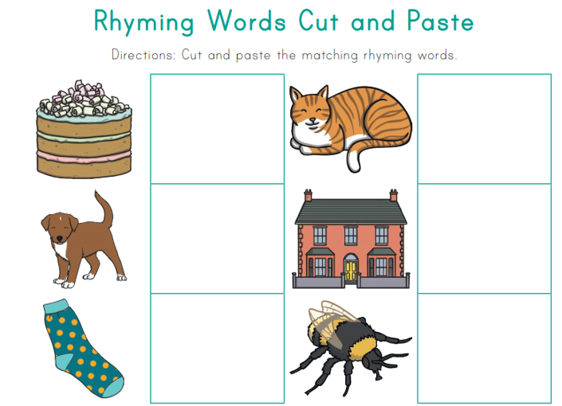

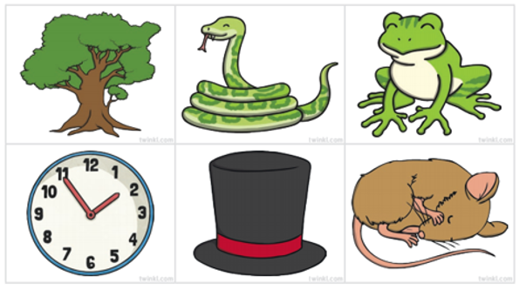

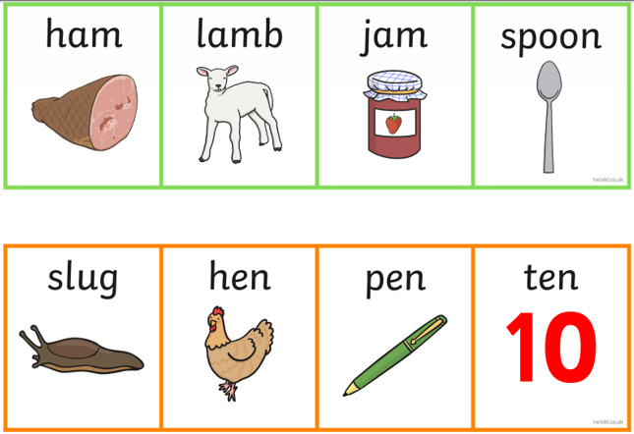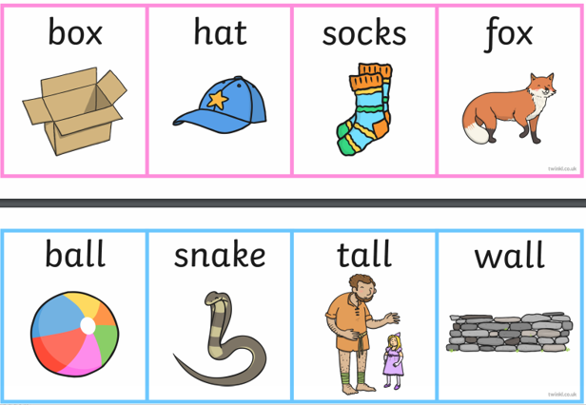Odd One Out Rhyming

Odd One Out Rhyming

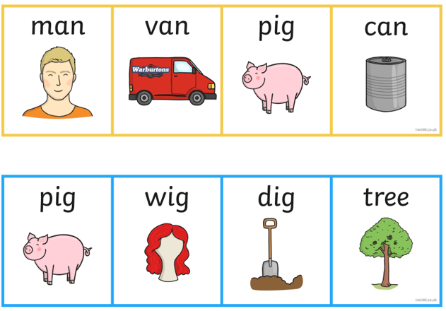

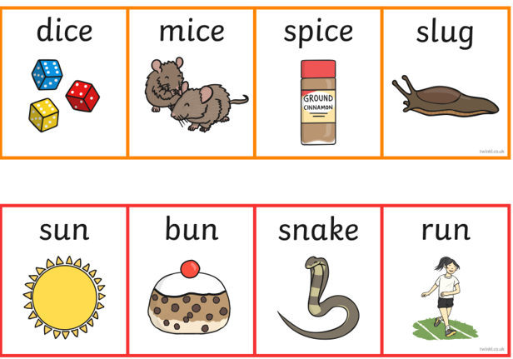

Maths – positional language

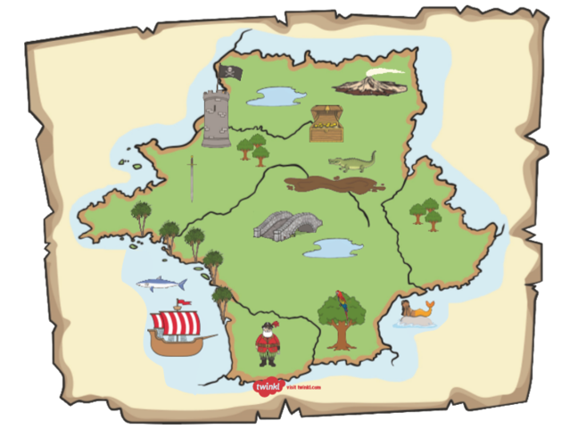

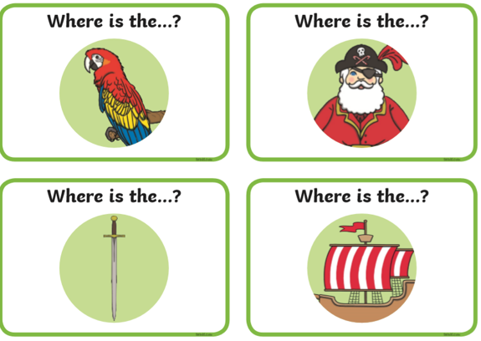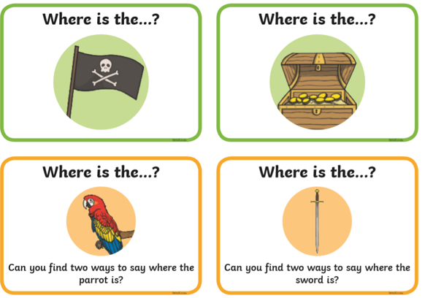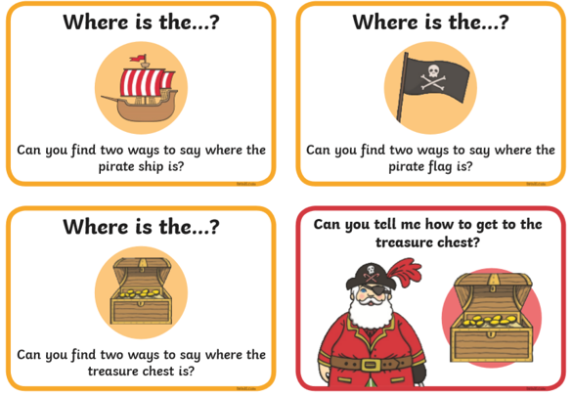use these words in your answers:

next to between

to the left of

to the right of

under

above/ on top of

in the

