|  |  |  |  |  |
| --- | --- | --- | --- | --- |
| =Monday | Tuesday | Wednesday | Thursday | Friday |
| Listen to the story of The Rainbow Fish. <https://www.youtube.com/watch?v=r9mryuEKkKc>  Can you draw a beautiful picture of the Rainbow Fish and write some describing words around your picture? Or maybe you could write some describing sentences? | Watch the cartoon of The Rainbow Fish <https://www.youtube.com/watch?v=ifXlc0QI2kY>  Is the Rainbow Fish a nice fish? How does he change at the end?  Can you draw a picture and write about 1 thing you would like to share with a friend? | Listen to the story of The Rainbow Fish again. <https://www.youtube.com/watch?v=Z3cmddZh6t8>  Can you write a few sentences to retell the story?  What happens in the beginning, the middle and the end? | Children’s Rights  Article 24 – We have the right to clean water.  Can you find out any countries that don’t have clean water to drink?  What must it be like to have no clean water to drink in the tap in your house?  What could happen to you if you drink dirty water?  Can you log into your Hwb account and make a picture about clean water?  If not, can you draw your ideas on paper? | Can you log into your Hwb account and go on Jit 5? Now click on ‘mix’ at the top right of the page. Now choose which style of page you want. Can you write about the Rainbow Fish?  You can add pictures if you click on the word ‘animals’ then click on the little world logo then type in Rainbow Fish. |
| Place Value  Can you play <https://www.topmarks.co.uk/learning-to-count/place-value-basketball> Start with numbers up to 19  If you don’t have a computer can you write a number up to 100 and partition it like we do in CLIC? 2 5  Like this  20 5 | Place Value  Go on Top Marks and play <https://www.topmarks.co.uk/place-value/place-value-charts>  Start with TU (Tens and Units) under the ‘Numbers’ column. When you are confident with those numbers, try HTU (Hundreds, Tens and Units)    If you don’t have a computer, ask an adult to call out numbers to 100 for you to write down. | Ordering Numbers  Can you play the shark game?  <http://www.ictgames.com/sharkNumbers/mobile/index.html>  Start on numbers to 29  If you don’t have a computer,find some pens to use as 10s and counters to use as 1’s. Can you make these numbers  15, 29, 37, 44, 12, 26, 33,47, 50    15 = 1 ten and 5 ones. | Can you order the numbers to 100? Play the caterpillar game  <https://www.topmarks.co.uk/ordering-and-sequencing/caterpillar-ordering>  If you don’t have a computer, can you make some number cards to 50 or 100. Cut them out then stick them back together again in the right order? | Practise your learn its! All children need to know these number facts by quick recall.  See pages below for Learn IT’s. |
| Water – What is water? How many different types of water can you think of? The sea, the river, the water we drink and so on. Make a poster about water. If you have Pic Collage you could use that?  (See page 4) | Why is water important? Can you make a word or picture list of all the things we use water for? | Can you paint a Rainbow fish? Can you stick some foil from the kitchen on to make him shiny? | Can you do some Cosmic Kids Yoga today? You could do Squish The Fish <https://www.youtube.com/watch?v=LhYtcadR9nw> | Welsh Colours  Can you match the colours on this game? <https://www.learn-welsh.net/welshgames/mix-and-match?topic=Colours&level=primary> |

Step 1 - Ensure children can form all of these letters correctly in the correct starting place. 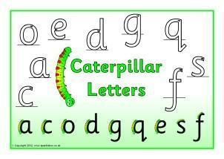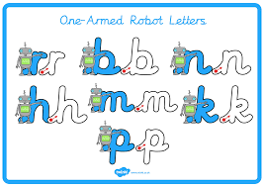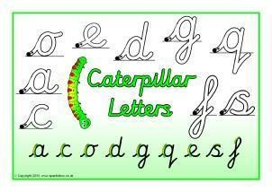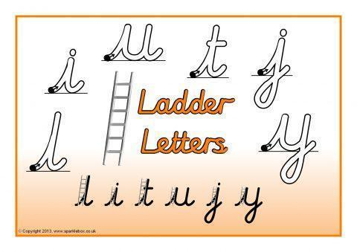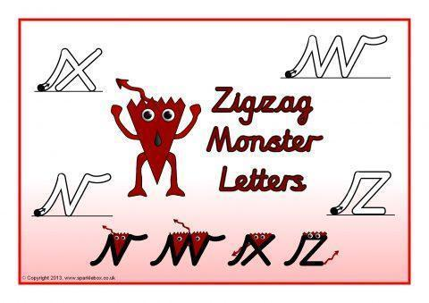

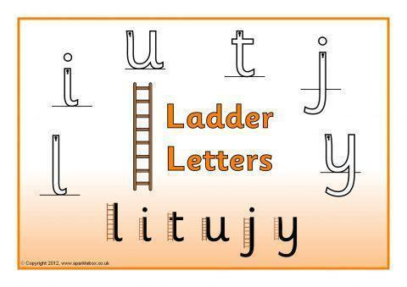

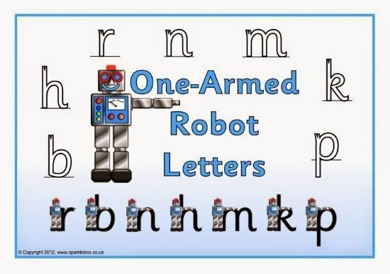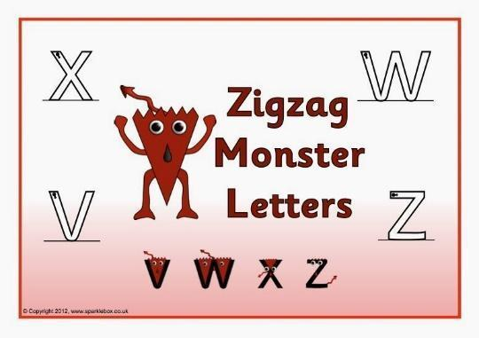

Step 2 – Only start joining letters together, once children can correctly form all their single letters correctly.

Spellings (your child should know what group they are in)

Group 1 Group 2 Group 3 Group 4 Group 5 Group 6

crunch sure zoo see shop up

shrink pure boot feel shed mum

spring cure zoom feet shell run

street mature moon meet fish cup

twisting secure food week wish mud

printer are root deep

scrunch were

