22nd June 2020

|  |  |  |  |  |
| --- | --- | --- | --- | --- |
| Monday | Tuesday | Wednesday | Thursday | Friday |
| This is our last week of PIRATES!  Our story for this week is The Pirate Cruncher    And you can listen top it on YouTube if you follow this link.  <https://www.youtube.com/watch?v=Ro5S_UdvWkI>  Can you answer the reading comprehension questions below? | Listen to the pirate cruncher again.  On the first page it says  “Nuggets of gold as big as ships beams” and  “Diamonds and rubies the size of your eyes.”  These are called Similes  A simile is when you compare something to something else.  Like this:  The giraffe was as tall as a house.  The socks were as smelly as cheese.  The parrot was as red as blood.  Can you complete the similes below? | Can you have a think about the things you treasure the most?  What would you put in your treasure chest?  Maybe your favourite book or toy?  Maybe a photo of your family?  Maybe a photo of a happy memory?  Can you write on the ‘Things I treasure’ sheet below? | In the story the fiddler warns the pirates about a monster. Look at this page    The pirates are imagining all different kinds of monsters.  Can you create your own sea monster?  Draw a picture and write lots of describing sentences about it. | Practise your spellings.  Click on this link to BBC Bitesize  <https://www.bbc.co.uk/bitesize/topics/zd63xyc/articles/zncgvk7>  Have a go at lots of different word games. |
| Money  Can you ask your mum or dad for some coins?  Put them on the table and make sure you can name all the coins.  Now have a go at putting some of the coins together and using your adding skills to see how much is there.  Have a go at the ice cream adding coins sheet first.  If that is easy for you then try the Number bonds with money worksheet below. | Money  Now that you are good at adding coins together, we are going to practise taking away.  When we give the shopkeeper too much money they give us **CHANGE.**  Can you complete the worksheets below?  First practise 10p then from £1. | Money  Can you play some money games on the computer?  There are lots to choose from on this page.  The more you go down, the harder they get.  Give yourself a challenge!  <https://www.topmarks.co.uk/maths-games/5-7-years/money> | Money  Can you play shops today?  Ask for some real money coins to play with.  You could set up a toy shop or a food shop using things from your house.  Try to use the skills you have learnt while you are playing… adding coins and giving change.  Have fun! | SPORTS DAY  Today is the Adamsdown Virtual Sports Day.  How many activities can you complete?  Don’t forget to keep your score.  I will definitely be playing along!  See separate PPT on the website for details.  Scoring: If you complete  1 -4 activities = Bronze  4 – 9 activities = Silver  9 + activities – Gold  Please Tweet or email me photos of your day! |
| Geography  Pirates used treasure maps to remind them where they had buried their treasure.  Can you draw a map of your street and some streets around you? Can you mark on your house and any other buildings? A shop? A bank?  You could go for a walk to look around or use Google Maps. | Creative Development  Can you make your very own Pirate treasure map?  Get a piece of paper.  Rip it around the edges.  Soak a teabag in water for a minute.  Squeeze out the water.  Rub the teabag all over your paper.  Let it dry.  Now you can draw your map!  Look at treasure maps on google images for ideas. | PSD  **Link this work to today’s English.**  Can you find a box and cover it or decorate it to make it really special? Now can you put some special things in it?  What is special to you?  You could put in some photos or favourite things.  Or you could use an egg box to make a treasure chest! | Physical Development  Can you learn a pirate dance?  Watch this and dance along!  <https://www.youtube.com/watch?v=oe_HDfdmnaM>  You’ll have to do it a few times before you can remember it! | SPORTS DAY  Carry on with the sports day activities. |

Spellings (your child should know what group they are in)

Group 1   Group 2 Group 3 Group 4 Group 5 Group 6

clue hump ear fur too less

blue band dear burn zoo hiss

glue dent fear curl boot mess

true felt hear burp zoom boss

issue gulp near hurt cool kiss

tissue lamp tear

due wind

Reading Comprehension. The Pirate Cruncher.

1. Name 3 different kinds of treasure listed on the first page.

_____________ _________________ ________________

2. What did the old fiddler promise the pirates they would find?

________________________________________________________________________

3. What is the name of the Captain?

________________________________________________________________________

4. What did the fiddler have to help them find the way?

_________________________________________________________________________

5. The fiddler tried to warn the pirates that it was dangerous. Why did they still go?

_________________________________________________________________________

6. What did the fiddler warn them would be in the sea?

__________________________________________________________________________

7. Did the pirates get their treasure in the end? Then what happened to them?

____________________________________________________________________________

8. What do you notice about the fiddler on the last page? What are those strings coming from his arms and legs?

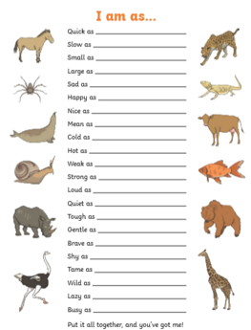 Similes

I know this is very small.

If you log onto Hwb.

Open Just 2 Easy.

Open My Files

Open shared files

Open Star Class

Open simile worksheet

You should then be able to print the sheet off full size.

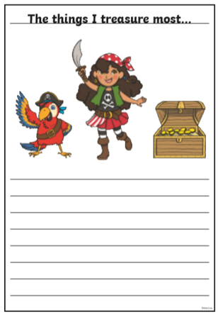Things I treasure

I know this is very small.

If you log onto Hwb.

Open Just 2 Easy.

Open My Files

Open shared files

Open Star Class

Open Things I Treasure worksheet

You should then be able to print the sheet off full size.

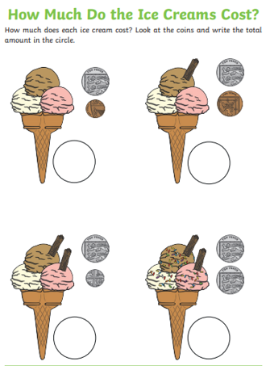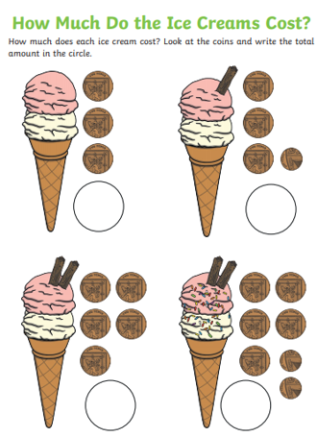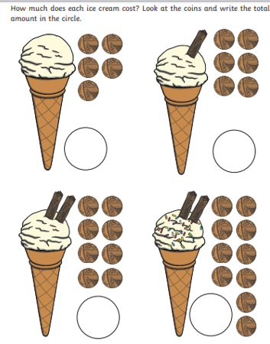

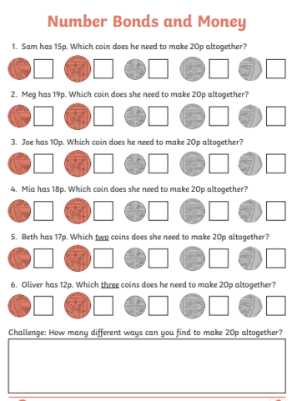

I know this is very small.

If you log onto Hwb.

Open Just 2 Easy.

Open My Files

Open shared files

Open Star Class

Open Money Number Bonds worksheet

You should then be able to print the sheet off full size.

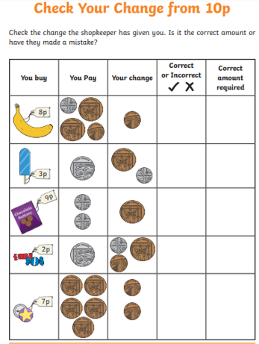Change from 10p

I know this is very small.

If you log onto Hwb.

Open Just 2 Easy.

Open My Files

Open shared files

Open Star Class

Open Change from 10p worksheet

You should then be able to print the sheet off full size.

Change from £1

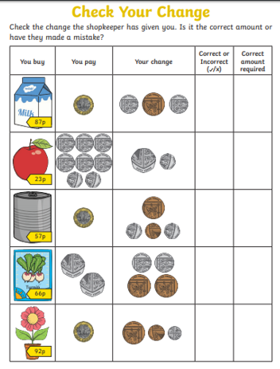I know this is very small.

If you log onto Hwb.

Open Just 2 Easy.

Open My Files

Open shared files

Open Star Class

Open Check Your Change worksheet

You should then be able to print the sheet off full size.

