20.04.20 SPRING WEEK  I have put activities into a daily table to make it easier to access. Do as much as you are able to and don’t stress if you don’t complete all the activities. I will try and add more fun activities on twitter. Mrs Goodwin 😊

|  |  |  |  |  |
| --- | --- | --- | --- | --- |
| Monday | Tuesday | Wednesday | Thursday | Friday |
| Practise your handwriting.  Look at the next page to correctly form each letter. These posters show children how to form each letter and their starting place.  Use spellings words below (on page 3) to write in best handwriting. | Practise your spellings. Look at the lists below and see which words the children need to practise to read and write independently. Write a sentence to go with each word. Sentences must have a capital letter, finger spaces and a full stop. Groups 1 - 4 should also have a connective to extend the sentence (and, so, but, because)  Play on phonics games on BBC bitesize and Phonics Bloom. Find the sound you are on and practice. | Can you read a new story on [www.oxfordowl.co.uk](http://www.oxfordowl.co.uk)  Parents: If you’re looking for a Biff, Chip and Kipper book they are on this site. Stage 1 is pink, Stage 2 is red, Stage 3 yellow, stage 4 blue, stage 5 green, stage 6 orange, stage 7 turquoise.  **If you don’t have a computer and are reading this on your phone, see if you can read a book from your house.** | Children’s Rights  This month’s Right Of The Child is Article 24 - The right to good health and health care.  So… what healthy things have you been doing? PE with Joe Wickes, Cosmic Kids Yoga, a daily walk, eating lots of healthy fruit and vegetables? Can you make a poster about being healthy?  And tonight at 8 o’clock, if you’re allowed, open your front door and thank all the doctors and nurses for being so amazing by clapping. | Can you log into your Hwb account and go on Jit 5? Now click on ‘mix’ at the top right of the page. Now choose which style of page you want. Can you write about spring and put some spring pictures in your work?  For the pictures click on the word ‘animals’ then click on the little picture of the world, then type in ‘Spring’ then choose which spring pictures you want to use.  **If you do not have a computer, do this on paper. Write sentences about spring then draw pictures.** |
| Can you go on a Maths Shape treasure Hunt in your house?  Can you find:  4 cuboids  1 sphere  5 triangles  3 circles  2 cylinders  5 squares  1 cone  2 rectangles  Clue: check your kitchen cupboards and your toys! Take photos and post on Twitter.  Now can you think of a way of sorting the shapes you found? | Practice:  The days of the week  The months of the year.  The seasons  O’ clock, half past  (Groups 1&2 : quarter past and quarter 2)  Here are some songs you might like on youtube.  <https://www.youtube.com/watch?v=mXMofxtDPUQ>  <https://www.youtube.com/watch?v=Fe9bnYRzFvk>  <https://www.youtube.com/watch?v=ksGiLaIx39c>  [https://www.youtube.com/watch?v=tEmg914-9](https://www.youtube.com/watch?v=tEmg914-9xY) | Ordering Numbers  Play the ordering caterpillar game  <https://www.ictgames.com/mobilePage/countingCaterpillar/index.html>  Move the slider to” from 0” “ to 20” then as you get better you can go back and change the bigger number up to 100.  **If you do not a computer, write out the numbers to 20, cut them out, then stick them back in the correct order.** | Practise your learn its! All children need to know these number facts by quick recall.  See pages below for Learn IT’s. | Can you practice the direction words?  You are the boss so you can direct your brothers/ sisters / parents around your house!  Use forward, backward, left, right, turn.  Can you direct someone in your family to the fridge? To the sofa? To the TV?  Challenge: Try saying turn clockwise, turn anti clockwise. |
| What signs of spring can you see outside your window?  Draw a picture of a tree in blossom, or some flowers. | Can you make a sweet treat for your family?  Some biscuits, cakes or crispie cakes? | Can you find out what animals have babies in Spring? You could use Google or you can log into your Hwb account and use Encyclopedia Britannica. | If you have a garden or you are allowed out for a little walk can you complete the spring treasure hunt? See below. (page 5 of this document) | Can you make a spring model out of the recycling? Maybe a daffodil out of a tube and an egg box? Or a tree in blossom using old paper and cartons? |

Step 1 - Ensure children can form all of these letters correctly in the correct starting place. 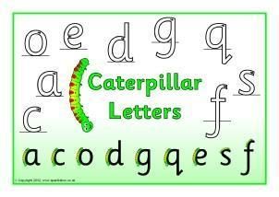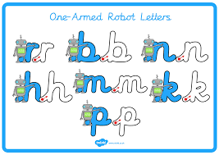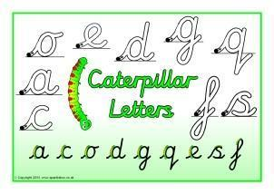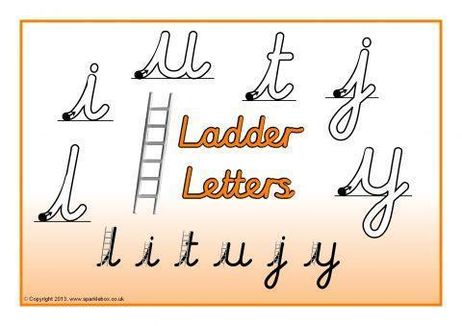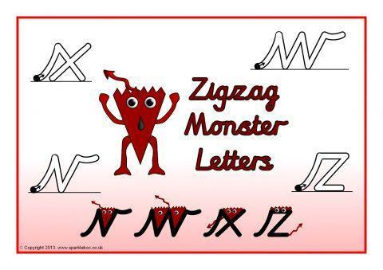

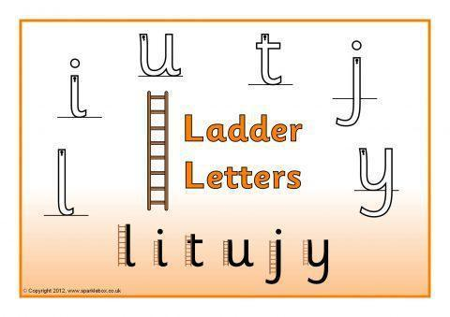

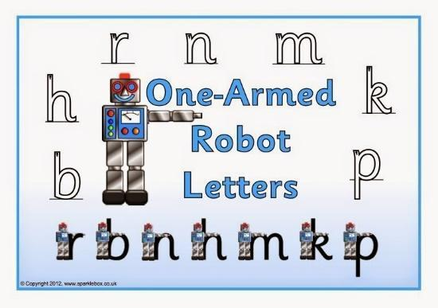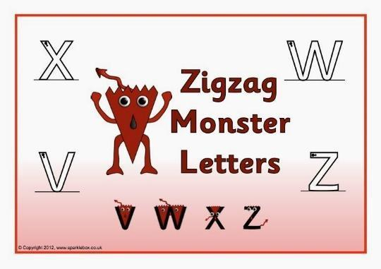

Step 2 – Only start joining letters together, once children can correctly form all their single letters correctly.

Spellings (your child should know what group they are in.)

Group 1 Group 2 Group 3 Group 4 Group 5 Group 6

blend air coat wait chop get

trust hair goat pain chin pet

crept fair load rain chick pen

drift pair loaf tail chat hen

think chair road sail chill ten

blink they soap aim

trunk all

