18th May 2020

|  |  |  |  |  |
| --- | --- | --- | --- | --- |
| Monday | Tuesday | Wednesday | Thursday | Friday |
| This week’s story is Dear Greenpeace. You can listen to the story here on YouTube <https://www.youtube.com/watch?v=hDkAWg2r80w>  Can you talk about the story with your dad or mum?  Do you think Emily really had a whale in her pond? Why? Why not? | Listen to the Dear Greenpeace story again.  Can you remember any facts about whales?  What do they eat?  Where do they live?  What do they look like? (Description) Can you make a whale fact file like this?   |  | | --- | | Whales | | Live in: | | Eat: | | Description: | | In the story Dear Greenpeace Emily and Greenpeace write letters.  Can you have a go at writing a letter? You could write it to me! You could tell me some of the things you have been doing! You could even email it to me if you ask for help.  [ThomasK328@hwbmail.net](mailto:ThomasK328@hwbmail.net)  Dear Mrs Goodwin,  Love from ______  I Can’t wait to hear from you! | Can you think of an animal you would love to have as a pet?  A tiger?  A snake?  An octopus, maybe?  Draw me a picture and write about why you would like to have that animal as a pet.  Why do you want one?  What would you feed it?  Where would you keep it?  What fun things would you do with it? | Can you practise your spellings and your handwriting today?  Copy out your words then write a sentence to go with each word.  See page 3 below for your words. |
| Subtraction  This week we are subtracting numbers (taking away)  Can you complete the worksheets below? On pages 4 and 5? | Can you find 20 objects around your house? Things like toys, lego bricks, pasta pieces. Now can you complete these subraction problems, using your counters to help you?  20 - 4 =  17 - 5 =  13 - 3 =  16 - 1 =  15 - 2 =  Now if you have a 100 square (you can find one online here)<https://www.findel-education.co.uk/product/curricular/computing-and-ict/floor-robots/earl-100-square-mat/he1829387>  Can you have a go at these for a challenge?  25 - 2 =  36 - 5 =  47 - 3 =  59 - 4 =  75 - 1 = | Can you play some subtraction games on Topmarks? **Choose the ‘subtraction’ option.**  <https://www.topmarks.co.uk/maths-games/mental-maths-train>  <https://www.topmarks.co.uk/subtraction/subtraction-to-10> | Can you go onto BBC Bitesize and complete some maths games?  <https://www.bbc.co.uk/games/embed/karate-cats-2?exitGameUrl=http%3A%2F%2Fbbc.com%2Fbitesize%2Farticles%2Fzf4sscw>  Go on Karate Cats Maths, start the game then and choose addition and subtraction. | Practise your learn its! All children need to know these number facts by quick recall.  See pages below for Learn IT’s. |
| Who are Greenpeace? What do they do? Ask your parents or try to find out on Google. You could go to this link <https://www.natgeokids.com/uk/kids-club/cool-kids/general-kids-club/save-earth-with-greenpeace/>  and get a grown up to help you look through and read it. | Can you find out about the problem of plastic in our oceans?  You could try looking at the same website as yesterday and scrolling down to **Oceans**    Or look below on page 6 for the same information, if you don’t have a computer. | Can you make a poster about saving our oceans?  Use the facts from the Greenpeace website, or look up some other facts.  You could use ‘Draw’ on Hwb or ‘Mix’ on Hwb or you can draw one on paper.  You could even try Adobe Spark. Take a look at mine below on Page 7. | Have you got a lot of plastic in your recycling?  Have a look and see what you can make out of your plastic rubbish.    Here are some ideas, but use your own imagination! | Can you complete the survey online to help the children’s commissioner for Wales know how you are feeling while school is closed? Follow this link  <https://www.childcomwales.org.uk/coronavirusandme/>    **[Sally Holland](https://twitter.com/childcomwales)**  [@childcomwales](https://twitter.com/childcomwales) |

Spellings (your child should know what group they are in)

Group 1 Group 2 Group 3 Group 4 Group 5 Group 6

pie thing for zoo aim but

lie short fork moon wait big

tie arch cord boot rain bad

die north sort zoom pain bed

cried lightening born cool sail back

tried thorn worn food

fried church

replied chain

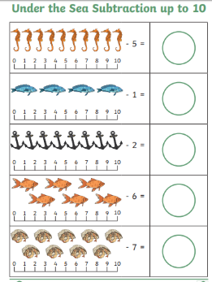

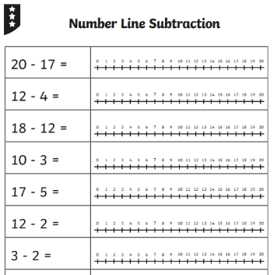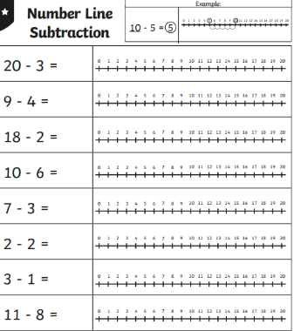

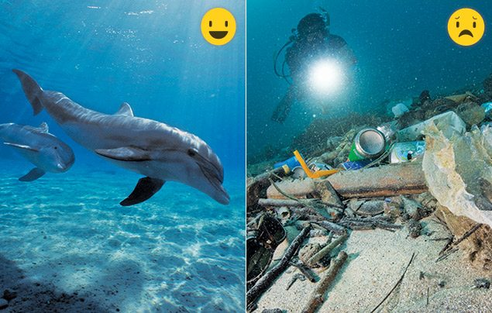

**Wild wonder:** The world’s oceans contain 97% of the Earth’s water and give us half of the oxygen we need to breathe. They also generate the rain that supports all life on our planet. Vast ocean ice flows help regulate our climate. Plus, biologists say many more marine species are yet to be discovered.

**Danger zone:** Sadly, up to 12.7 million tonnes of plastic end up in our oceans each year (below). That’s a whole truck load every minute. Plastic chokes and entangles turtles and seabirds, and clogs up the stomachs of creatures who mistake it for food.

**Action stations!** Greenpeace is calling on big companies to use less plastic – and to stop making plastic packaging that’s designed to be used once then thrown away.

