11th May 2020

|  |  |  |  |  |
| --- | --- | --- | --- | --- |
| Monday | Tuesday | Wednesday | Thursday | Friday |
| This week’s story is The Lighthouse Keeper’s Lunch. You can watch it here on Youtube <https://www.youtube.com/watch?v=46wCRq50Wwg>  Talk about the story with your family. What was the problem? How did Mr and Mrs Grinling solve the problem? Can you make up some of your own speech bubbles for what the seagulls were saying?  The Lighthouse Keeper's Lunch By Ronda Armitage | Listen to the Lighthouse Keepers Lunch Story again. <https://www.youtube.com/watch?v=46wCRq50Wwg>  Can you think of the most delicious lunch for your family? Can you draw pictures and write the names of each one like in the story? Can you make the foods sound even more delicious, using describing words? Look below on page 4 for some ideas. | Poor Hamish! He really didn’t want to go in the basket did he?    Can you draw a picture and write some describing words for how he was feeling?  I think he was scared of heights!  What are you most scared of? Can you write about it and tell me why you are scared of it? | Can you remember the order of the Lighthouose keeper’s Lunch story?  Can you write 1 sentence for each day.  On Monday…  On Tuesday…  On Wednesday…  On Thursday…  On Friday…  On Saturday… | With help from an adult, can you make a sandwich for your lunch today? Can you write out the **instructions** on how to do it?   1. Spread the butter onto the bread. 2. Place the cheese on one side of the bread.   And so on… |
| Data Handling  In the story, Mrs Grinling made mustard sandwiches to keep the seagulls away. What is your favourite sandwich filling? What about everyone in your family?  Can you make a tally chart like this one, asking everyone their favourite sandwich filling?   |  |  |  | | --- | --- | --- | | Sandwich | Tally | Total | | cheese | l l l l | 5 | | tuna | l l | 2 | | tomato | l l l | 3 | | Can you look at the tally chart on page 5 below and answer these questions?   1. Which sandwich was the most popular? 2. Which sandwich was the least popular? 3. How many people chose ham? 4. How many people chose cheese and tuna altogether? 5. How many more people chose cheese than tuna? 6. 1 more person chose lettuce and tomato. Add it on to the tally. How many people like lettuce and tomato now? | With the help of an adult, can you draw a pictogram of the tally chart on page 5?                  __________________________ | Can you log onto your Hwb account and make a pictogram of different sandwich filings in Jit 5? You can make up your own on ‘blank’ or use the data on the tally graph on page 5. Don’t forget, you can use the little world logo to search the internet for your own pictures.  If you can’t do that, see if you can draw another pictogram like yesterday, but about different favourite foods. | Practise your learn its! All children need to know these number facts by quick recall.  See pages below for Learn IT’s. |
| Mr and Mrs Grinling live at the seaside. Have you ever been to the seaside?  Draw a seaside picture. Can you add some names of the features? Beach, sand, rocks, rockpools, sea, waves, shells, pebbles, seaweed. | Mr Grinling looks after a lighthouse. What is a lighthouse?  Can you find out on Google or in Hwb on the Encylopedia Britannica about lighthouses?  Read the poster on page 6 and answer the questions of page 7 below. | Have you ever tasted mustard? If you have any mustard at home try a little bit on some bread and butter. Go on! What does it taste like?      Can you make a junk model lighthouse? You could use a tube and come paints, if you have them. | Can you do some seaside themed Yoga?  Try this on YouTube  <https://www.youtube.com/watch?v=0hvwLdk5D5g> | Can you act out the story of The Lighthouse Keepers Lunch with your brothers and sisters or parents? 1 person is Mr Grinling, 1 person is Mrs Grinling, 1 person is Hamish the cat and other people can be the seagulls. If you haven’t got enough people, use your imaginations!  You could even dress up!  I would LOVE to see pictures!  Watch this for ideas …<https://www.youtube.com/watch?v=epJsN9ZcPrQ> |

Spellings (your child should know what group they are in)

Group 1 Group 2 Group 3 Group 4 Group 5 Group 6

out tooth car coat ring had

about chair park load hang him

cloud sharp dark loaf bang hot

found torch mark goat long hop

sound looking bark road wing hat

proud sheet shark soap

loudest waiter

mountain powder

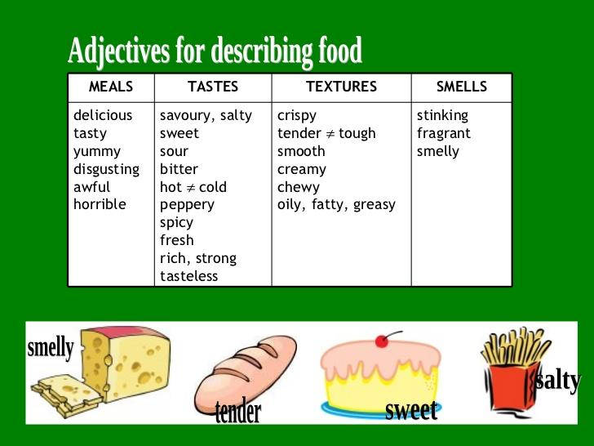

|  |  |  |
| --- | --- | --- |
| Sandwich filling | Tally | Total |
| cheese | l l l l l |  |
| tuna | l l l l |  |
| ham | l |  |
| lettuce and tomato | l l l l |  |

1. Which sandwich was the most popular?
2. Which sandwich was the least popular?
3. How many people chose ham?
4. How many people chose cheese **and** tuna **altogether**?
5. How many **more** people chose cheese **than** tuna?
6. 1 more person chose lettuce and tomato. Add it on to the tally. How many people like lettuce and tomato now

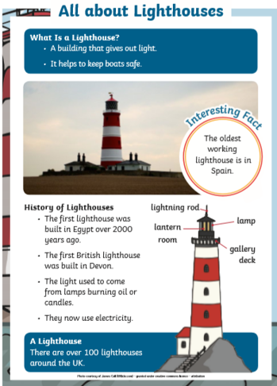

Tick the word which means the same as ‘away from harm’.

**Danger safe problem**

Where was the first British lighthouse built? Tick one.

**Devon Derby London**

How long ago was the first lighthouse built? Tick one.

**100 years 2000 years 1000 years**

Lighthouses use electricity. Tick one.

**True False**

Tick one thing you would find in a lighthouse.

**Lamp Boat Fish**

