8th June 2020

|  |  |  |  |  |
| --- | --- | --- | --- | --- |
| Monday | Tuesday | Wednesday | Thursday | Friday |
| This week’ story is Pirates Love Underpants. You can find it here:<https://www.youtube.com/watch?v=Vd8_Y1bEzA8>    Listen to the story. What happens in the story? What are the pirates looking for? Do they find it? How do they get rid of the other pirates?  Look at the first page with the picture of the pirate ship. What can you see on the ship? Can you describe the ship? | Listen to Pirates Love Underpants again.  Look at all that treasure!    If you found treasure, what would you do with it?Write some sentences about what you would do with your treasure.  Can you write your ideas on ‘Write’ in Jit5? | Listen to Pirates Love Underpants again.  Can you use some describing words to describe all the underpants?  Can you design your own underpants (see below on page 5)  Now write some describing sentences.  Here are some describing words you could use:  big, small, spotty, stripy, colourful, frilly, pretty, ugly, enormous. | Can you practise you reading today?  Here is a story. If you are reading green, orange or turquoise you should be able to read it yourself.  <http://www.megamousebooks.com/thepiratesparrot.html>  Go onto Oxford Owl and read a book for your age. You might have to pick an age younger than you are.  <https://www.oxfordowl.co.uk/for-home/find-a-book/library-page/?view=image&query=&type=book&age_group=Age+4-5&level=&level_select=&book_type=&series=#>  You should recognise some of the book swe have done in GGR groups in class. | Practise your spellings.  Have a go at this Pirate Phonics game: <https://www.phonicsplay.co.uk/BuriedTreasure2.html#>  Start on Phase 2 then see how many phases you can do. |
| Shape  Watch the songs <https://www.youtube.com/watch?v=OEbRDtCAFdU>  and  <https://www.youtube.com/watch?v=2cg-Uc556-Q>  Can you find some 2D shapes around your house?  Circle, square, rectangle, triangle, semi circle.  Now can you find some 3D shapes? (Try the kitchen cupboards!)  Sphere, cube, cuboid, cylinder, cone, pyramid.  Now can you sort them put into 2 groups? | Can you sort out the shapes on the worksheets below on pag e5.  <https://content.twinkl.co.uk/resource/af/04/T-N-5314-2d-shape-sorting-activity-sheet_ver_3.pdf?__token__=exp=1591264451~acl=%2Fresource%2Faf%2F04%2FT-N-5314-2d-shape-sorting-activity-sheet_ver_3.pdf%2A~hmac=5b85e92567e5e333ed3b07cb5fe5b5c1733a4e6628e8f9fa418ea1e095128b42> | Can you play the shape games?  <https://www.ictgames.com/mobilePage/shiftingShapes/index.html>  Choose 2D then 3D. Drag the torch over the shape to guess what it is. Press the picture of the eye to see the answer. | **Year 2 children** go to this link. Watch the video then complete the activities underneath  <https://www.bbc.co.uk/bitesize/topics/zjv39j6/articles/zgqpk2p>  **Year 1 children** go to this link and watch the video then complete the activities underneath.  <https://www.bbc.co.uk/bitesize/topics/zjv39j6/articles/ztpwdmn> | Practise your learn its! All children need to know these number facts by quick recall.  See pages below for Learn IT’s. |
| Today is World Ocean Day    Here is the link to lots of activities  <https://twitter.com/wodforschools/status/1268258651409530880/photo/1>  You can pick any activity you like, but scroll down to ‘Oceans For Beginners’ and ‘Why is sea salty’ are for 5-7 year olds. | All about pirate ships  Pirates spent alot of time on their ships. What can you find out about pirate ships?  You could Encyclopedia Britannica : <https://kids.britannica.com/kids/article/pirate/353633>  Or <http://www.the-pirate-ship.com/piratefacts>  (Also on page 7 below)  Can you label the pirate ship on page 8 below? | Can you make a junk model pirate ship?  You could use an egg box or any junk you have in your recycling.  Now test it in some water to see if it floats. | Can you make music with water?  Watch this link on YouTube:  <https://www.youtube.com/watch?v=sIO-JhMvu6M>  Have a go! | Can you make some Pirate biscuits |

Spellings (your child should know what group they are in)

Group 1 Group 2 Group 3 Group 4 Group 5 Group 6

boy thicker owl bar high off

toy coach now car light huff

joy sheep down bark might puff

destroy march cow park night lap

enjoy longer how dark right let

royal booth town leg

annoying they

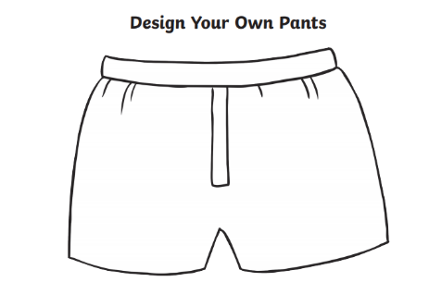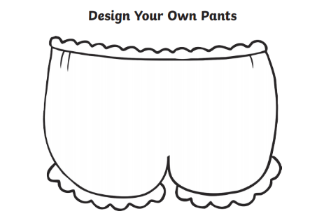

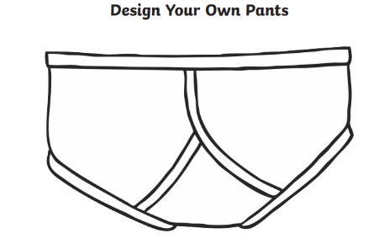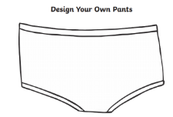

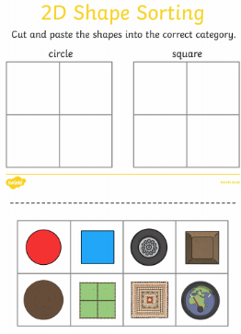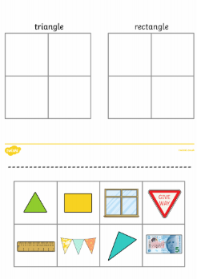

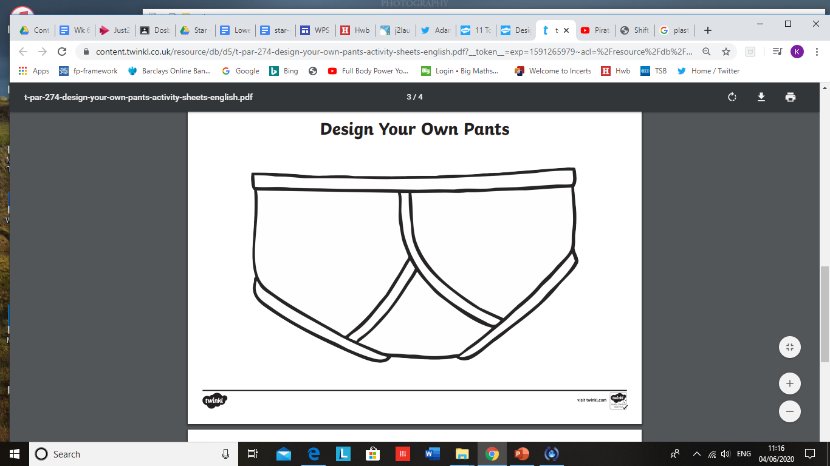

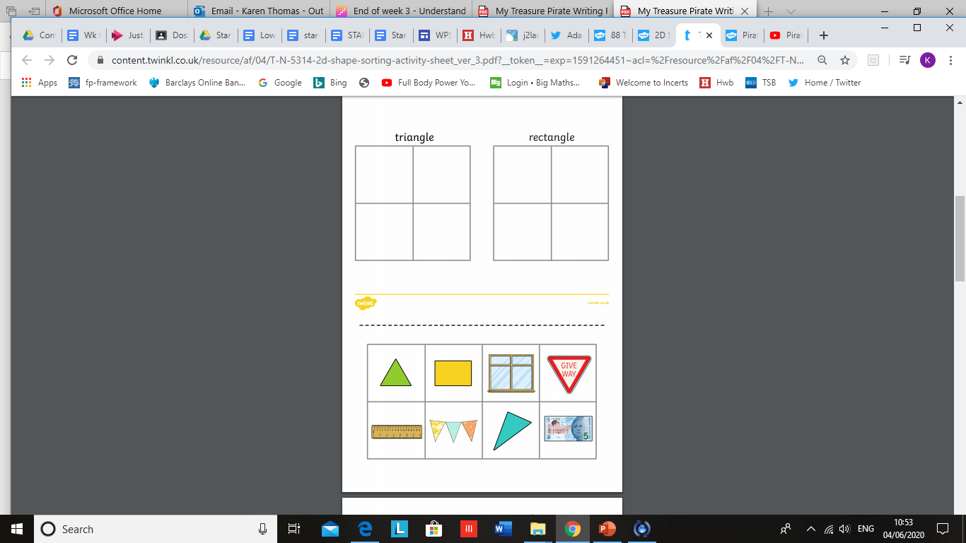

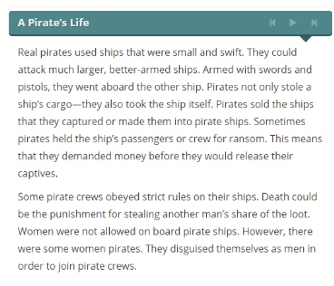

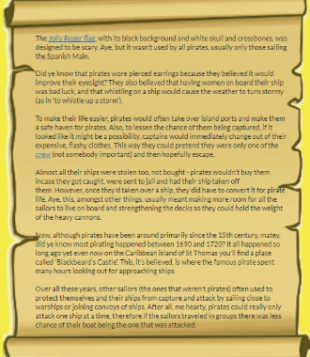

**Jolly Roger Flag**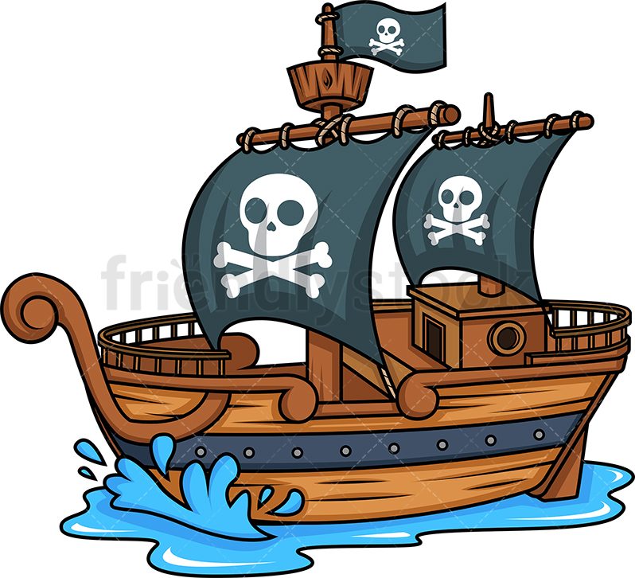

**mast**

**sails**

**gun ports**

**bow**

**crow’s nest**

|  |  |
| --- | --- |
|  |  |
|  |  |

