4th May 2020

|  |  |  |  |  |
| --- | --- | --- | --- | --- |
| Monday | Tuesday | Wednesday | Thursday | Friday |
| This week’s story is The Snail And The Whale by Julia Donaldson  Watch it here on Cbeebies iplayer. <https://www.bbc.co.uk/programmes/m000cslw>  Can you retell the story in your own words? Tell your brother or sister or mum or dad the story. | Watch The Snail And The Whale again on Cbeebies iplayer.  <https://www.bbc.co.uk/programmes/m000cslw>  The snail and the whale are great friends. How did the snail help the whale?  Can you write about your best friend? How do you help them? Write some sentences about your best friend with capital letters and full stops. Don’t forget a capital letter for someone’s name. | Can you remember the order of the Snail And The Whale story? Can you draw 6 boxes and draw the story in order?   |  |  |  |  |  |  | | --- | --- | --- | --- | --- | --- | | **1.** | **2.** | **3.** | **4.** | **5.** | **6.** | | All about snails.  I have got loads of snails in my garden! If you have a garden, see if you can find any snails today. Where will they be hiding?  Read the information about snails below on page 5 and answer the questions on page 6. | Can you make a book of different sea creatures?  You could draw a picture, write a heading and write a fact about each animal.  You could add a caption (sentence to go with the picture). You could even add the Welsh name (see below page 7)  You can make this on Hwb in ‘mix’ or you can make a paper one. Good luck! |
| Measuring Length  The snail is short and the whale is long!  Can you make a chart of short and long things around your house? It could look like the one below on page 4. | Can you find 6 objects in your kitchen that you are allowed to measure?  If you have a ruler, can you measure them in cms? Remember you have to start measuring from the 0cm.  If you don’t have a ruler, what else could you measure in? Pasta pieces? Spaghetti? Tins? Spoons?  How many spaghetti pieces long is your cereal box? | Can you find the same 6 things you measured yesterday?  Can you put them in order from shortest to longest?  How short is the shortest? How long is the longest?  If you have a computer you could play <https://www.topmarks.co.uk/early-years/lets-compare> At The Beach. Or you can try <https://www.topmarks.co.uk/maths-games/measuring-in-cm> Level 1 then Level 2. | Can you draw these sea creatures:  Octopus, starfish, whale, dolphin, Nemo fish.  Now can you measure your drawings in cms? Which one is shortest? Which one is longest?  If you don’t have a ruler you can measure in pasta pieces. | Practise your learn its! All children need to know these number facts by quick recall.  See pages below for Learn IT’s. |
| In this week’s story there is a whale. How many other sea creatures do you know? Can you find out any more? Can you draw a picture and name them? | How many different sea creatures did the snail and the whale meet on their adventure? I counted 8 different ones, but there could be more.  Make a list and draw a picture of the different sea creatures they met. | Can you paint an Under The Sea painting, make a collage, or make a junk model of a sea creature? | Can you find out the names of any sea creatures in Welsh?  See the word bank below for help on page 7 below. | Baking/ Cooking  Can you have some fun in the kitchen this afternoon?  You could help make tonight’s tea or bake something yummy for your family. |

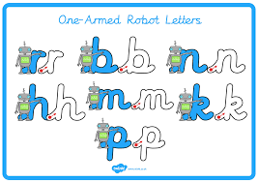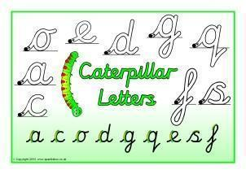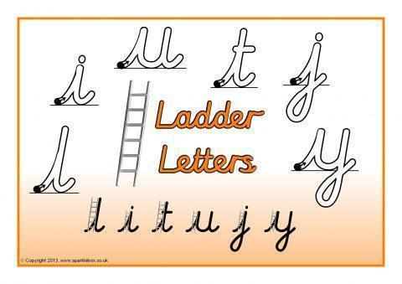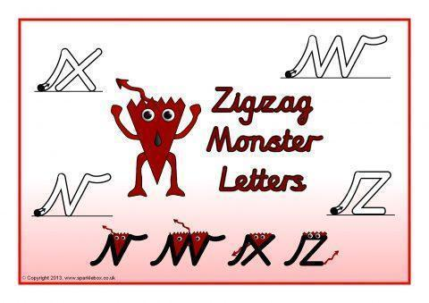

Step 1 - Ensure children can form all of these letters correctly in the correct starting place.

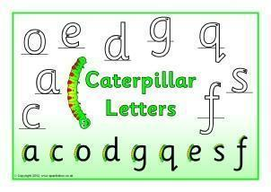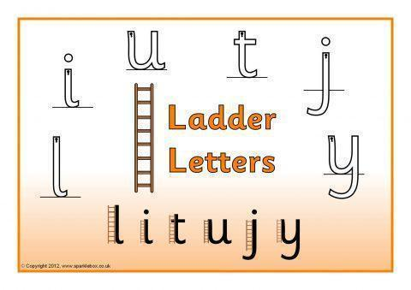

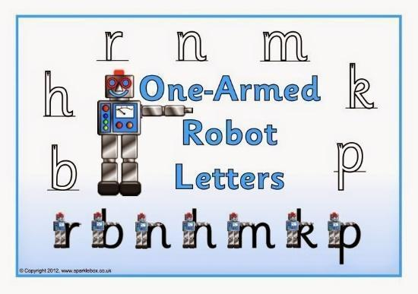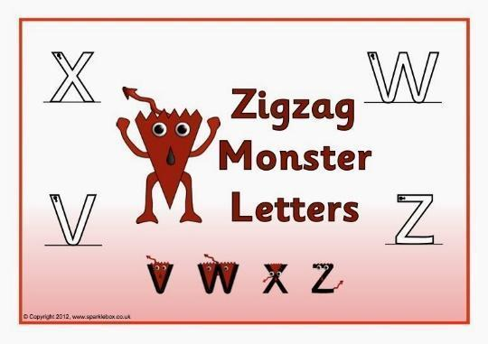

Step 2 – Only start joining letters together, once children can correctly form all their single letters correctly.

Spellings (your child should know what group they are in)

Group 1 Group 2 Group 3 Group 4 Group 5 Group 6

day hammer look high them rip

play letter foot light then rat

say ladder took might that rug

stray supper cook night this rot

spray dinner good right with

crayon boxer book fight

delay better

tray summer

|  |  |
| --- | --- |
| Long things | Short things |
| My sofa | My spoon |
| My table | My crayon |
|  |  |
|  |  |

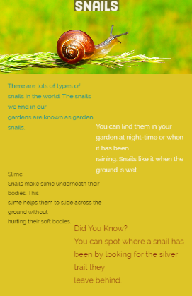

Questions

1. What do we call the snails we find in our gardens?

Tick one. Home snails Garden snails Bush snails

1. When can you find snails in the garden?

Tick one. During the night During the day During snow

1. What do snails like the ground to be?

Tick one. Dry Hot Wet

1. What does slime help snails to do?

Tick one. Slide across the ground

Taste their food

Hide from predators

1. How can you spot where a snail has been?

Tick one. They leave a silver trail. They leave a dry patch. They turn rocks over.

