1st June 2020

|  |  |  |  |  |
| --- | --- | --- | --- | --- |
| Monday | Tuesday | Wednesday | Thursday | Friday |
| This week we are starting a new Context: PIRATES  This week’s story is called ‘How I Became A Pirate’ and you can find it on YouTube here: <https://www.youtube.com/watch?v=5-0VHrSwg2k>    Can you write a list of things Pirates do? | Listen to the ‘How I Became a Pirate’ story again.  Can you draw some speech bubbles and write some piratey words or sentences in them?  See below page 6. | Listen to the story ‘How to become a pirate’ again.  Can you make a list of all the things pirates DON’T do!    **Can you think of any of your own pirate rules?** | Would you like to be a pirate? Why? Why not?  Can you be like the little boy in the story and go on a pirate adventure?  Write me a story about your adventures!  You can log into Hwb and write your story on Jit 5 or you can write it on a paper. | Can you practise your spellings and your handwriting today?  Copy out your words then write a sentence to go with each word.  See page 3 below for your words. |
| Addition  This week we are adding numbers to find the total.  See if you can do the worksheets below on pages 4 and 5. They get harder! The last one is a real challenge. Remember, you can take the zero off, work out the answer, then put the zero back on.  60 + 70 =  I know 6 + 7 = 13  So 60 + 70 = 130 | Just like last week, can you find 20 objects around your house? Things like toys, lego bricks, pasta pieces. Now can you complete these addition problems, using your counters to help you?  2 + 4 =  7 + 3 =  3 + 3 =  6 + 1 =  5 + 2 =  Now if you have a 100 square (you can find one online here)<https://www.findel-education.co.uk/product/curricular/computing-and-ict/floor-robots/earl-100-square-mat/he1829387>  Can you have a go at these for a challenge?  25 + 2 =  36 + 5 =  47 + 3 =  59 + 4 =  75 + 1 = | Can you play some addition games on Topmarks? **Choose the ‘addition’ option.**  <https://www.topmarks.co.uk/maths-games/mental-maths-train>  <https://www.topmarks.co.uk/addition/robot-addition> | Can you practice all your adding skills today?  Go onto Topmarks addition and play Hit The Button. Choose Number Bonds. Then you can make it as easy or as hard as you think you can manage!  <https://www.topmarks.co.uk/maths-games/hit-the-button>  If it’s too hard go back and pick an easier option. | Practise your learn its! All children need to know these number facts by quick recall.  See pages below for Learn IT’s. |
| Can you find out any more information about pirates?  You could look at this website:<https://www.dkfindout.com/uk/history/pirates/>  or this one: <https://www.nassauparadiseisland.com/arrr-did-you-know-10-fun-pirate-facts-and-myths>  Ask an adult to help you read the words and find out some facts? | Can you make a pirate fact file like this?  PIRATES   |  |  | | --- | --- | | Live |  | | Eat |  | | Job 1 |  | | Job 2 |  | | Punishments |  | | Famous  Pirate |  | | The weekend before half term our Muslim families celebrated Eid. Can you watch the video clip about people celebrating Eid? Can you make a picture about Eid of a lovely family meal?  <https://www.bbc.co.uk/cbeebies/puzzles/lets-celebrate-eid> | Science Time!  Can you make a salt crystal?  <https://uk.video.search.yahoo.com/search/video;_ylt=AwrP4k.bqMdecQsAfA4M34lQ;_ylu=X3oDMTByMjBhOWN0BGNvbG8DaXIyBHBvcwMzBHZ0aWQDBHNlYwNzYw--?p=how+to+make+a+salt+crystal&fr=mcafee#id=4&vid=4140dbac3864b453713911e4d872ed90&action=view>  Watch the video and have a go. Draw a picture of all the things you needed and make a prediction about how long it will take to grow a crystal. Keep an eye on your crystal over the next few days and see what happens. Draw a picture or take photos. You can email me or Tweet me. | Can you finish off the week with some lovely, relaxing yoga.  There is a pirate one here.  <https://www.youtube.com/watch?v=T_0P5grVoyg> |

Spellings (your child should know what group they are in)

Group 1 Group 2 Group 3 Group 4 Group 5 Group 6

sea shook fur look see fit

seat farmer curl foot feel fun

meat singer burn cook feet fat

treat faith hurt good meet fog

least teeth surf book week fan

steamy shark

repeat shorter

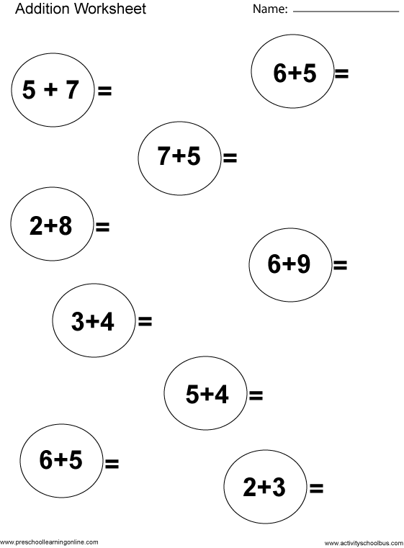

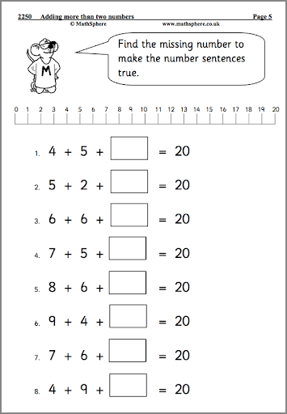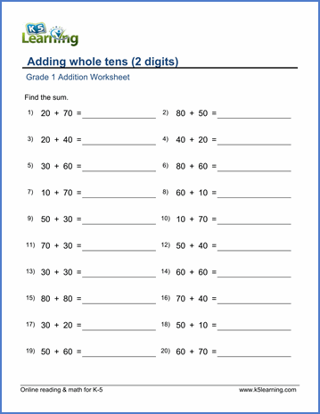



|  |  |
| --- | --- |
|  | **Come ‘ere you landlubbers!**  **Where’s the treasure?**  **Ai treasure!**  **Down the hatch!** |
|  |  |

