Learning tasks for week beginning Monday 20th April



Complete as many of these tasks as are you able to. I would love to see a picture of your work! You can tweet it to me at @DosbarthSilver on Twitter. The theme this week is all about Easter and Spring.

English

* Read a book (or listen to someone read a book to you). You could visit <https://www.oxfordowl.co.uk/for-home/find-a-book/library-page/> to find stories to read online for free. You do not need a class login – you can register for free as a parent.
* Practise reading and writing your key words. Start with Phase 2. When you can read or write all of those, try to learn some of the words in Phase 3, then Phase 4 and Phase 5.

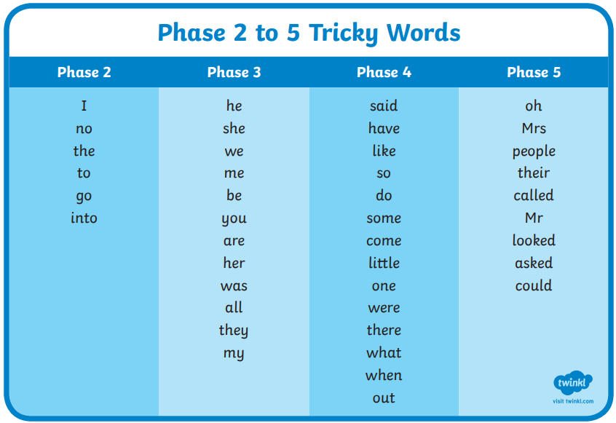

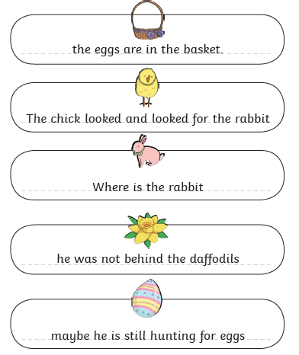

* Read the sentences and make sure they all have capital letters at the beginning and punctuation at the end, like a full stop (.), question mark (?) or an exclamation mark (!).

Maths

* Try using what you know about money and coins to work out the price of each Easter egg below. Start with Level 1. If you are able to do this, try Level 2, and then Level 3 if you can. You do not have to complete all of the levels; just go as far as you can.

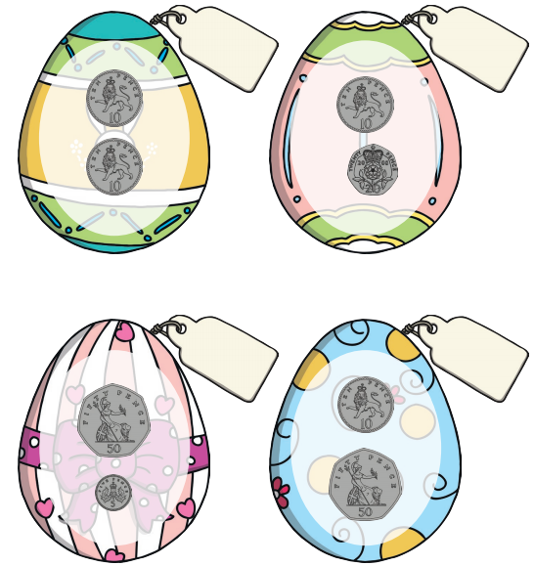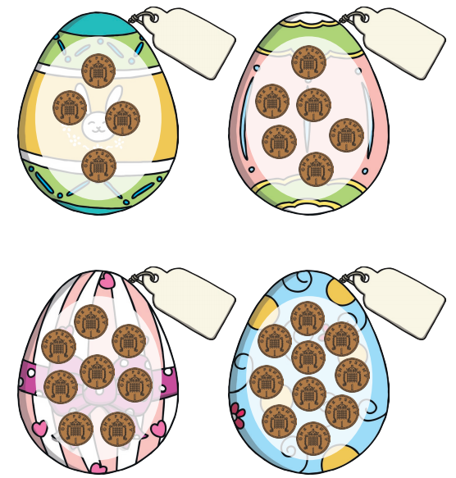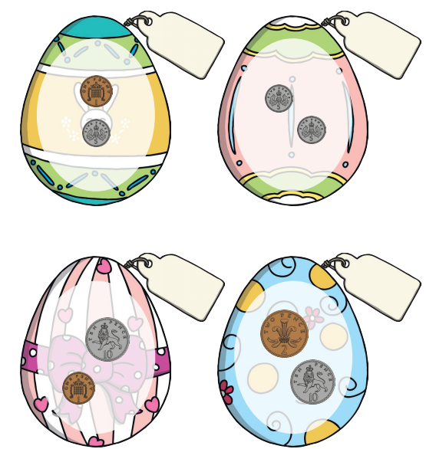

* Next week, we will be learning to tell the time. To start preparing this week, go on a hunt to find all of the devices that tell the time in your home. How many can you find?
* Don’t forget to practise counting forwards and backwards in 1s, 2s, 5s and 10s. Use the songs from Jack Hartmann YouTube channel to help you.
* Practise your Big Maths tests.

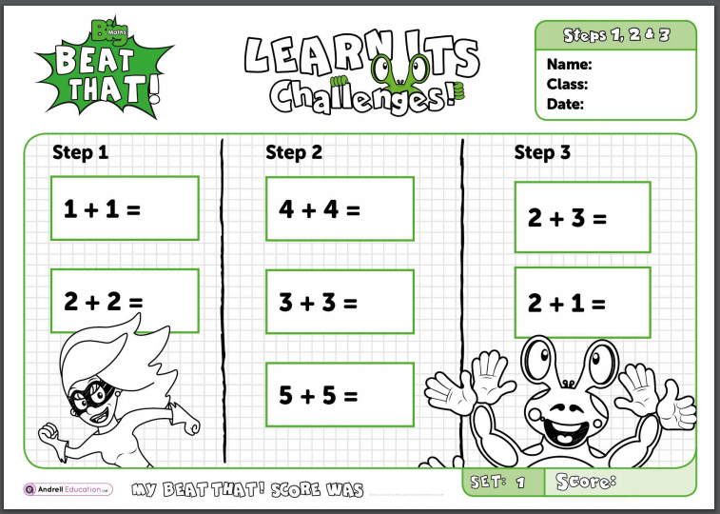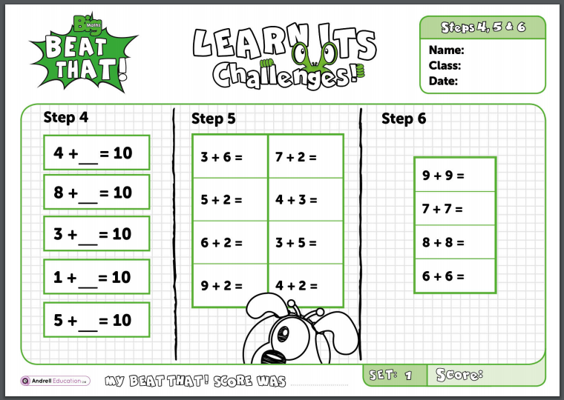

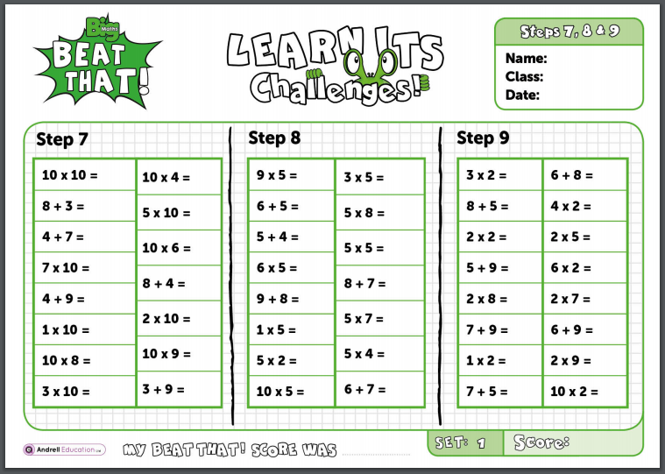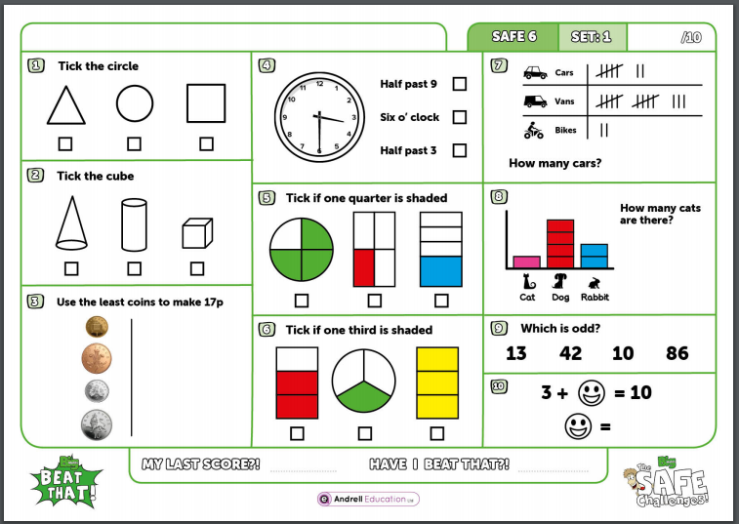

Other learning

* Use old food packaging and other recycling from around your home to create something that reminds you of Spring. Can you make a lamb, a chick, an egg, a flower or something else?
* Can you cook something using eggs? Perhaps an omelette or a cake? Tweet a picture!
* Look out of your window or look around you on your daily walk; can you see the signs of spring appearing? What are they? Draw or write about the things that happen in Spring.
* Can you do something kind for everyone you live with today? Perhaps you could tell them something you like about them, or help them with something they need to do.
* Find Cosmic Yoga on YouTube and choose a story to follow along to. Can you get someone in your family to join in with you too?