The world in your hands  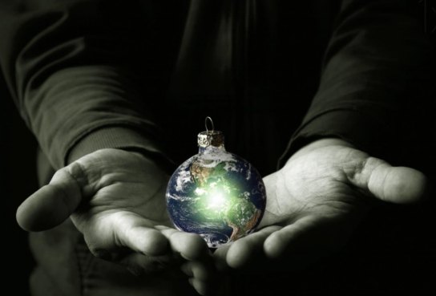 | Observe
Wonder | Infer

