Homework for Dosbarth Pearl (Spring Term 2020)

Language, Literacy and Communication  Write a shape poem about different weathers.   | Maths & Numeracy  Write digital times and match to analogue clocks.   | Creative  Design and make a Roman shield. You can use any materials/ colour/ patterns you wish.  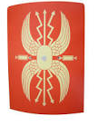
Digi  Research 5 facts about the Romans and draw a picture of the army.   | History  Draw and label a Roman Soldier. E.g. the helmet, armour etc.  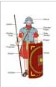 | History  Research the Roman army. Write 5 positive and 5 negative things about the Roman army.  