Homework for Dosbarth Emerald (Spring Term 2020)
Please complete one activity to complete per week.
Once you have finished an activity, bring it into school by Thursday for your teacher to mark.

Language, Literacy and Communication  Write a shape poem about different weathers.   | Maths & Numeracy  Write digital times and match to analogue clocks.   | Creative  Design and make a Celtic shield. You can use any materials/ colour/ patterns you wish.  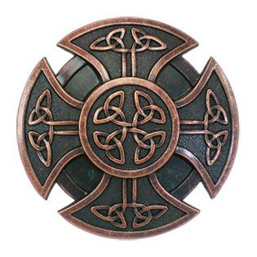
Digi  Research 5 facts about the Celts and draw a picture of the army.   | History  Draw and label a Celtic Warrior e.g. shield, sword, woad, dress.  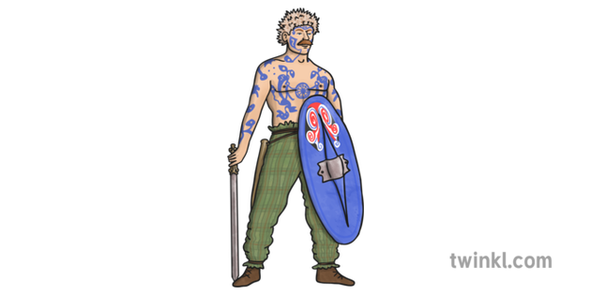 | History  Compare a roundhouse with your own house. What is the same? What is different?  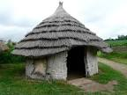  

Please practise your spellings, ready for your spellings tests on Friday. Also, complete your Maths Homework and bring back by Friday.

