**Homework for Dosbarth Emerald (20/04/20)**

|  |  |  |
| --- | --- | --- |
| Language, Literacy and Communication  Write a letter to a family member that you love. Include reasons why you love them and pictures.    Write a thank you letter to the NHS including reasons and pictures. | Maths & Numeracy  Double any number using the diamond method.    Practice your CLIC, Learn its and SAFE questions. | Creative  Design an Easter egg. |
| Digi  On Google Docs write instructions for washing hands. | Creative  Create a rainbow and put it up in your window. Take a picture and tweet it. | Welsh  Write a weather diary in Welsh.  Dydd Llun (Monday)  Dydd Mawrth (Tuesday)  Dydd Mercher (Wednesday)  Dydd Iau (Thursday)  Dydd Gwener (Friday)  Mae hi’n ___  Gymylog (Cloudy)  Heulog (Sunny)  Boeth (Hot)  Oer (Cold)  Wyntog (Windy)  Bwrw Glaw (Raining)  Bwrw Eira (Snowing) |

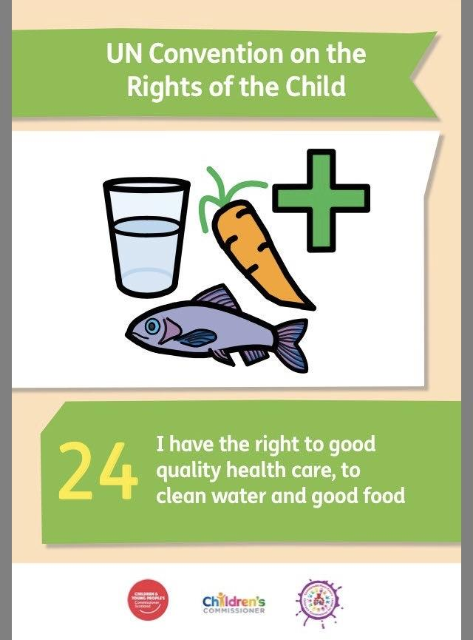

April

Right of the Month

Article 24- Right to good health and health care.

Can you create a poster with all the ways we need to stay healthy. Please include lots of pictures too.

E.g. Eat nutritious food, exercise, see a doctor if we are unwell, good hygiene.